What is in this document:
- FFA.org Roster Help Link
- Roster Terminology Guide
- Chapter Leaders - How to Request access to an FFA Chapter
- Areas for Review – Chapter & Individual Profile
- Renewing Previous Memberships
- Adding New Memberships
- Membership Transfers
- Roster Errors

When in Doubt – FFA.org for Help!
National FFA has some great step by step instructions on their website. They can be found here: https://help.ffa.org/categories/roster/.

Managing Your Roster – Terminology
  - Membership Year – September 1 to August 31 Annually
  - Chapter Number – WA + 4 digit code assigned to each chapter
  - Membership Type
    - One-Year – One year of FFA membership.
    - Ag-Ed Only – Students are not full-fledged FFA members, need access to systems for education purposes. Not eligible for State Contests, Awards, etc.
  - FFA ID – Unique Identifier to each FFA member, alumni, and advisor.
  - Batch/Batch ID – Students added to your roster at one time. If you upload student groups at different times, you’ll create different batches and/or batch IDs. Batch ID’s may be referred to for invoicing/billing purposes by Washington FFA.
  - Status – Assigned to batches at different phases of approval.
    - Local – Membership has not been approved by local chapter. Membership is not approved.
    - State – Membership has been submitted to state by the local chapter. Membership is not approved.
    - National – Membership has been approved at the state level and is pending national approval. Membership is not approved.
    - Approved – Membership has been approved by National FFA.

New Teacher or Need to Switch Chapters?
You can request access to your new chapter under the Teacher Dashboard on FFA.org and selecting “Request Access to a Chapter” (https://www.ffa.org/my-toolbox/instructor/). From there you will log-in (or create a new account if you’re BRAND new) and look up the chapter you need to get access to. State staff will approve you as a chapter leader and from there you’re good to go!
Tips:
- If you’re in a multiple teacher program, please use unique emails to log in so you all can have access to your chapter.
- State staff can remove anyone who shouldn’t have access to your chapter (i.e. previous advisors or staff). Just send us an email if that’s needed.

Your Profile – Is it Current?
Make sure your profile is current in the National FFA System. This profile contact information is used by National FFA for communication.
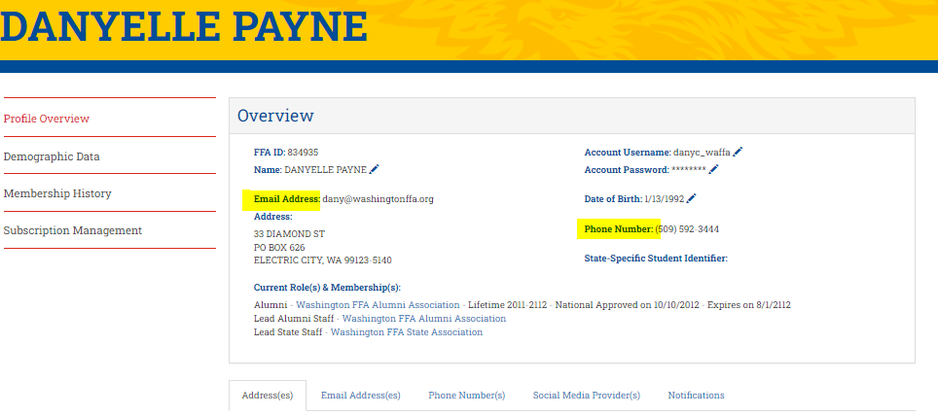
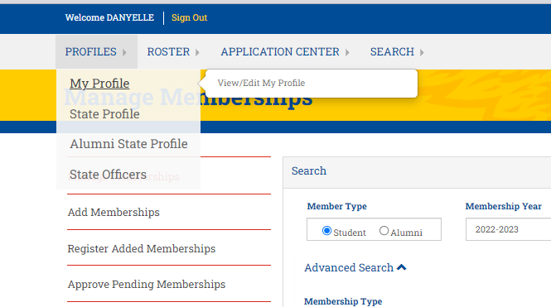

Chapter Profile Data: Make sure contact information is current including primary chapter and billing contact data. This info is used by both Nationals and the State Association (for invoicing).

Additionally – this would be a GREAT place to store your chapter information (charter, constitution & bylaws) for yourself and future advisors!
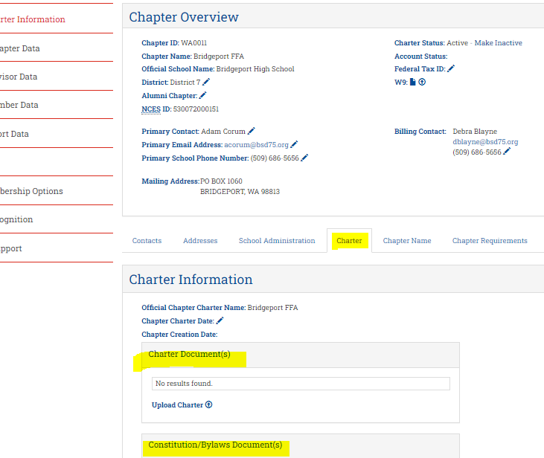
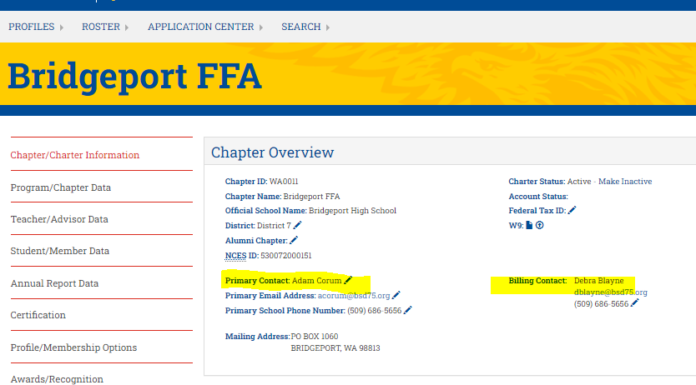

Existing Membership (Renew)
- Manage Membership
  - Update Membership year to the previous membership year.
  - Update Grade to desired year and Below/Above
  - “Search” – This will bring up students that fit in the qualifying grade. The grade displayed is in real-time and not what it would have been for the selected membership year (i.e., if you search the 2021-2022 membership year for grades 11 and below, those showing as grade 12 were in grade 11 in 2021-2022. Those showing as grade 11 were in grade 10 in 2021-2022, and so on).
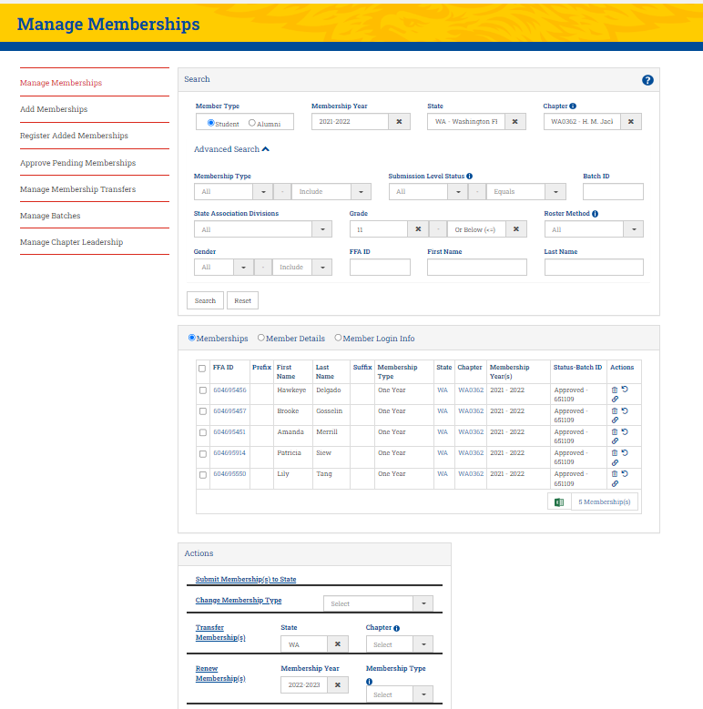
- Select the members you plan to renew and under Actions select “Renew Membership”. Be sure the membership year is current and membership type is completed.

Existing Membership (Renew) – CONT’D
- Move to “Approve Pending Memberships”
- Select members and under Actions, hit “Submit Memberships to State”
- After this step, membership is pending approval at the state and national level. Invoices will be generated by state staff via Quickbooks and delivered via email.
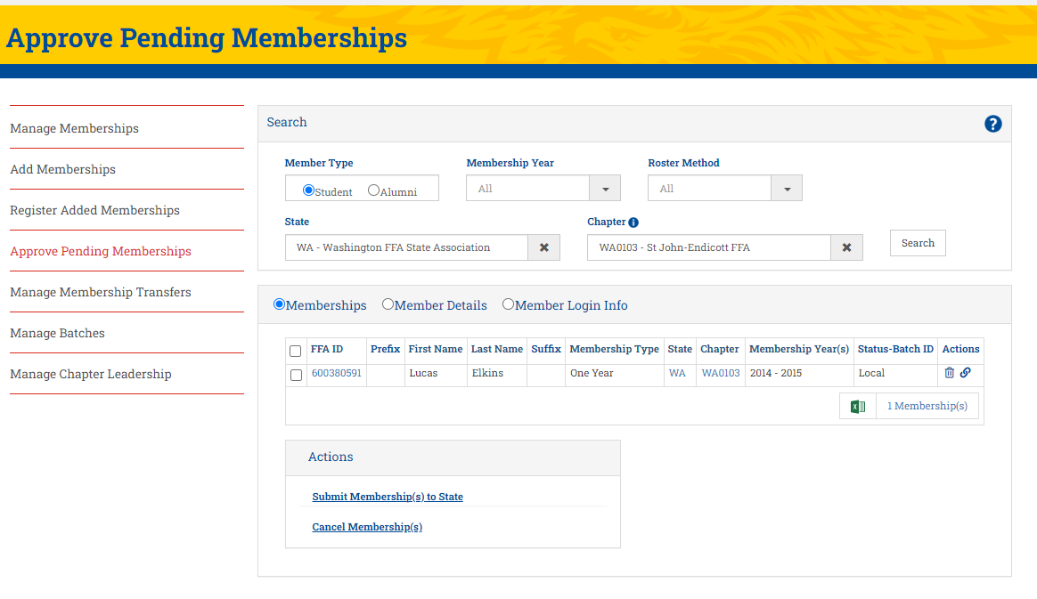

New Membership
Adding a few new members? Start here. If you need to add lots of new memberships, start on page 7.
- Add Memberships
- Input Student Information
  - Membership Year, State , Chapter Membership Type
  - First, Last, DOB, Phone, Email
  - Mailing Address
  - Graduation Year, Month, Grade, Gender, Race, Location
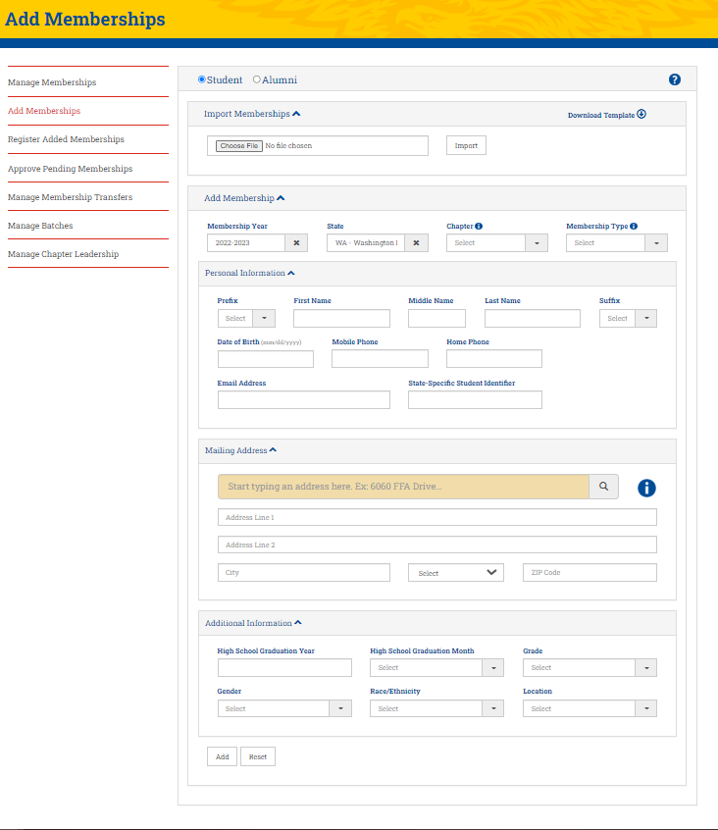
- Hit “Add” – Repeat for additional New Members

Adding a few new members CONT’D
- Move to “Register Added Memberships”
- Select the newly added members (check box) and under Actions, hit “Analyze Added Memberships”. This will look for potential duplicates.
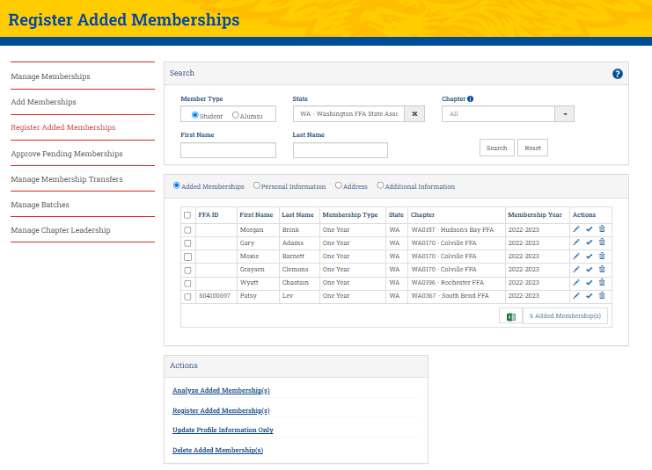
- Select newly added members again and under Actions, hit “Register Added Members”. This will formally register and assign an FFA ID.
- Move to “Approve Pending Memberships”
- Select members and under Actions, hit “Submit Memberships to State”
- After this step, membership is pending approval at the state and national level. Invoices will be generated by state staff via Quickbooks and delivered via email.

Adding lots of new members? Start here:
- Add Memberships
  - Input Student Information into the Template including
    - Membership Year, State , Chapter Membership Type
    - First, Last, DOB, Phone, Email
    - Mailing Address
    - Graduation Year, Month, Grade, Gender, Race, Location
Please note that some of the cells are drop down selections and others require specific format.
IF YOU DON’T FOLLOW THE TEMPLATE REQUIREMENTS THE SYSTEM WON’T ACCEPT YOUR SPREADSHEET.
Detailed outline of requirements can be found here: https://ffa.app.box.com/v/addmem-template-addmem-import
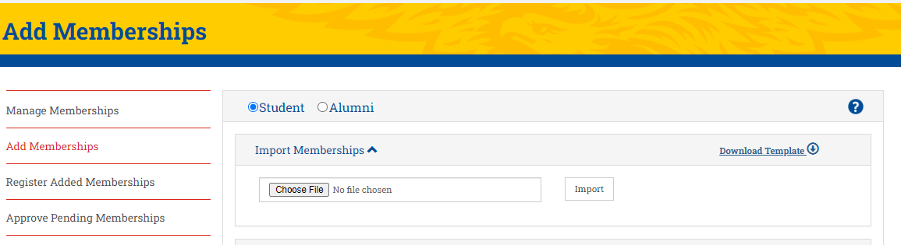
- Once your file is complete, you can upload it under the “Import Memberships” section.

- Move to “Register Added Memberships” Select the newly added members (check box) and under Actions, hit “Analyze Added Memberships”. This will look for potential duplicates. Select newly added members again and under Actions, hit “Register Added Members”. This will formally register and assign an FFA ID.

Adding lots of new members – CONT’D
- Move to “Approve Pending Memberships”
- Select members and under Actions, hit “Submit Memberships to State”
- After this step, membership is pending approval at the state and national level. Invoices will be generated by state staff via Quickbooks and delivered via email.
Membership Transfers
New student that was an FFA member at another school (WA or not)? Memberships can be transferred in or out of chapters as necessary. This can be done accessing “Manage Memberships”, selecting the student, and under actions selecting Transfer Membership by filling out the state and new chapter information. Transfers will then have to be approved by state staff (incoming state). Membership transfers need to be initiated by the original chapter advisor, not the new chapter.
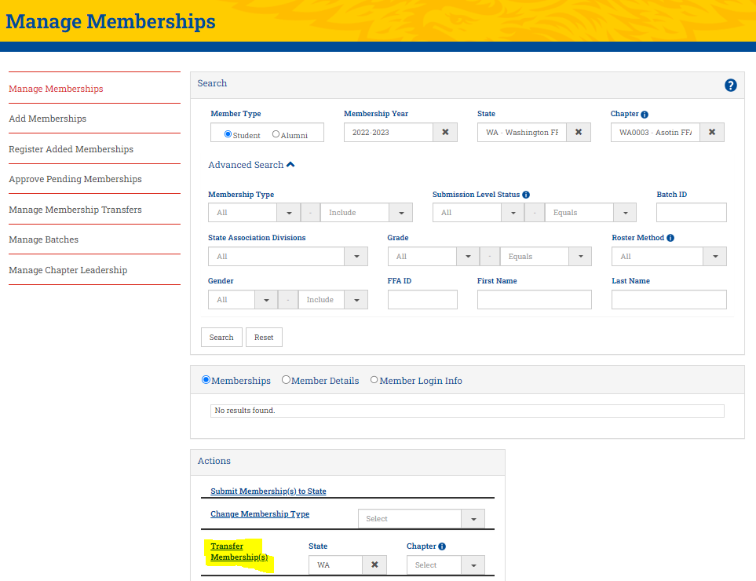

Roster Errors
If you're submitting your roster but running into this big red error, the message can be misleading. It doesn't necessarily mean that there is something wrong; however, you're required to review and verify this data annually.

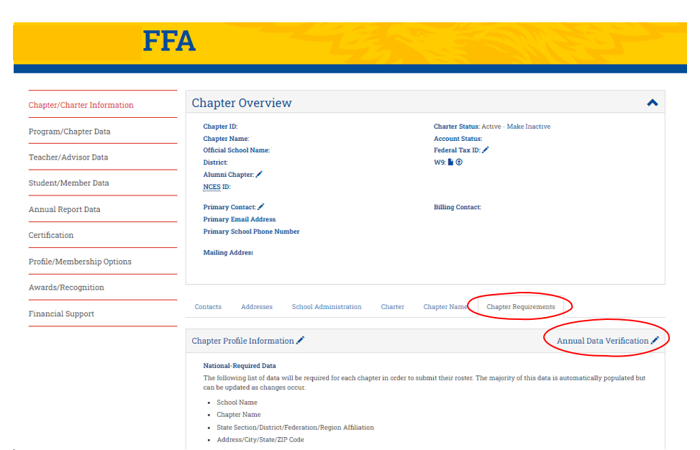
To fix it, head over to your chapter profile and under Chapter Requirements, select "Annual Data Verification". Please review the data on this page for accuracy then hit "Submit/Verify". Once you've done that, pop back into your roster and submit.

