*Toolkit of Resources for Engaging Families and the Community as Partners in Education*

*Mona Halcomb, Native Student Success Program Supervisor,* [*mona.halcomb@k12.wa.us*](mailto:mona.halcomb@k12.wa.us)

[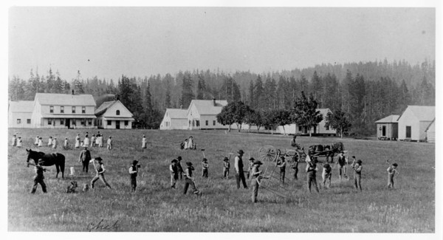](https://nam02.safelinks.protection.outlook.com/?url=https%3A%2F%2Fwww.kxly.com%2Freport-burial-sites-found-at-53-native-american-boarding-schools%2F&data=05%7C01%7Cmona.halcomb%40k12.wa.us%7Ce5e388666c89409157f008da339e1129%7Cb2fe5ccf10a546feae45a0267412af7a%7C0%7C0%7C637879051238714209%7CUnknown%7CTWFpbGZsb3d8eyJWIjoiMC4wLjAwMDAiLCJQIjoiV2luMzIiLCJBTiI6Ik1haWwiLCJXVCI6Mn0%3D%7C3000%7C%7C%7C&sdata=9siJKZ98jmod4juMD%2BJEasCRkW7B6CQJYPLbVqUu1gs%3D&reserved=0)Watching the evening news may impact some families differently than others. As a Native American woman, watching the recent events about the Pope apologizing to Indigenous Groups in Canada about residential schools brought up painful conversations with my family. – see video [here.](https://www.cnn.com/2022/07/24/americas/pope-francis-canada-visit-intl/index.html)

As you may know, the United States shares a similar history. A recent report was released regarding Native American Boarding Schools and the content may be triggering. You can [read the report: Burial sites found at 53 Native American boarding schools](https://nam02.safelinks.protection.outlook.com/?url=https%3A%2F%2Fwww.kxly.com%2Freport-burial-sites-found-at-53-native-american-boarding-schools%2F&data=05%7C01%7Cmona.halcomb%40k12.wa.us%7Ce5e388666c89409157f008da339e1129%7Cb2fe5ccf10a546feae45a0267412af7a%7C0%7C0%7C637879051238557984%7CUnknown%7CTWFpbGZsb3d8eyJWIjoiMC4wLjAwMDAiLCJQIjoiV2luMzIiLCJBTiI6Ik1haWwiLCJXVCI6Mn0%3D%7C3000%7C%7C%7C&sdata=d5PSeyAEa6C2ciVHXsYMe31ccCqY86QUn%2BVDNQ1E%2FRg%3D&reserved=0). The investigation found that from 1819 to 1969, the federal Indian boarding school system was comprised of more than 400 schools across 37 states.

The good work you are doing for reengagement considering these stories is even more critical. Starting from a place of acknowledging, healing, and co-creating safe and inviting places of learning will reengage our youth and families. Here are some resources I hope you will find helpful in your efforts.

## Toolkit of Resources for Engaging Families and the Community as Partners in Education:

The [Toolkit of Resources for Engaging Families and the Community as Partners in Education](https://ies.ed.gov/ncee/rel/Products/Publication/3767) is a four-part resource that brings together research, promising practices, and useful tools and resources to guide educators in strengthening partnerships with families and community members to support student learning.

[Part 1: Building an understanding of family and community engagement](https://ies.ed.gov/ncee/rel/regions/pacific/pdf/REL_2016148.pdf)

[Part 2: Building a cultural bridge](https://ies.ed.gov/ncee/rel/regions/pacific/pdf/REL_2016151.pdf)

[Part 3: Building trusting relationships with families and the community through effective communication](https://ies.ed.gov/ncee/rel/regions/pacific/pdf/REL_2016152.pdf)

[Part 4: Engaging all in data conversations](https://ies.ed.gov/ncee/rel/regions/pacific/pdf/REL_2016153.pdf)

Please do not lose hope, your work is making a difference, and if you need a thought partner, do not hesitate to reach out to me. Mona Halcomb, Native Student Success Program Supervisor, [mona.halcomb@k12.wa.us](mailto:mona.halcomb@k12.wa.us)