Eliminating Disparities in Access While Improving College and Career Readiness

By Kristin Trostel and Steven Gering, Abl. Schools

Research suggests that when students have access to advanced coursework, they are more engaged, and this simultaneously improves student college and career readiness outcomes. Recent data from the U.S. Department of Education, however, suggests that some students (e.g. African American, Latino, free and reduced lunch, etc…) are less likely than others to have access to advanced coursework. Studies by the Washington state legislature found similar data which led to the passing of RCW 28A.320.195 - requiring all school districts in Washington to have an Academic Acceleration Policy in place to actively encourage more students to enroll in advanced coursework as part of their K-12 experience.

By using advanced analytics software, districts will better understand how critical resources are allocated across schools, as well as unintended consequences of school schedules, to increase access to advanced coursework which leads to college and career readiness. This visual highlights course progression of students in a high school mathematics curriculum. By surfacing the flow of students through their curriculum, this district received new insights into how students were progressing through their curriculum and what choices students and families were making as they navigated course offerings and high school and beyond plans. With this new information, they were able to work with guidance counselors to encourage and promote math in senior year. This adjustment impacted overall student math enrollment significantly and improved student post-secondary readiness.
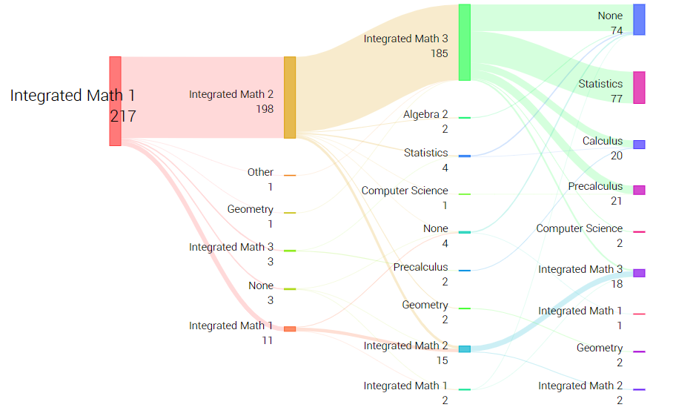

Through partnership with Abl, a social impact technology company, districts apply cutting-edge analytics tools to not only map school schedules but identify time that can be used for high-impact interventions to boost college and career readiness among their students.
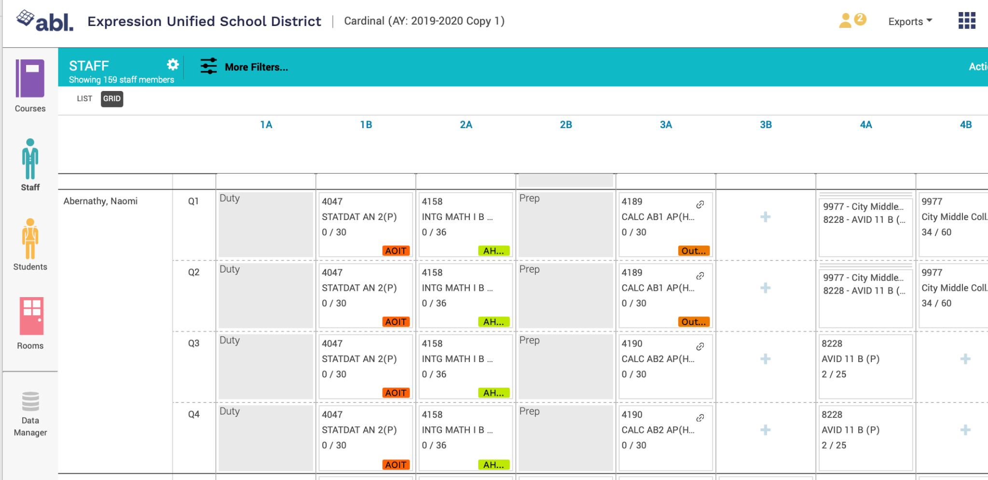

Developed by a team of educators and technology innovators with a passion for improving equity in K-12 schools, Abl's scheduling software transforms school scheduling from a process rooted in spreadsheets and magnet boards to a strategic, data-driven approach that reflects district goals and priorities. The process empowers school leaders to evaluate the implications of budget allocations and school schedules with a focus on educational equity. By understanding and addressing disparities in student experiences and course offerings, school leaders can identify paths of low academic rigor and distribute resources to improve advanced coursework pathways and increase specialty courses that lead to college and career readiness. To learn more, click here

