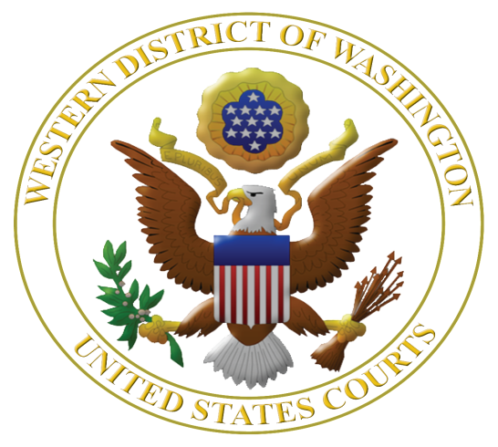
Virtual Fourteenth Annual

Judicial Institute for Teachers Grades 5-12

July 5, 6, and 7, 2022 if in-person
July 5, 6, 7, and 8, 2022, if virtual

Featuring Mary Beth Tinker of Tinker v. Des Moines School District

Learn More about the U.S. Constitution, Federal Judiciary, Civil Rights, and Federal Criminal Law
www.wawd.uscourts.gov/educators-media/educational-resources

Registration - Judicial Institute 2022
Judicial Institute for Teachers Grades 5-12
July 5, 6, and 7, 2022 if in-person; and July 5, 6, 7, and 8, if virtual.

The U.S. District Court for the Western District of Washington in collaboration with the Seattle University School of Law is offering teachers a unique opportunity to learn about the U.S. Constitution, federal judiciary, civil rights, federal-state courts, and federal criminal law. The institute is highly interactive.

This year the program features Mary Beth Tinker, plaintiff in Tinker v. Des Moines School District, 1969, in which the U.S. Supreme Court ruled that public school students do not shed their free speech rights at the schoolhouse door. There will be a section on qualified immunity for police officers, as well as presentations on the U.S. Supreme Court and Judicial Review.

Judges who hear the cases you read about in the news will be faculty along with long-term law-related education expert Margaret Fisher to help translate this content into lessons immediately usable in the classroom.

Teachers from last year's virtual Judicial Institute had this to say:

“The Judicial Institute rocked my summer! I have a greater knowledge of the judicial branch of the government. I am inspired by the judges to connect with my students more deeply, and I feel privileged for being able to attend. Thank you for this opportunity! You have made me a better teacher.”

“The Judicial Institute is a great resource and program for teachers who want to promote civics in their classroom. The program provides teachers resources and opportunities to build their understanding and confidence in teaching civics. If you teach Social Studies, this program is a MUST!”

“Endless thanks to all who offered their time and shared their expertise with us. The Judicial Institute has been one of the top 3 most informative workshops I have attended in my 32 years in education.”

“After Judge Jones spoke, I wanted summer to be over so I could go inspire young minds. He inspired me.”

Eligible applicants: Forty teachers in grades 5-12, teaching in any of 19 western counties of Washington *who did not participate in a prior Judicial Institute.

Dates and times: This is currently being planned as a virtual 4-day program but may pivot to a 3-day in-person program if conditions are deemed safe. Overnight accommodations will also be included if the program is offered in person. The program will be offered virtually over four days from 8 to 1 p.m. with a special Teatime with Tinker on July 7 at 4:00 p.m. If held in person, the program occurs over three days, July 5-7 from 8 to 5 each day. On February 1, 2022, the decision will be made whether conditions are safe enough to offer an in-person program. Details on timing will be made available later.

Judicial Institute Location: TBD – either in the U.S. District Court, 700 Stewart St., 19th floor,
Seattle, WA 98101 or over Zoom.

Clock hours: 23 clock hours available at no cost.

Cost: No registration fee. If the program is able to be offered in person, breakfasts and lunches will be provided on July 5-7, group dinner provided on July 6, parking is provided, and double occupancy hotel rooms provided for the nights of July 4, 5, and 6. If single occupancy is required, teachers are required to pay the additional cost for the half of the room plus tax and fees.

Registration: Rolling registration until 40 slots are filled.

Selection: Based on time of application and geographic diversity.

More information: Margaret Fisher, Seattle University School of Law, fisherm2@seattleu.edu
or 206-501-7963.

Please apply early by completing and submitting this Form to Margaret Fisher, fisherm2@seattleu.edu

*Counties in the Western District of Washington are Clallam, Clark, Cowlitz, Grays Harbor, Island, Jefferson, King, Kitsap, Lewis, Mason, Pacific, Pierce, San Juan, Skagit, Skamania, Snohomish, Thurston, Wahkiakum, and Whatcom.

APPLICATION to the 2022 Judicial Institute for Teachers Grades 5-12

First and Last Name: _________________________

Have you attended this Judicial Institute in the past? Yes ☐ No ☐ If yes, what year ___________

Name of School: ____________________________

School Dist./Employer: _______________________ County School Located: ____________

School Address: _____________________________

City: _____________ Zip: ______________

Work Number: ________________________ Cell Number: _____________________

Work Email Address: ___________________ Personal Email Address: ____________

Preferred during school year: Yes☐ No☐ During summer 2022: Yes☐ No☐

Washington Teaching License #: _______________

Home Mailing Address: _______________________

Provide a brief statement of intent – no more than 300 words – as to how you will use the Judicial Institute experience in your teaching assignment and share your experience with teaching colleagues.
________________________________________________________________________________________________________________________________________________________________________________________________________________________________________________________________________________________________________________________________________________________________________________________________________________________________________________________________________________________________________________________________________________________________________________________________________________________________________________________________________________________________________

By submitting this application, I certify that (please initial) _______________,
I will commit to attending all sessions on all four virtual days or three in-person days of the Judicial Institute.

NOTE: Absent an emergency, teachers will not be excused from full participation in all sessions.
And I have notified my principal of my application to this Institute.

Name of Principal or Administrator: ________________________

Please send your completed application as soon as possible to:
Margaret E. Fisher
Distinguished Practitioner in Residence
Seattle University School of Law
P. O. Box 222000
Seattle, WA 98122 or send by email to: fisherm2@seattleu.edu

