National Mentoring Month is quickly approaching! January is an exciting time for the mentoring movement, full of opportunities to learn, inspire, connect, and advocate. For ideas on how you can drive meaningful change for young people this month and beyond, check out the resources and opportunities below!

- Mentoring Practices Survey guides us in designing training, developing and providing technical assistance, and determining the adoption of new initiatives to further benefit youth and mentoring programs. It is also required for us to provide funding to organizations.

- The National Quality Mentoring Systems is an eye-opening self-assessment process that provides enrollees with a deep understanding of their program’s strengths and weaknesses along with a roadmap and MW support to help achieve the best outcomes for kids.

- National Mentoring Resource Center is a national training and technical assistance center focused solely on mentoring. The goal is to improve the quality and effectiveness of mentoring programs and relationships across the country by supporting practitioners to more deeply incorporate evidence-based practices into their work
  - How do I submit a request for no-cost consultation?
    - Fill out this application
    - If you’re having issues submitting your request, there is a tutorial video here
    - The last question asks, “I am a/an:” please mark, ‘Requester’
  - For general information on the National Mentoring Resource Center go here

- The Chair’s Initiative for a Sounder Future grants are made possible by the passing of Senate Bill 5152, which created special license plates for the Seattle Sounders FC. Lieutenant Governor Brad Owen requested the bill which Governor Jay Inslee signed into law in May of 2013. A significant portion of the funds generated from the sale of Sounders FC license plates helps fund efforts by youth mentoring programs across Washington State to increase the number of youth they can serve. Applications are due: April 1st & October 1 each year.

- MENTOR Washington Trainings are a diverse menu of informational and technical assistance opportunities for Mentoring Programs, focusing primarily on the Elements of Effective Practice, program development, operations, race/equity and cultural competency in mentoring, and evaluation.

National Mentoring Month Toolkits

Ready to start planning for National Mentoring Month? We've got you covered! Our four new National Mentoring Month toolkits (Digital Engagement, Media Outreach, Public Official Outreach and Advocacy, and Corporate Engagement) are full of creative ideas and helpful tips for engaging the mentoring field and potential new partners during January and beyond. Click the photo on the right to start exploring! | 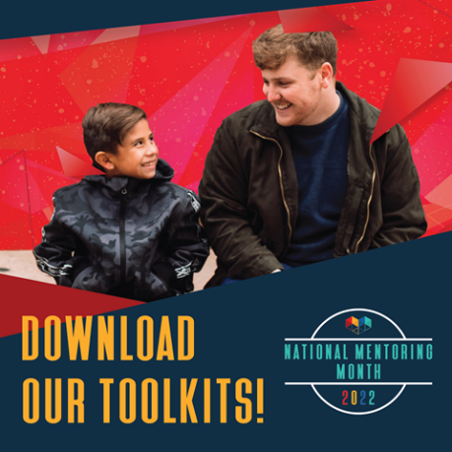

Celebrate With Us

There are several important dates in January that we encourage you to elevate! By unifying our movement around these dates, we can leverage our collective voice to effectively amplify the power of mentoring. When posting, feel free to use our suggested messaging (available in the Digital Engagement toolkit) and graphics below (click to download), or to personalize your post by sharing an inspiring mentoring story, relevant resource, or exciting opportunity for mentors in your area. Don't forget to use hashtags #MentoringAmplifies and #MentoringMonth!

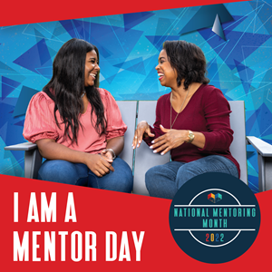  January 6: I Am A Mentor Day | 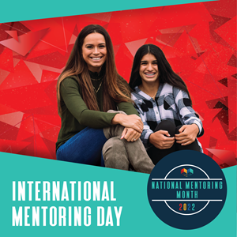  January 17: International Mentoring Day

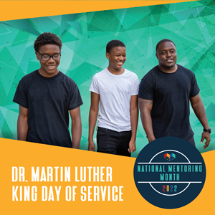  January 17: Dr. MLK Day of Service | 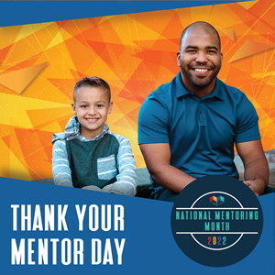  January 27: Thank Your Mentor Day

New Video For National Mentoring Month

This National Mentoring Month, we are kicking off the festivities with a brand new video! We've worked to capture scenes that celebrate both the power of relationships and the diversity of our movement. Our hope is that everyone who watches will be able to see themselves in these visuals and be inspired to engage. We can't wait to share the video with you soon, but in the meantime check out the photos below for a sneak peek of what's to come!

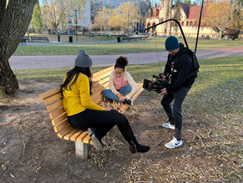 | 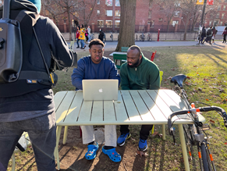 | 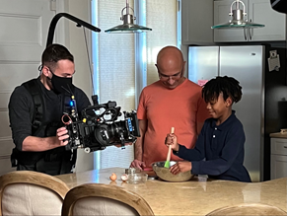

Register for the 2022 National Mentoring Summit

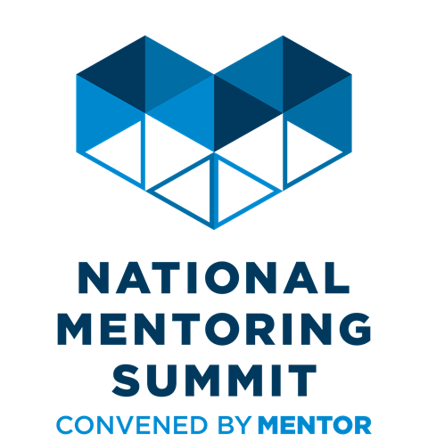 | Don't forget to register for the 2022 National Mentoring Summit! This year's Summit will be a hybrid event, with opportunities to engage both in-person and virtually. Join practitioners, researchers, youth leaders, and public officials from across the country in conversations around supporting young people, strengthening programs and practices, and advancing a collective mentoring agenda.

New Resource for Mentors

This January, MENTOR will be launching a new 12-topic resource designed specifically for mentors! It will cover research-backed best practices for supporting young people and addressing the mindsets and skills mentors need to develop when building a strong mentoring relationship. It will be released as a written resource, an audiobook, and a series of animated videos. Stay tuned for more details! | 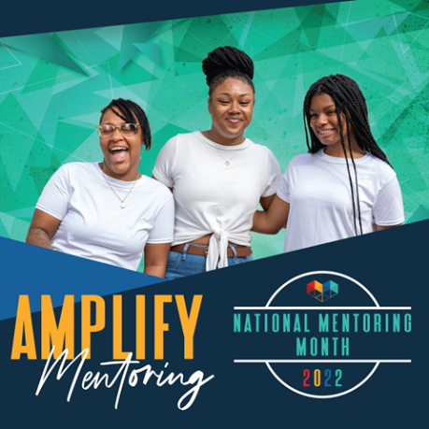

More resources for you:

10 Tips: Building Relationships with Youth (naaweb.org)

The Chronicle of Evidence-Based Mentoring | Three ways that mentoring programs will be forever changed by COVID-19 (evidencebasedmentoring.org)

Older and Wiser
New Ideas for Youth Mentoring in the 21st Century
Jean Rhodes
Frank L. Boyden Professor of Psychology University of Massachusetts, Boston
Director, Center for Evidence-Based Mentoring
Book review here

DO-IT Mentors
DO-IT (Disabilities, Opportunities, Internetworking, and Technology) serves to increase the successful participation of individuals with disabilities in challenging academic programs and careers. Primary funding for DO-IT is provided by the National Science Foundation, the State of Washington, and the U.S. Department of Education. This material is based upon work supported by the National Science Foundation under Grant #HRD-0227995 and #HRD-0833504. Any opinions, findings, and conclusions or recommendations expressed in this material are those of the author and do not necessarily reflect the views of the National Science Foundation.

Mentor WA
https://www.mentorwashington.org/
BEST (Beginning Educator Support Team) Program
https://medium.com/wagovernor/mentors-help-new-teachers-be-their-best-c6db78e984a0
Paraeducator Peer-Mentoring: Working Together for Student Success in Washington
Note: General mentoring information in this article was gathered from the “Passing on the Message” mentoring project developed in cooperation with the Puget Sound Education Service District, WEA, and supported by the Washington Education Association and the National Education Association.
https://ici.umn.edu/products/impact/152/prof3.html
Youth.GOV
Information on Successful Relationships & Programs
https://youth.gov/youth-topics/mentoring/best-practices-mentoring-relationships-and-programs
Community for Youth (Seattle Metro area)
http://communityforyouth.org/
10 Tips for Building Relationships with Youth (NAAWEB)
Three ways that mentoring programs will be forever changed by COVID-19

