5 Questions Every Team Should Ask About Racial Disproportionality
Addressing disproportionality is a complex process…however, the complexity of this work should not deter us from having courageous conversations about our systems.
By Ruthie Payno-Simmons, PhD
I have always engaged in equity work as an educator. I recall my early teaching days. I participated in ongoing action research around what it meant to teach for social justice. I used the research findings to provide learning spaces for students in ways that centered their voices, lived experiences, learning interests, and identities.[1] Everyone has a story about what led them to go into education. These are three of my experiences that influenced my approach and focus as an equity-oriented educator.
As an African American student, most of my teachers did not reflect my racial identity. My textbooks focused on the contributions of the dominant culture. History books portrayed people representative of my race in ways that reinforced negative or deficit stereotypes. During Black History month, we always saw images of and learned about the same two or three individuals: Martin Luther King, Rosa Parks, and Frederick Douglass. While these three incredible people contributed to making our world more just, I spent most of my K-12 years learning about a history that did not reflect my culture or contributions from people who looked like me. I experienced the pressure to conform to dominant cultural expectations, what scholars call assimilation that occurs in schools.[2] These experiences led to negative racial and gender identities, and the following set of questions that I wrestled with during my K-12 experience:
- Why don't prominent historical figures look like me?
- Did only a few people who look like me make important contributions to society?
- What is wrong with Black people?
- What is wrong with me?
- I want to become a doctor. Will I be able to go to college?
- Will I graduate from high school?
- Will I be a successful adult?
Then, in high school, something extraordinary happened. I met Mrs. Cunningham, an African American female who became my 9th grade English teacher. I intentionally took drama for four years because she captured my imagination about what a professional woman of color could be. She made me feel better about being a brown girl. She gave me hope that I could be successful. She engaged in my life actively and showed genuine care and concern.
My second influential experience occurred in 11th grade. My American History teacher Mr. Lewis, an African American male, consistently taught about the contributions of Black people. I began to hear a very different history than the one from my K-10 experience. Every day, I couldn't wait to get to his class. I sat on the edge of my seat in this American history class, waiting to learn something new about people who looked like me.
As a teacher, administrator, and parent, I observed adults fearing five and six-year-old African American male students. They were negatively labeled, frequently sent to the hallway or office, viewed as guilty, and rarely proven innocent. Additionally, they experienced more suspensions than any other ethnic or racial group of students.
Because of Mr. Lewis’ class, I majored in history as an undergraduate student. I wanted to learn more about history as it occurred and from multiple perspectives. I also wanted to learn about the accounts of others around the world and how we were all connected. Majoring in history was my third influential experience; it opened my eyes to truths I did not know. It was liberating. I was empowered as I learned more about systems of power and oppression. Majoring in history played an important role in increasing my positive racial and gender identities. I learned that Black free people were living in North America before the Mayflower. I learned that women wrote the Declaration of Sentiments and collectively fought for women's rights. I learned about the brutality of slavery and the intentional efforts put forth to maintain the status quo of systemic oppression following the abolishment of slavery. Majoring in history had an enormous impact on my teaching. During teacher preparation, my questions shifted to:
- How can I ensure that students of all backgrounds see historical figures that look like them?
- How can I infuse multicultural literature across content areas?
- How can I help people interrogate their conceptions of Black people?
- What's wrong with people and their thinking? How did they get there?
As a teacher, administrator, and parent, I observed adults fearing five and six-year-old African American male students. They were negatively labeled, frequently sent to the hallway or office, viewed as guilty, and rarely proven innocent. Additionally, they experienced more suspensions than any other ethnic or racial group of students. As a parent of three Black males, I experienced low expectations, gatekeeping, and micro racial aggressions, such as being surprised by their intelligence and "good behavior." During parent-teacher conferences, we often heard comments such as "he is a good boy" and "he is so articulate." On my critical reflection journey, I became more aware of how power and privilege work to maintain harmful practices. As a school administrator, I participated in meetings where adults from dominant culture made decisions about school systems to support students they did not understand culturally. Collectively, these experiences fuel my passion and desire to assist educators in centering equity in education and school discipline systems. Educational equity occurs in systems where "educational policies, practices, interactions, and resources are representative of, constructed by, and responsive to all people so that each individual has access to, meaningfully participates in, and has positive outcomes from high-quality learning experiences, regardless of individual characteristics and group memberships."[3]
In my current role as an equity implementation specialist and consultant, my questions evolved to:
- How do I continue to interrogate my own biases and assumptions?
- How can I help teachers and administrators understand issues of bias and systems of oppression?
- How can I ensure that all students have access to equitable educational opportunities?
- How can I help educators and school communities interrogate their conceptions of Black people and others from non-dominant cultures?
With the documented success of Positive Behavior Intervention Supports (PBIS), significant discipline disproportionality of African American students continues to exist across our nation. Scholars have linked these longstanding disparities to systemic racial bias.[4] I have worked with many caring and dedicated adults in PBIS schools who, when faced with the realization of such educational inequities, responded by saying, "I care about all of my students. How do I begin addressing issues of racial discipline disproportionality?”
One way to start is with a problem-solving process.
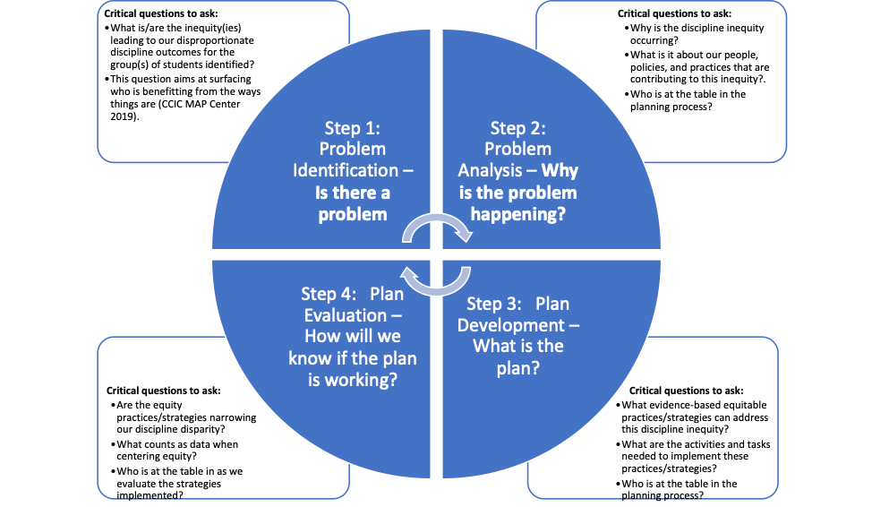
This four-step process is similar to the Team Initiated Problem Solving model.[5] The questions associated with each step are influenced by the work happening at the Great Lakes Equity Assistance Center. Using this process, teams ask these five critical questions to understand why disproportionate discipline occurs for certain groups of students in their systems.

Question 1: Is there an inequity problem in our school?
This question aims at surfacing those who don't benefit from the way things are. It allows teams to view discipline disparities as a systemic inequity rather than a deficit characteristic of a group of students based on identity markers. Teams can look at Referrals by Ethnicity Reports and Risk Ratios in SWIS as a starting point to identify if there is a discipline disparity. For example:
An elementary school leadership team looks at their Risk Ratios and discovers African American students are more than four times more likely to receive a referral than students from all other groups.
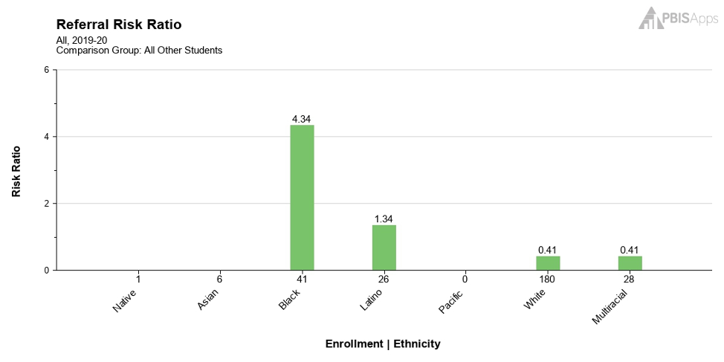
Next, the team reviews Referrals by Ethnicity and sees that African American students make up only 15% of student enrollment, but received 60% of total referrals. This indicates an overrepresentation in discipline. White students make up 64% of the students enrolled and only 21% of the office referrals. This suggests underrepresentation in discipline.
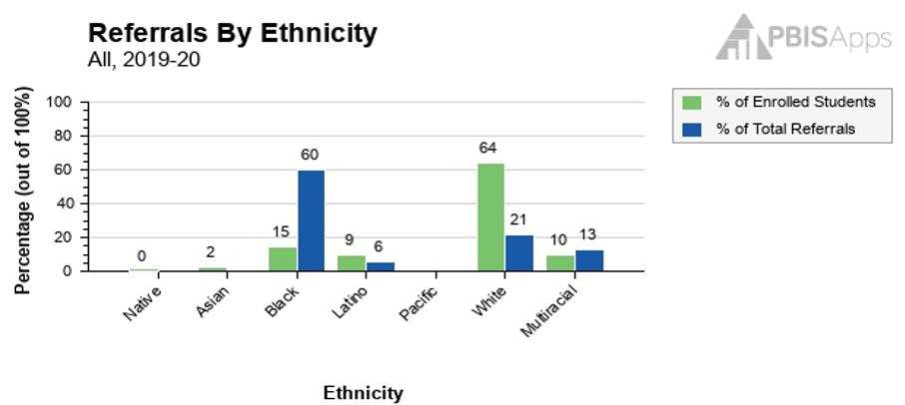
The team views the higher risk ratio and total referrals of African American students compared to lower risk and outcomes of all other groups as a red flag.
The next step is to follow up and dig deeper to understand more about what in their systems affects this group the most. The team narrows the problem using the SWIS drill-down tool to understand more specifically the inequity related to African American students:
- Where does the inequity occur?
- When does it happen?
- Why does the inequity happen?
Answering these questions yields the following precise inequity statement:
As of October 1, first and third grade African American students (boys and girls) are referred most often from the classroom for disruption. The motivation appears to be for task avoidance and peer attention. These referrals occur more frequently on Tuesdays and Wednesdays.

Question 2: What is it about our people, policies, and practices that contribute to this inequity?
As school leadership teams develop goals and objectives, these critical questions focus on systems, not on fixing students or teachers. Remember, the disparity is linked to systemic inequity and not the fault of students or their perceived circumstances. During this part of the process, teams should use multiple data sources, such as the Tiered Fidelity Inventory, fidelity use of asset-based instructional practices, and stakeholder survey data. The data should assess systems, practices, and outcomes.
Remember our leadership team from the first question? Now, the team seeks to understand what it is about their people, policies, and practices that contribute to the inequity. The school’s TFI scale and subscale scores are above the 70% threshold; the lowest score was their implementation score.
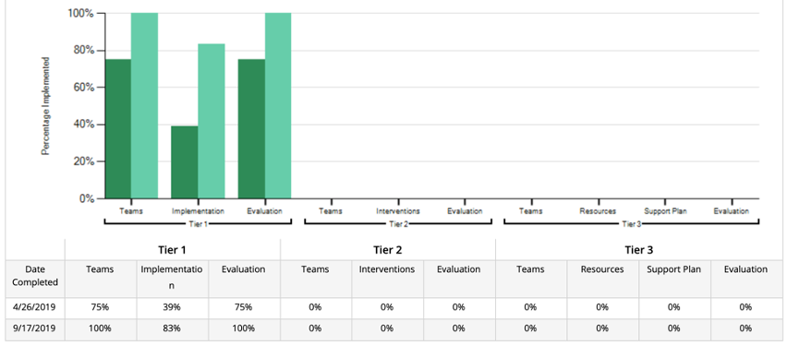
They drill down into their TFI score and notice three items’ scores related to implementation are not sufficiently in place:
- Discipline policies
- Feedback and acknowledgement
- Student/family/community involvement.

Question 3: Which equitable practices can address this discipline inequity?
When teams develop actions plans to address racial disproportionality, they should select activities and tasks that directly support implementing equity strategies. Likewise, strategies selected should align with the team's goal. School leadership teams should leverage the PBIS Cultural Responsiveness Field Guide: Resources for Trainers and Coaches to consider strategies aligning with their goal of providing cultural elaboration to PBIS systems.
In the case of the example above, the three items not fully implemented are great opportunities to include multiple and diverse perspectives in understanding more about the students’ experiences as well as understanding more about ways in which people, practices and policies in the system are harmful or serving as barriers. One strategy aimed at addressing the team’s goal would be to “expand the leadership team and the problem-solving continuous improvement process to include parents, students, and community members representative of the student population.”
Possible activities to support the strategy are:
- Engage in professional learning that focuses on inclusive practices for student and family engagement
- Create an equitable way of soliciting parents, students, and community members to participate in meetings where decisions are made about behavior and other systems
- Professional learning for the newly expanded leadership team
- Schedule future meetings at times optimal for the group to increase inclusivity and participation

Question 4: Did the equity strategies decrease our discipline disparity?
Schools should use multiple data sources to monitor and check to see if the plan is working. Various data sources can include TFI data, asset-based instructional practices data (i.e., universal design and culturally responsive practices), stakeholder survey data, climate data, etc. The data should assess systems and methods in seeking to understand student outcomes rather than only looking at outcome data as a measure of determining equitable outcomes.

Question 5: Who is at the table when decisions are made about our school systems?
Schools should intentionally include diverse stakeholders and multiple perspectives at all levels of PBIS implementation and continuous improvement processes. This question surfaces who is present and included and who is not as systems are created and maintained. It also reveals whose experiences and identities are privileged and whose are not.
Addressing disproportionality is a complex process, and we are all still learning how to do this work in meaningful and practical ways. However, the complexity of this work should not deter us from having courageous conversations about our systems. Nor should it stop us from changing our systems to benefit all students, especially those who have been historically marginalized. These questions serve as a starting point that can support equity efforts within our PBIS systems. So, lean into the problem-solving process, knowing that by asking questions such as the five highlighted above and applying strategies to mitigate disproportionality that you are tackling systemic inequities head-on.

Resources from the Field
Schools often implement PBIS from a highly technical approach. While implementing PBIS from a technical perspective is an essential part of the process, contextual and critical considerations are equally important when seeking to address disproportionate outcomes. the National PBIS center provides tools of technical and adaptive approaches.

5-POINT INTERVENTION APPROACH FOR ENHANCING EQUITY IN SCHOOL DISCIPLINE
This multi-component approach supports a focus on implementing a preventative, multi-tiered, and culturally responsive behavior framework, engaging academic instruction, equity-oriented policies, the use of neutralizing implicit bias in discipline decisions, and systematic problem solving using disaggregated data.

USING DISCIPLINE DATA WITHIN SWPBIS TO IDENTIFY AND ADDRESS DISPROPORTIONALITY: A GUIDE FOR SCHOOL TEAMS
This guide provides a process and rationale for engaging in the data review process for examining disaggregated data, action planning, implementation evaluation, recommendations for addressing disproportionality, and cultural elaboration within the big ideas of PBIS.

PBIS CULTURAL RESPONSIVENESS FIELD GUIDE: RESOURCES FOR TRAINERS AND COACHES
This field guide outlines an integrated framework to embed equity efforts into school-wide positive behavioral interventions and supports (SWPBIS). The goal of using this guide is to make school systems more responsive to the cultures and communities that they serve.

GREAT LAKES EQUITY ASSISTANCE CENTER (GLEAC)
The Great Lakes Equity Assistance Center provides a wealth of accessible literature and tools for practitioners supportive of centering equity in educational policies and practices as well as cultivating critical reflection and learning around issues of power, privilege, and implicit bias. These resources can support incorporating a crucial component missing from the problem-solving process. This critical component involves having multiple and diverse perspectives involved in the problem-solving process. It also involves a shift from focusing on fixing students and teachers to asking, "whose interests are being served well by our systems, and whose are not?" It also involves interrogating systems by asking, "what is it about our organizational system, people, policies, and practices that result in inequities?"

1. Damico, J., & Riddle, R. (2004). From Answers to Questions: A Beginning Teacher Learns to Teach for Social Justice. Language Arts, 82(1), 36-46.

2. Paris, D., & Alim, H. S. (2017). Culturally sustaining pedagogies: Teaching and learning for justice in a changing world language and literacy series (pp. 1 online resource).

3. Kyser, T. S., & Skelton, S. M. (2019). The fundamentals of educational equity. Equity Digest, 2(3), 4.

4. Carter, P. L., Skiba, R., Arredondo, M. I., & Pollock, M. (2017). You can’t fix what you don’t look at. Urban Education, 52(2), 207-235. doi:10.1177/0042085916660350.

5. Newton, J. S., Horner, R. H., Algozzine, B., Todd, A. W., & Al- gozzine, K. (2012). A randomized wait-list controlled analysis of the implementation integrity of team-initiated problem-solving processes. Journal of School Psychology, 50, 421-441.

