Tiered Systems…
A Comprehensive, Integrate Approach: Introducing Ci3T Models

Dr. Kathleen Lane, Ph.D., BCBA-D is a professor in the Department of Special Education at the University of Kansas. She earned her master's degree and doctorate in education from the University of California, Riverside. Her research interests focus on academic and behavioral school-based interventions with students at risk for emotional and behavioral disorders (EBO), with an emphasis on systematic I screenings to detect students with behavioral challenges at the earliest possible juncture.

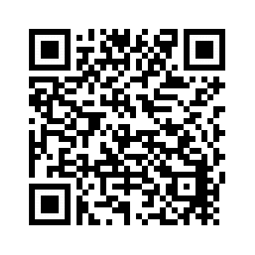
The Ci3T Model support systems are created to address all learners in academic, behavior, and social domains. Through professional collaborations these models share how to monitor these data elements with tools to provide accurate implementation for student performance.

Additional Training Topics~
- Introducing Ci3T – working collaboratively and efficiently
- Systematic Screening Tools & Logistics
- Using Screening Data to Inform Instruction
- Tier 1 practices
- Teacher-delivered strategies
- Tier 2 and 3 supports
- Action Plans: Moving Forward

LEARN MORE

March 8, 2019 Registration $200
8:00a-2:00p Teams of 4
Lunch Provided
Clock Hours available

C

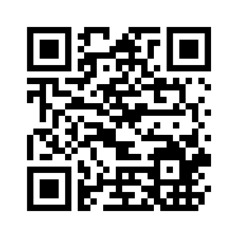
REGISTRATION DEADLINE
March 5, 2019

To register
Follow this link:
http://www.pdenroller.org/Catalog/Event/85405

REGISTER NOW

