Developmental Disabilities Board Report
April 2025

From the Early Childhood Team:
What’s Going On?
Early Support for Infants and Toddlers (ESIT) Scholarship | ESIT Scholarship Pilot is launching a second round on April 2, 2025!

The purpose of the scholarship program is to retain current ESIT workforce members, create career pathways for existing ESIT staff, and strengthen the ability of ESIT providers to work effectively with diverse families.

What’s Coming Up?
Infant and Early Childhood Mental Health (IECMH) Summit | IECMH Strategy invites all King County Providers to enhance knowledge in community and solidarity. Centering the baby in all sessions and grounding our work in equity and social justice we will present our IECMH Guiding Principles and promote social emotional development for our P-5 children in King County.

For more information and to register please visit the Best Starts for Kids website: Infant and Early Childhood Mental Health (IECMH) 2025 Summit | Best Starts for Kids

From the Adult Services Team:
What’s Going On?
Capacity Building | Adult Services sponsored workshops for providers and community partners on Community Inclusion best practices, the latest in our equity workshop series, and Turning Data into Impact (partnering with our Performance Measures and Evaluation team).

School-to-Work (S2W) | The S2W team is excited to share Cassie Glenn’s promotion to S2W Program Manager III!
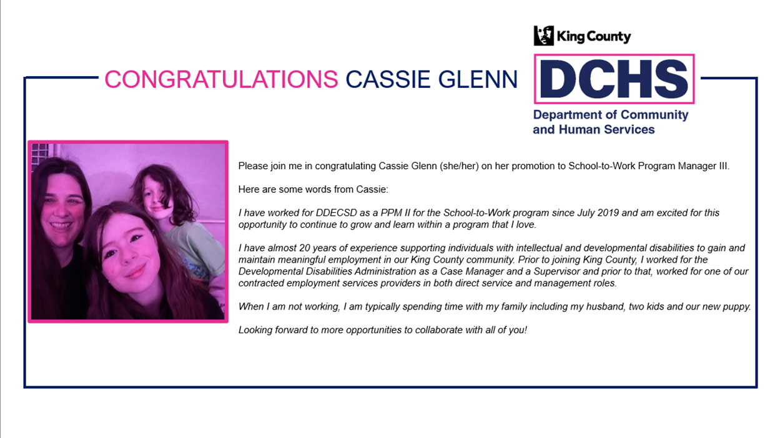

S2W will be welcoming Sue Anne Lemkin to the team at the end of the month. Sue Anne joins S2W as a Program Manager III, and we are excited for her start!

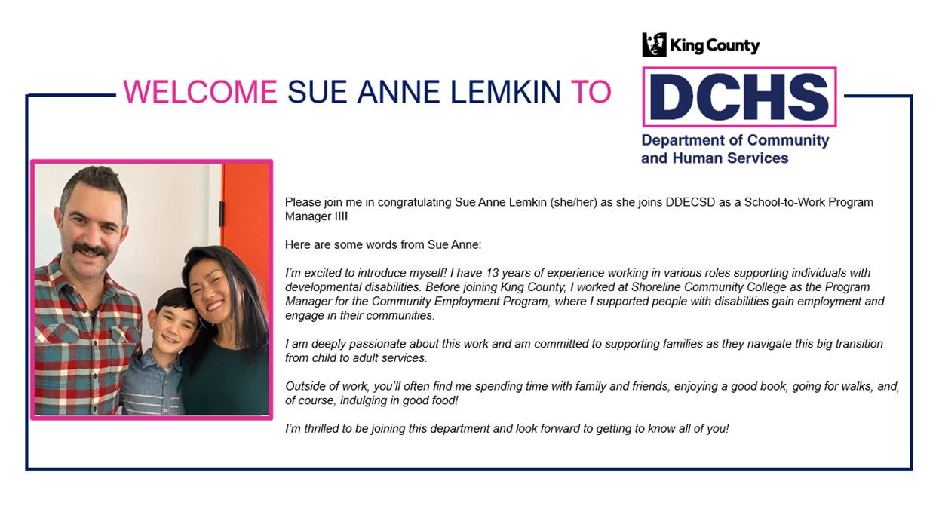

What’s Coming Up?
Capacity Building | Adult Services will be hosting customized employment training and mentoring for service providers, prioritizing person-centered jobs, matching strengths, interests, and preferences.

From the Community Information Outreach and Referral Team:
What’s Going On?
Board for Developmental Disabilities | The next quarterly hybrid Board for Developmental Disabilities meeting is scheduled for Wednesday, May 7, 2025, from 3:30 – 5:30 p.m. at the Tukwila Community Center, Meeting Room B, located at 12424 42nd Avenue, S., Tukwila.

What’s Coming Up?
Resource Fair | Save the date and spread the word for the DDECSD May 29TH Resource Fair to be held at the Microsoft Commons! Planning is moving forward with new sessions, more exhibitors, an inclusive technology room, and lots of fun! Please go to our website for updated information: www.kingcounty.gov/disabilities-fair.

