Health Care Authority (HCA) peer team introductions

Maureen Bailey BSW, CPC (she/her)
Recovery Support Services Supervisor
Email Maureen
“The Best is yet to come…”

Shelly Shor, MSW, PH.D, CPC (she/her)
Operationalizing Peer Support Program Manager
Email Shelly
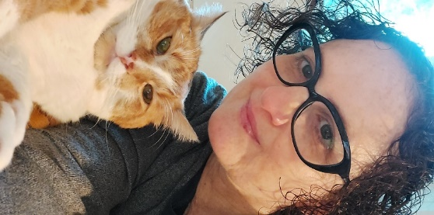
”I’m not a prophet or a stone aged man, just a mortal with potential of a superman.”

Amanda Major Polley, CPC (she/her)
Peer Support Program Administrator
Email Amanda
“She smiled at the stars as if they knew all of her secrets.”

Mary Chambers, CPC (she/her)
Peer Support Team Lead
Email Mary
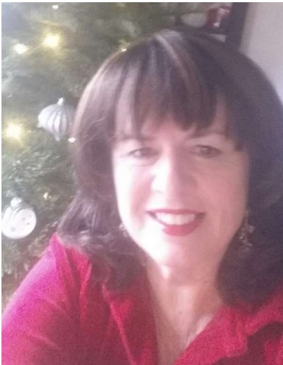
“She believed she could, so she did.”

Justin Wilson, CPC (he/him)
Peer Support Program Specialist
Email Justin
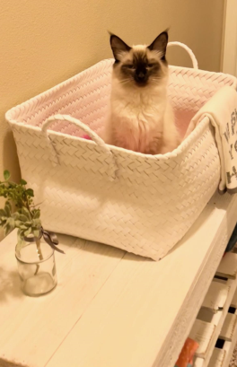

Dakota Steel CPC, CRC, CDP (he/him/his)
Senior Manager of Office of Recovery Partnerships
Email Dakota
“We believe recovery is not a dream; recovery is wholly attainable and is the expected outcome of a system that fully responds to the needs and directives of those it serves”

