How To: Clear your Browser Cache

Here are step-by-step instructions to clear the browser cache for all approved browsers:
- Microsoft Edge
- Google Chrome
- Mozilla Firefox

Microsoft Edge
- Open Edge, then click on the three-dot menu in the upper-right corner and choose Settings:
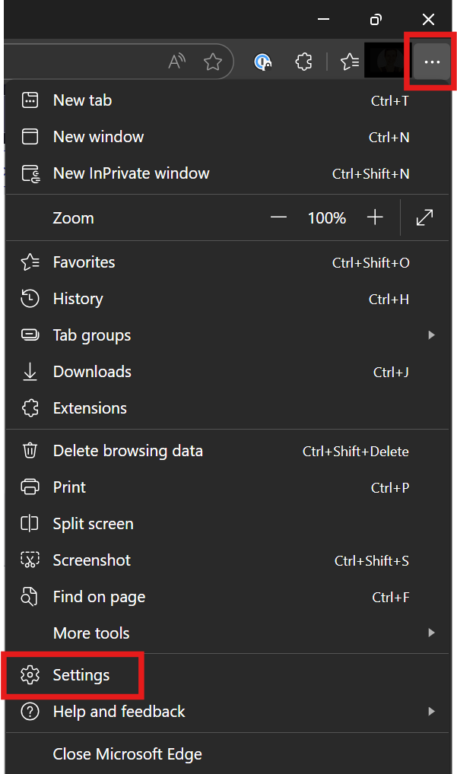
- On the left-hand side, select Privacy, search, and services, then select Clear browsing data on the right side:
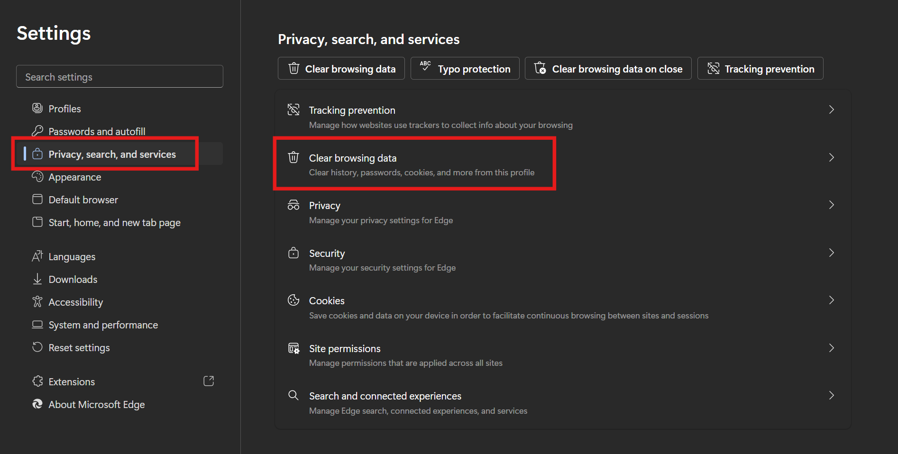
- Select Choose what to clear:
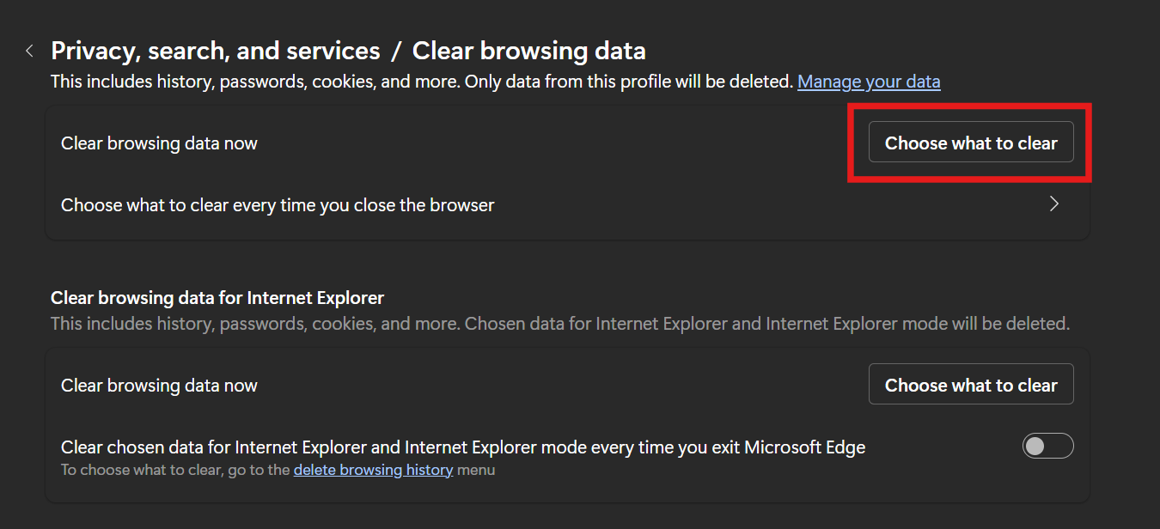
- Select “All time” for the time range, check the first four boxes, and then click on Clear now:
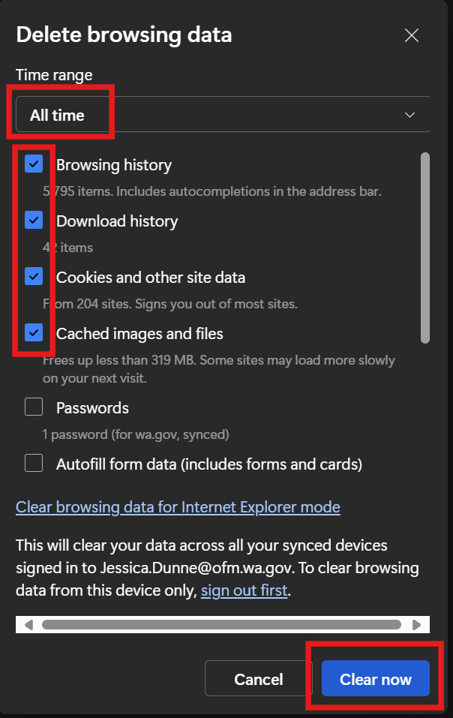

Google Chrome
- Open Chrome, click on the three-dot menu in the upper-right corner, and select Delete browsing data…
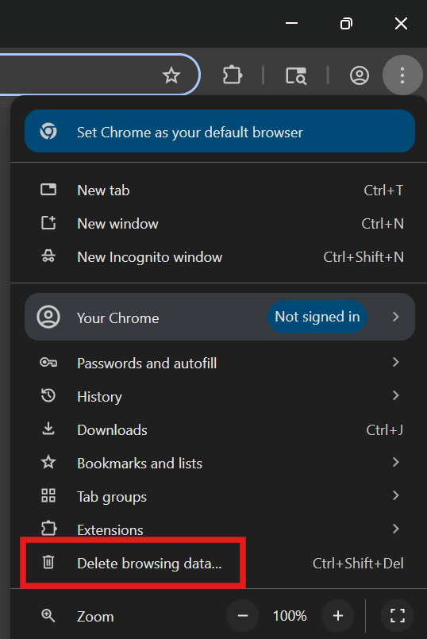
- Choose “All time” for the time range, ensure all boxes are checked, and select Delete data:
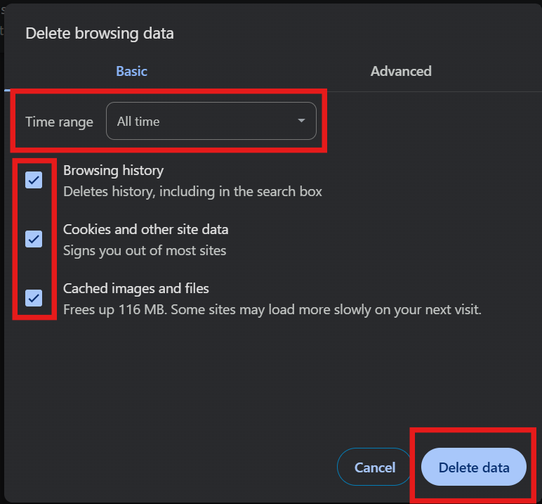

Mozilla Firefox
- Open Firefox, click on the three horizontal lines in the upper-right corner, and choose Settings:
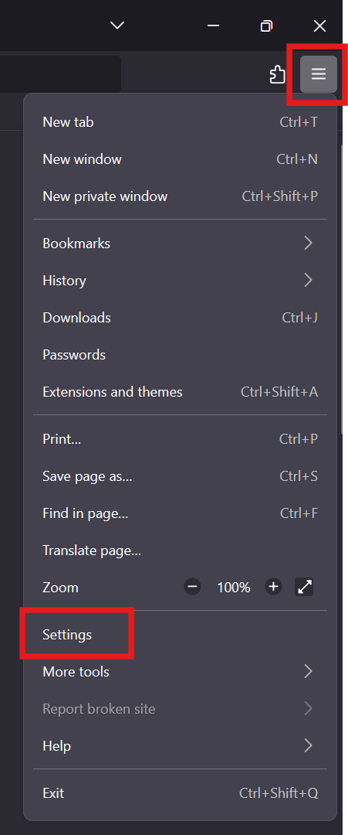
- On the left-hand side, select Privacy & Security, then select Clear Data… on the right side:
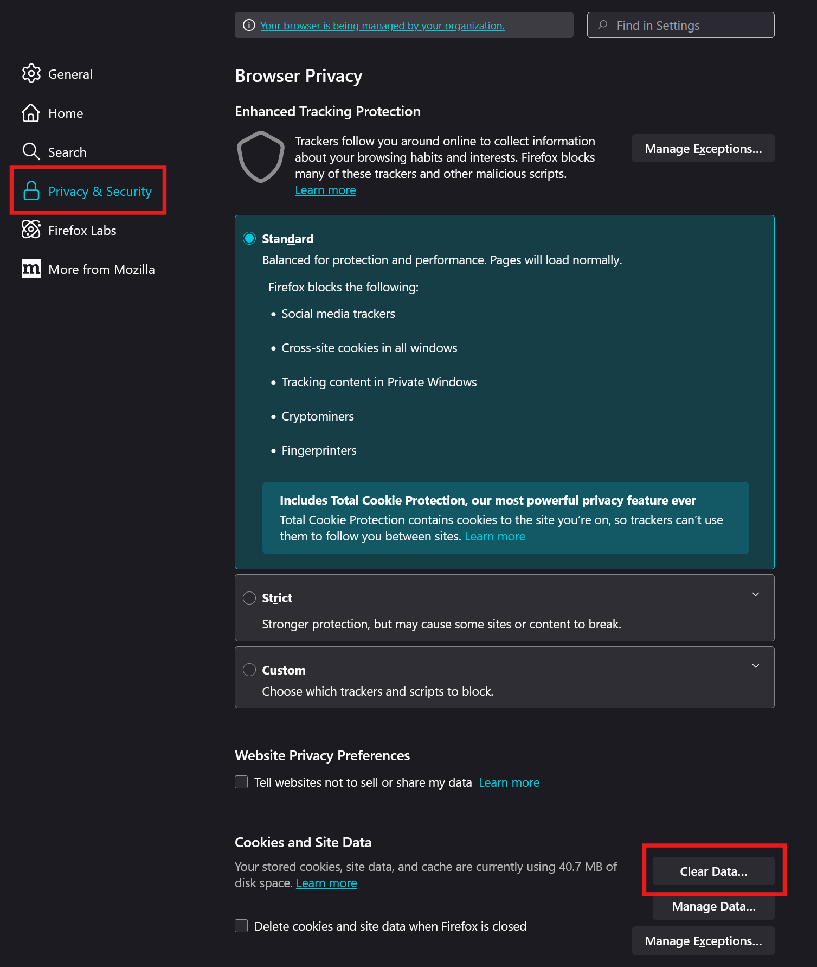
- Select “Everything” for the time range, check the first three boxes, and select Clear:
