

General Membership Meeting Minutes
2/15/24
2 to 5 p.m.
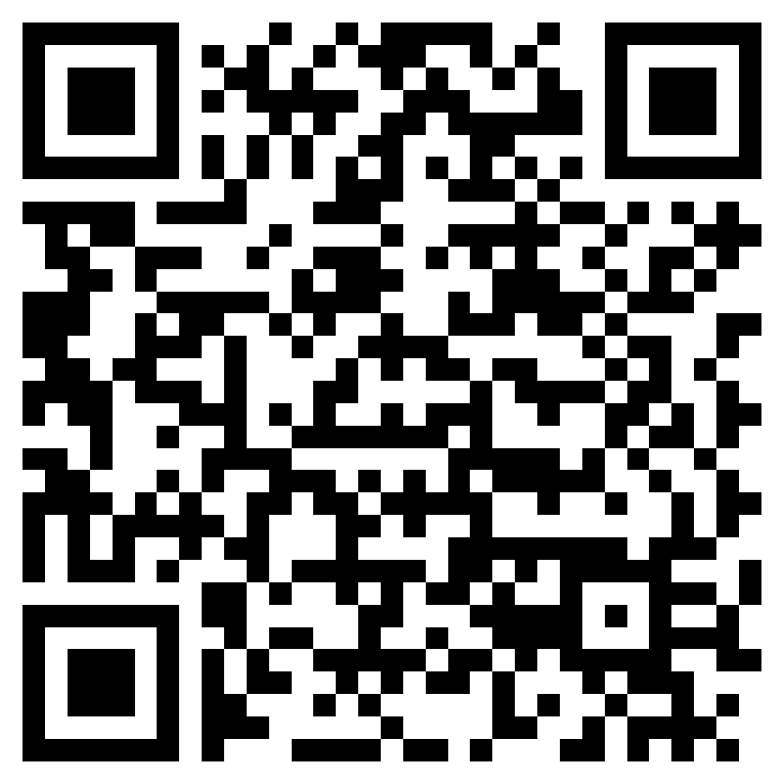
Check into the meeting: https://forms.office.com/g/n0wCkKea09?origin=lprLink
Facilitators: Chase Bayne and Mark Metzger
Recorders: Luke Martin and Tyler Troutman
Location: Virtual – Zoom Meeting Link: https://zoom.us/j/96683705169?pwd=cEtHUXFCZzV0a3h0eGdYdWpPTjFMZz09

2:00 p.m. to 2:15 p.m. – Welcome! (Chase and Mark)
- Membership check-in
  - Requirement for Exec Sponsor Role: Executive level agency head, cabinet level member. Not necessarily the LGBTQ+ Commission Director. John Wiesman was our first Sponsor, then Manny Santiago.
- New member introductions
- Approval of 1/18/24 GM Meeting Minutes - APPROVED

Mission: The BRG exists to help Washington State create safe and inclusive workplaces where every LGBTQ+ employee can bring their full authentic self to work, enabling them to do their best work every day for the people of Washington. The BRG will provide resources and support to employees and the stakeholders serviced by state agencies.

2:15 p.m. to 2:40 p.m – Guest Speaker (Tyler)

M Foley, they/them
Volunteer Coordinator, Peer Seattle
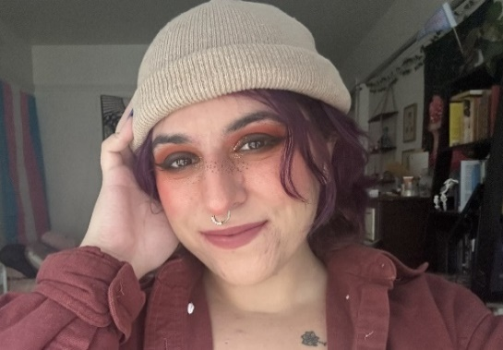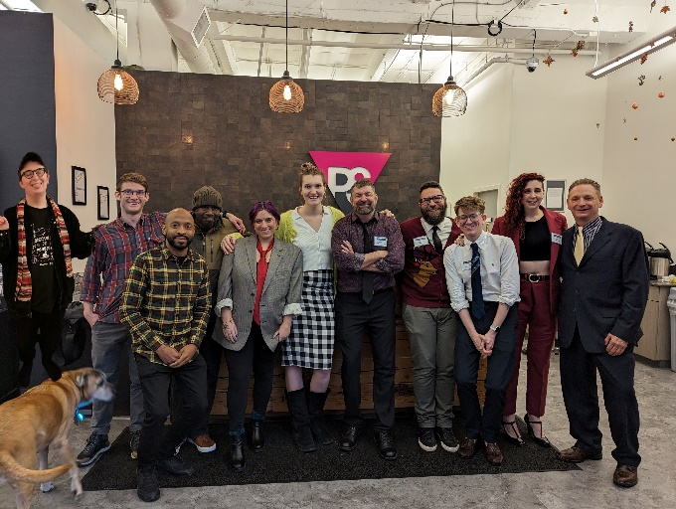
M Foley is the Volunteer Coordinator and former Housing Specialist for Peer Seattle. Peer Seattle is an LGBTQ+ organization that offers a peer-based model of services for those in recovery or seeking to get into recovery. The peer model means that lived experience is the forefront of what we do. All staff are in recovery, whether it be for mental health, HIV, and/or substance use disorders, and we use our own recoveries to connect and empathize with the members who come through our doors.
The organization began in the 1980s as an HIV/AIDs support group and has grown into a larger recovery space that offers peer led groups, peer coaching, employment and housing support, and volunteer opportunities. Peer Seattle follows the harm-reduction model of recovery, meaning we believe that there are many, many paths to recovery and it will look different from person to person. Folks who utilize our services are not required to be sober a certain length of time, nor are they required to be sober at all to receive services. Our approach is low-barrier and allows members to have autonomy and dignity in their own lives. As an organization that predominantly works with queer folks, there are unique challenges that we see with our members.

2:45 p.m. to 3:15 p.m. – Guest Speaker (Tyler)

Marcus Glasper, he/him
Director, Washington State Department of Licensing
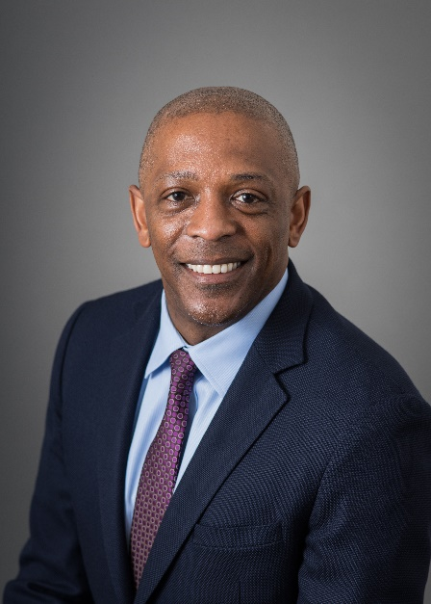
Marcus Glasper was appointed by Governor Jay Inslee to serve as the Director of the Department of Licensing in April 2023.
Glasper has over 30 years of public sector experience, recently serving as the Director of the Washington State Lottery since March 2018. He has served the public in a variety of Washington State executive leadership positions including Deputy Director of the Department of Revenue, Senior Assistant Director of Administrative Services at Revenue, and Assistant Deputy Secretary for the Department of Corrections. Prior to his state service, he spent a decade working for the United States Department of Energy and began his career as an engineer with General Motors.
Glasper was reared in Plaquemine, LA, received his Bachelor of Science degree in Mechanical Engineering from Southern University in Baton Rouge, LA, and a Master’s degree in Engineering Management from Washington State University.

Marcus has completed senior executive programs at the Harvard John F. Kennedy School of Government, USDA Graduate School, and the University of Washington’s Evans School of Public Affairs. He is a recipient of the Governor’s Award for Leadership in Management and is a volunteer senior mediator with the Thurston County Dispute Resolution Center. He serves on the Board of Directors of the Washington State Employees Credit Union as well as the Board of Directors for the South Puget Sound Community College Foundation.

3:22 p.m. – 3:32 p.m. – Break

3:32 p.m. to 3:50 p.m. – Announcements (Chase)
- BUILD’s Black History Month Celebration – Friday, February 23, 2024 2:00-5:00 PM.
- RAIN Charter Updates – moved to March 21 GM meeting due to additional feedback received.
- Trans Day of Visibility Panel – Thursday, March 28, 2024, Time TBD.
- Alison Mielke, DCYF is the new Co-Chair of the Safe Place Subcommittee.
- Liquor & Cannabis Board Response to recent concerns of enforcement at LGBTQIA2S+ spaces.
- K.J Divine, employee ID# 20041159 – In need of paid leave hours ~ please consider donating
- Queer Skate Night
- Health Care Authority Resource: With HCA’s firewalled specialty teams, you can call and see if your medical provider indicated as queer-/trans-affirming, they’ll make sure your need is actually met with the provider options – including calling the potential provider to ask the hard questions without disclosing any of your details (a true, third-party mediator invested in protecting you as the plan enrollee). You can also call this office when there is a provider complaint regarding service. See Lisa Little for questions.

3:35 p.m. – 3:50 p.m. – Small Groups Activity (Luke)
Question: What are you excited about professionally and personally in 2024?
Postponed to next month’s RAIN GM meeting due to time shortage.

3:50 p.m. – 4:00 p.m. – Subcommittee Report Outs (All)

Safe Places:
Introduction and discussion about the program going forward with new Co-Chairs Alison and Beth.
Best Practices:
Will be voting in new sub-committee Chair
Communication and Outreach:
Trainings:
Last Transitioning in the workplace toolkit training on 2/22/24
Project Manager:
Not present
Finance and Budget Manager:
Not present

4:00 p.m. – 5:00 p.m. – Subcommittee Break Out (All)
- Participation is optional!
- This is where the bulk of RAIN’s work gets done.
- And they’re chock full of fun humans!

