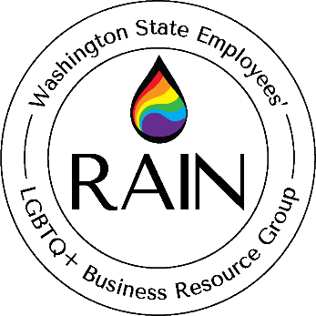

General Membership Meeting Agenda
3/21/24
2:00 pm to 5:00 pm
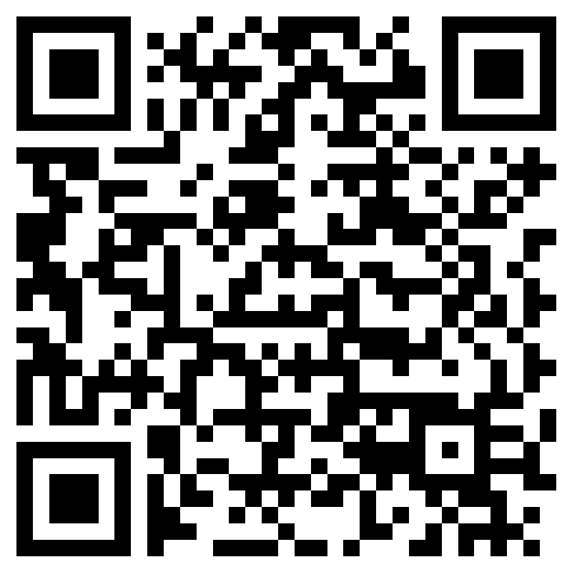
Check into the meeting: https://forms.office.com/g/n0wCkKea09?origin=lprLink
Facilitators: Chase Bayne and Mark Metzger
Recorders: Luke Martin and Tyler Troutman
Location: Virtual – Zoom Meeting Link: https://zoom.us/j/96683705169?pwd=cEtHUXFCZzV0a3h0eGdYdWpPTjFMZz09

2:00 pm to 2:30 pm – Welcome! (Chase and Mark)
- Membership check-in
- New member introductions
- Approval of 02/15/24 GM Meeting Minutes
- Announcements

Mission: The BRG exists to help Washington State create safe and inclusive workplaces where every LGBTQ+ employee can bring their full authentic self to work, enabling them to do their best work every day for the people of Washington. The BRG will provide resources and support to employees and the stakeholders serviced by state agencies.

2:30 pm to 3:00 pm – Guest Speaker Ebo Barton: Lavender Rights Project (Tyler)
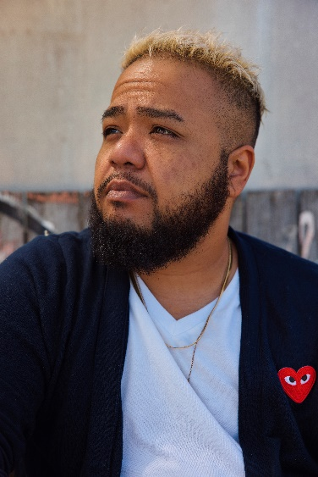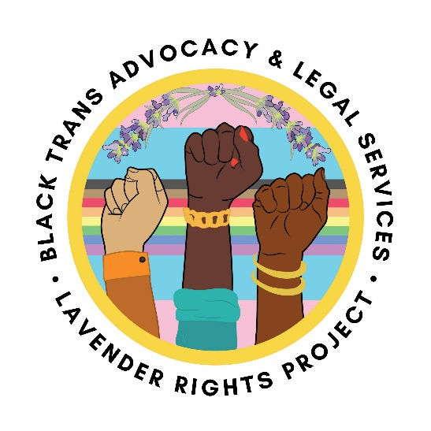
Ebo Barton (They/Them/Theirs or He/Him/His) is a passionate artist, educator, and activist dedicated to creating healing spaces and driving social change. They proudly embrace their mixed Black and Filipino heritage, and as a Transgender and Non-Binary Queer individual, they highlight the value and significance of intersectional identities.
Currently serving as the Director of Housing Services for Lavender Rights Project, Ebo advocates tirelessly for inclusive housing opportunities for LGBTQ+ communities. Their expertise also extends to the Seattle Social Housing Developer Board, where they contribute to equitable housing initiatives. Additionally, Ebo engages with the Community Advisory Board for Creative Justice Northwest, using art-based interventions to transform the juvenile justice system.
Ebo's artistry has made a profound impact, with their poetry featured in "Black Imagination" curated by Natasha Marin and their performances showcased on esteemed online platforms. Their exceptional talent led them to a 5th place finish at the Individual World Poetry Slam in 2016. They co-wrote and co-produced the award-winning play "Rising Up" in 2017, and their portrayal of "Invisible One" in Anastacia Renee's production "Queer. Mama. Crossroads" resonated with audiences.
In 2020, Ebo released their first published poetry collection, "Insubordinate," which received critical acclaim. The following year, the collection was named a finalist for the Washington State Book Award. A respected leader in the arts and activism, their transformative work fosters societal introspection and empowerment.”

3:00 pm – 3:10 pm – Break

3:15 pm to 3:30 pm – Guest Speaker Greg Mennegar: Washington State Productivity Board (Tyler)

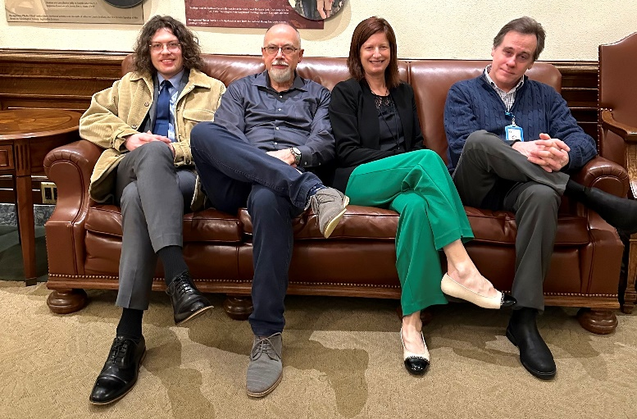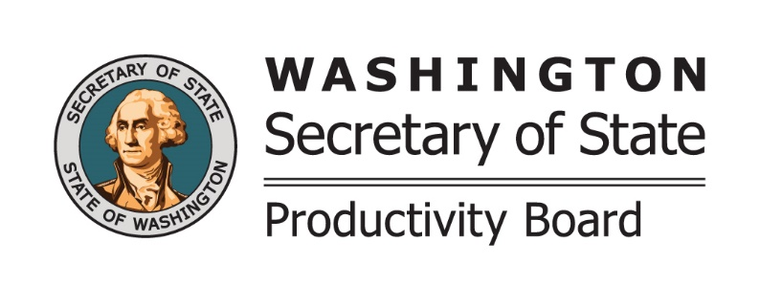
The Washington State Productivity Board is a statewide employee suggestion program. The Productivity Board provides an opportunity for state employees to receive cash awards for ideas that reduce expenses or increase revenue. Greg Mennegar is the Productivity Board Supervisor and will provide information on how the program works and how to submit ideas.

Greg has over 25 years of management, sales, and marketing experience in the information management industry. He previously served the Secretary of State managing the Imaging Program for the Washington State Archives. Throughout his career he has helped government and business entities operate more efficiently by helping them reduce waste. As the leader of the Washington State Productivity Board, he is excited about the opportunity to help state agencies reduce costs and recognize employees for their cost saving ideas.

3:30 pm – 3:45 pm – Small Groups Activity (Luke)
Discussion Questions (choose what feels good!):
What are you excited about professionally and personally in 2024?
What is bringing you queer joy?

3:45 pm – 4:00 pm – Subcommittee Report Outs (All)
Best Practices:
Communication and Outreach:
Safe Places:
Trainings:
Project Manager:
Finance and Budget Manager:

4:00 pm – 5:00 pm – Subcommittee Break Out (All)
- Participation is optional!
- This is where the bulk of RAIN’s work gets done.
- And they’re chock full of fun humans!

