BI Launchpad (Webi) Changing the Universe

- Under Home, click on Folders.
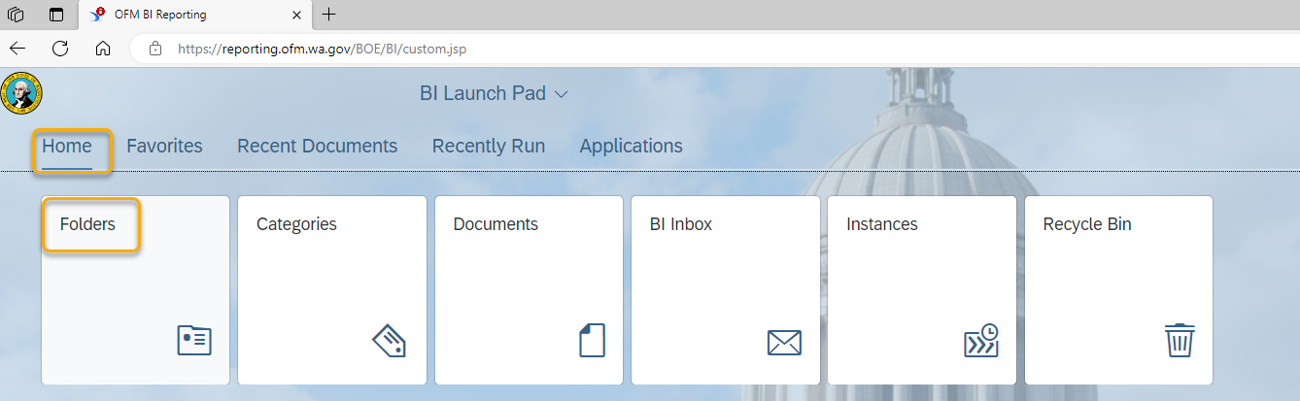

- Under Personal Folders, find the report that needs to have the data source updated and right click and select Modify from the context menu.
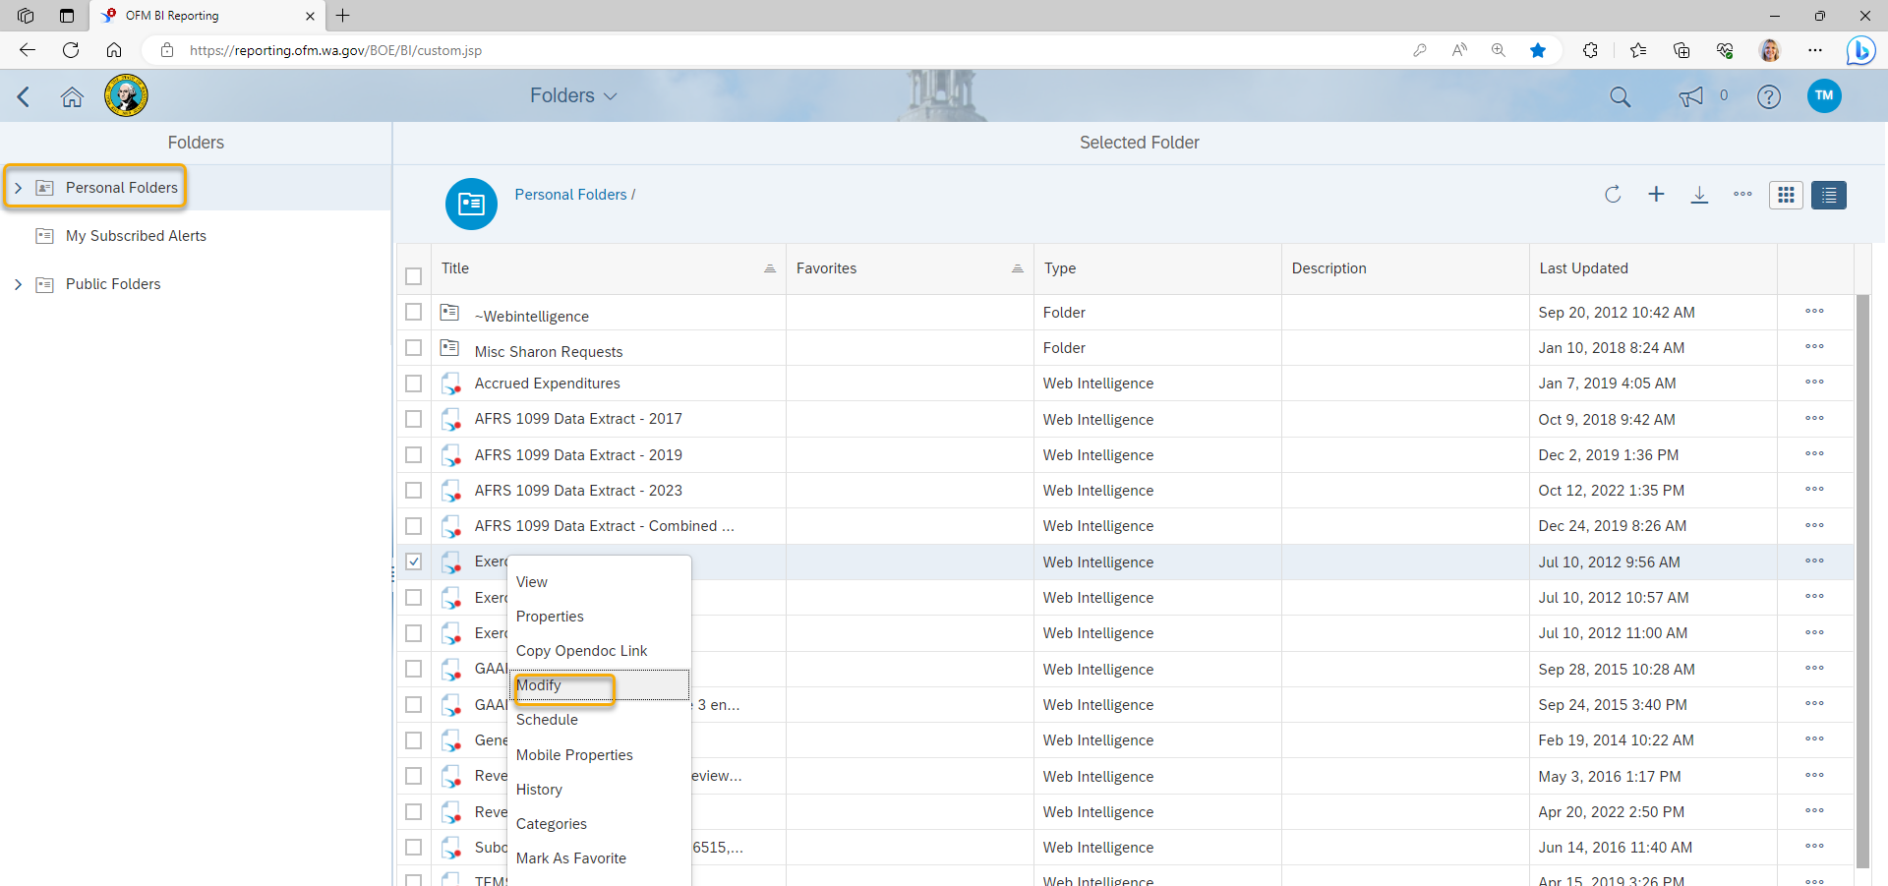

- Once the report opens, ensure Design Mode is active and click on Change Source
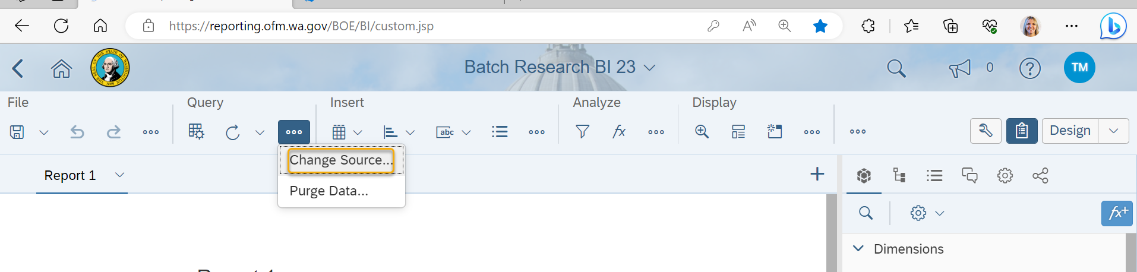

- Select the query that needs to be changed and click OK.
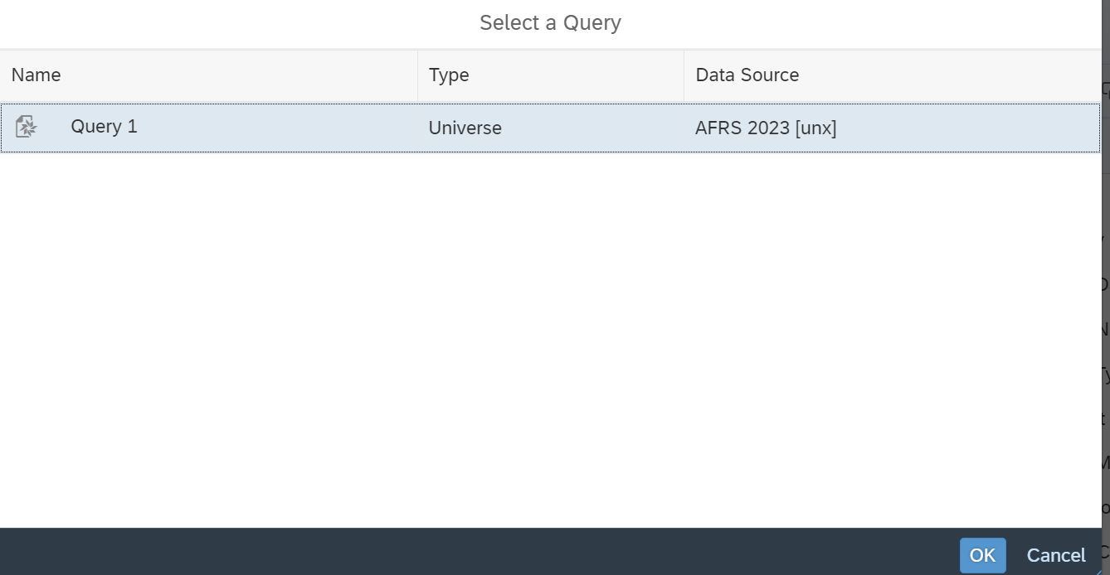

- In the Change Source Wizard window click on “Specify a new data source” and select universe from the drop down list.
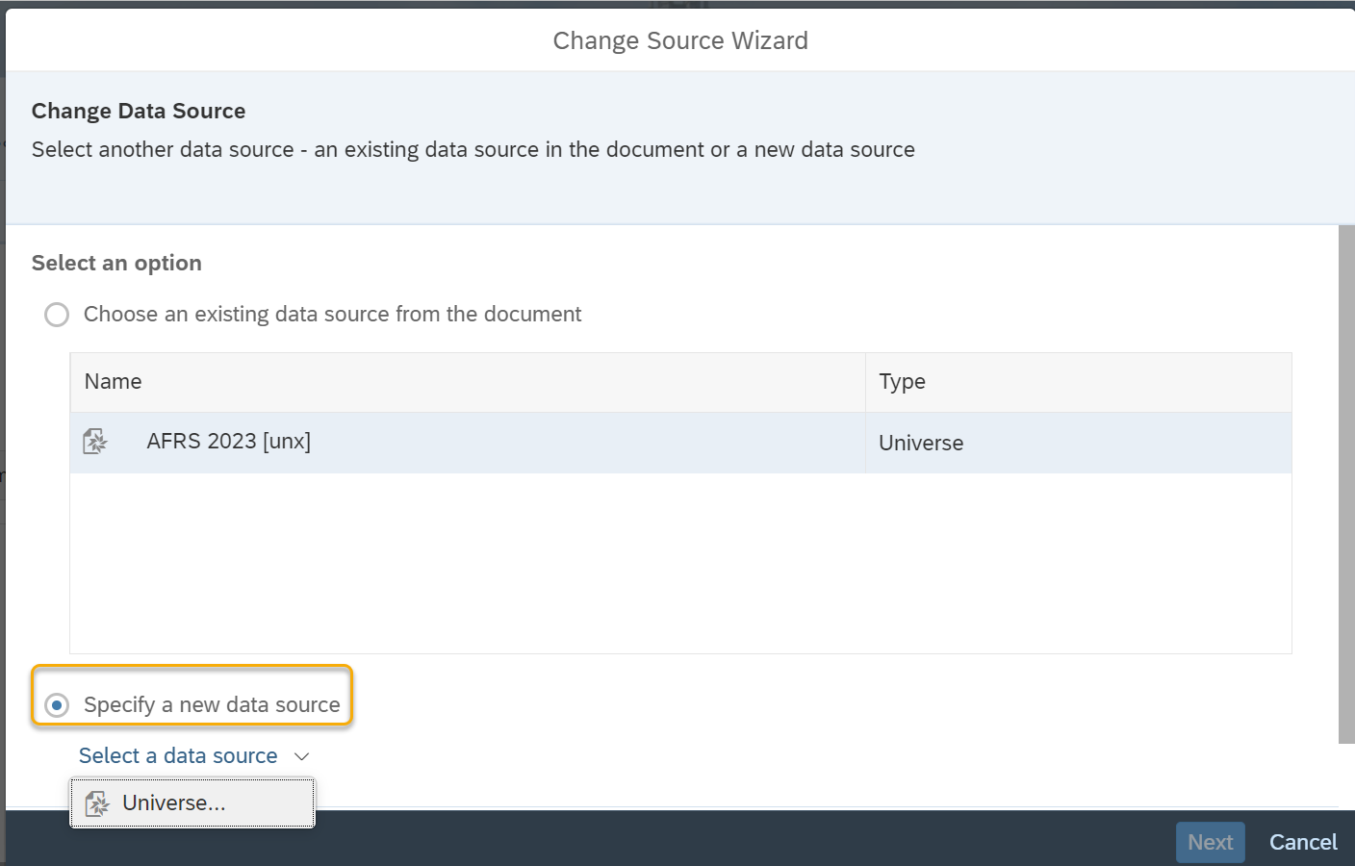

- Click on the 2025 universe then click OK.
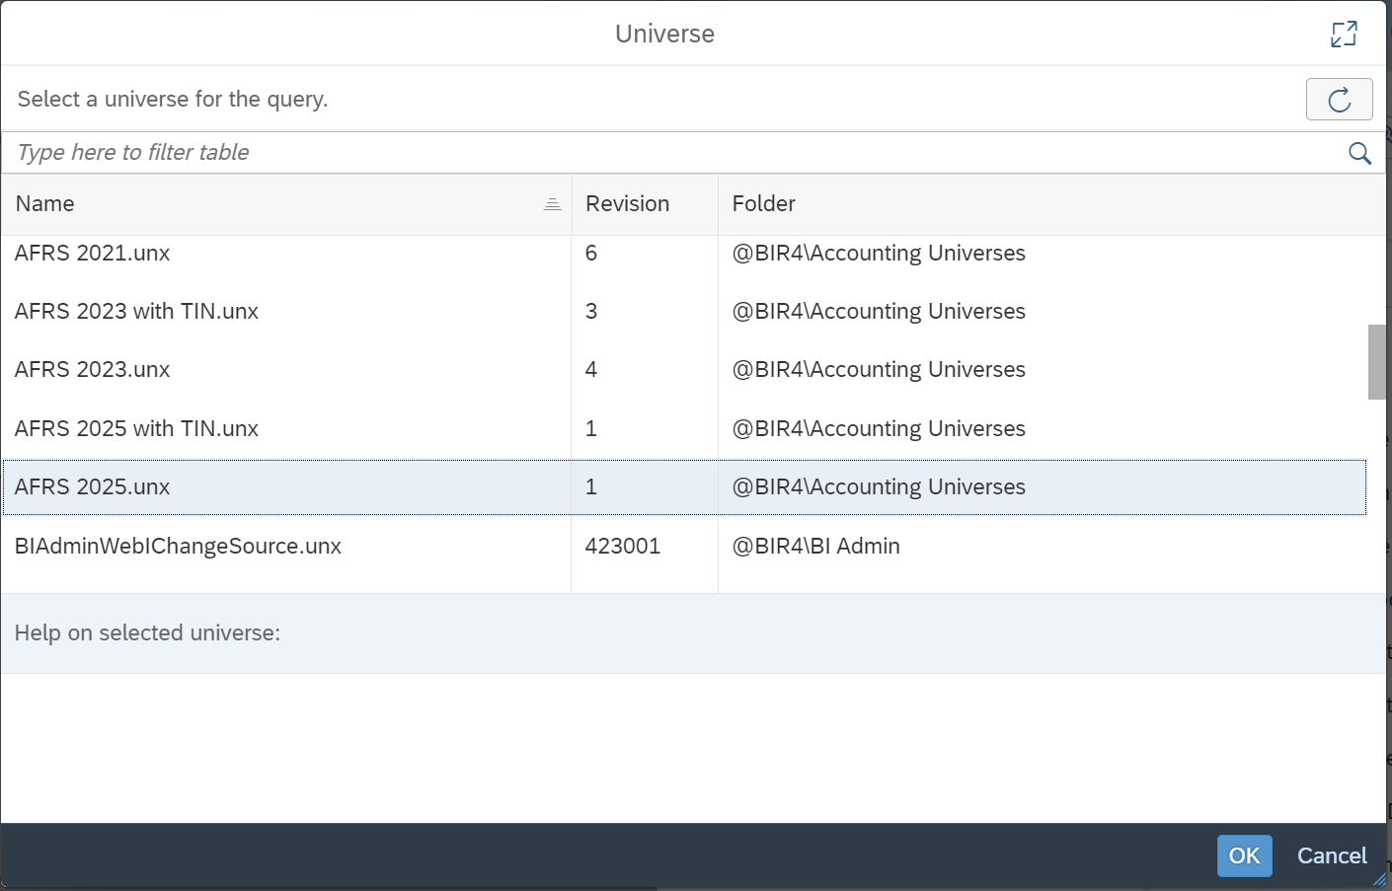

- Once you are returned to the Change Source Wizard window click Next.
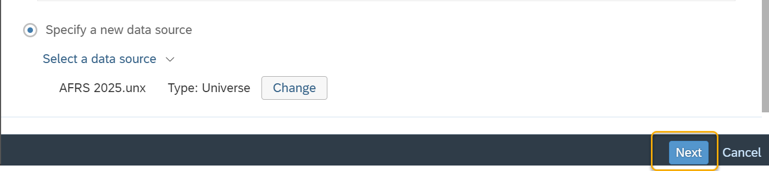

- In the Change Source Wizard, click Next.
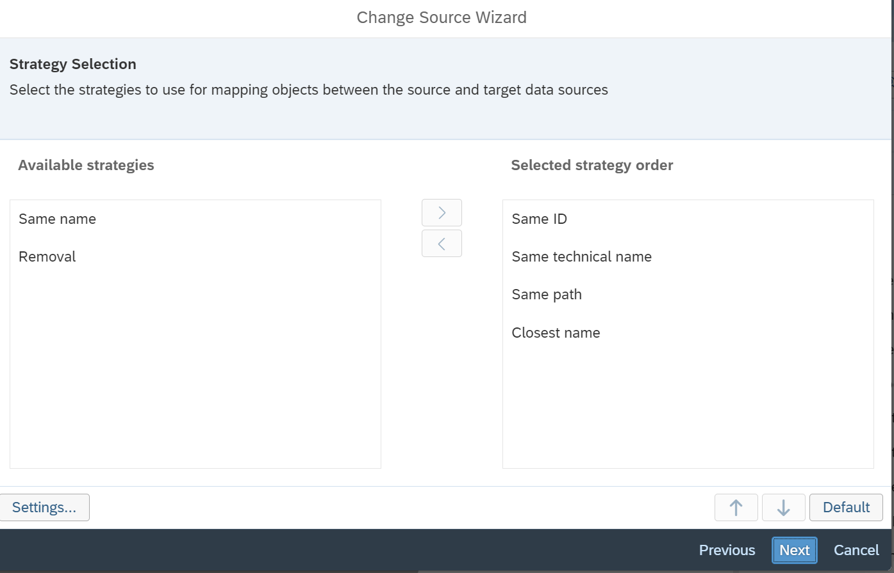

- Click Finish.
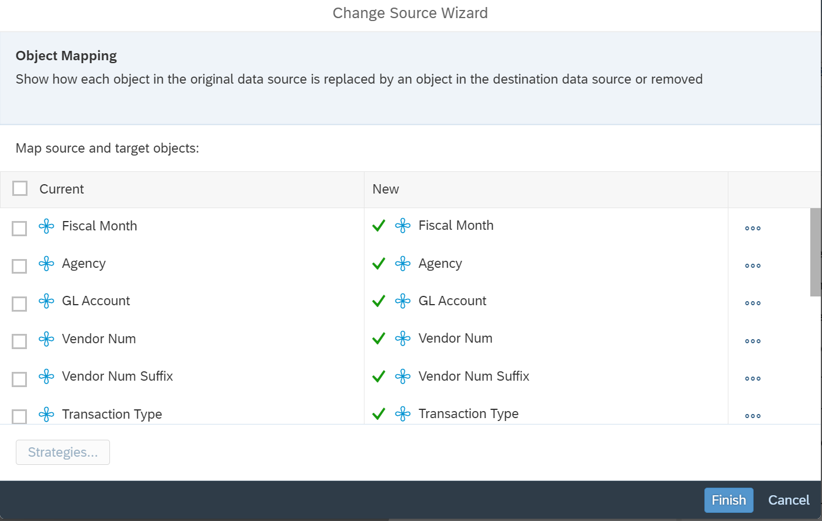

- When the Query Panel opens, Verify that the Universe has been changed to appropriate AFRS universe for the new biennium and click Run.
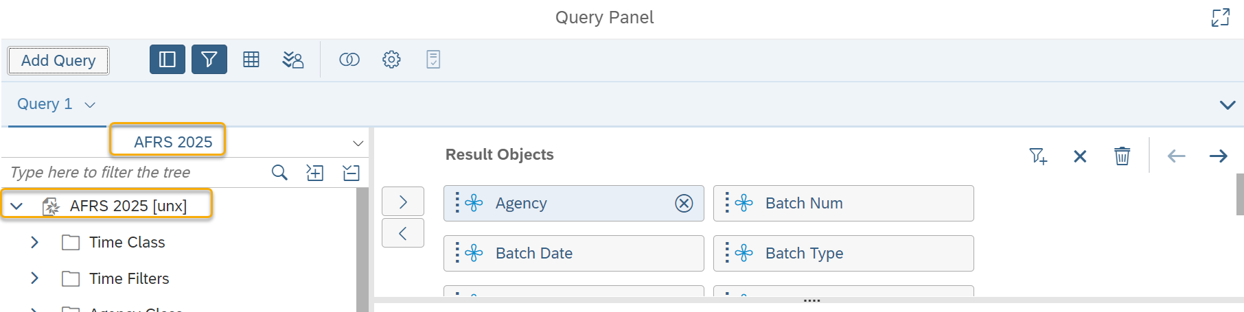

Your reports are now ready for the new biennium. Click on “Run” to re-run report with the new biennium data and then save the updated report.

If you have any questions or concerns contact the OFM Help Desk at: HeretToHelp@ofm.wa.gov or call 360-407-9100.

