Enterprise Reporting- Standard Reporting Rescheduling
The Reschedule feature allows users to schedule a new report using an existing instance. The parameter, run-time, destination, and format values are retained from the original instance. You can then change any of these values and schedule a new report.

To use the Reschedule feature:

- Navigate to the History Page of the report you wish to reschedule.

- Right click on the instance to be rescheduled and select Reschedule.

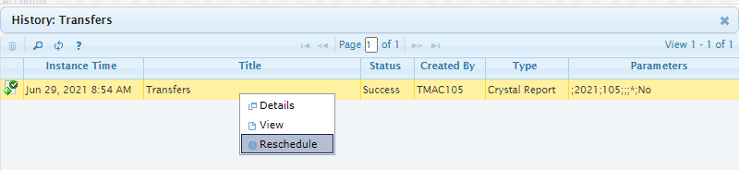
The Schedule screen for Parameters will display. Change the biennium and appropriate parameters values. Make any other changes in the Destination and Recurrence selection tabs and click Schedule to schedule a new report.
