PRI VATE SECT OR PRE PAREDNE S S
RE SP ON SE AND RECOVER Y SEMINAR SERIE S

MASS CASUALTY IMPACT & RECOVERY

Private Sector Preparedness Response and Recovery (PSPR2) is holding a monthly seminar series titled, “Mass Casualty Impact and Recovery,” which examines how businesses can better prepare, respond and recover from active shooter and other mass casualty events.
Each 90-minute seminar will include subject matter
experts from business and the government sharing critical infrastructure best practices, valuable lessons, and planning resources and tools
to assist with mass casualty impact and recovery. This series is designed for companies and organizations interested in enhancing their knowledge and understanding of the impact and recovery of a
mass casualty event. Courses are not cumulative and may be
taken individually. Each course counts toward continuing education with CEU credits.

When: 0900 PST/1200 EST, the third Thursday of every month from March 16 - November 16, 2023
Venue: Virtual Microsoft Teams live (hosted on P4)

REGISTER HERE
Registration: Register HERE or by using QR code to the left.

This series is presented by G&H International, Inc., in partnership with Alaska Partnership for Infrastructure Protection, Albertsons Crisis and Business Continuity Management, American Red Cross, Cybersecurity and Infrastructure Security Agency, Idaho Office of Emergency Management,
New York State Division of Homeland Security & Emergency Services, Oregon Department of Emergency Management and Washington Emergency Management Division.

Session 1: Mar 16
Session 2: Apr 20
Session 3: May 18
Session 4: June 15
Session 5: July 20
Session 6: Aug 17
Session 7: Sept 21
Session 8: Oct 19
Session 9: Nov 16
Introduction to Recovering from a Mass Casualty Incident It’s a Crime Scene – Addressing Immediate Needs Setting Up Crisis Communications for Media Response
When the Crime Tape Comes Down: Providing Immediate Crisis Support Reopening and Resuming Operations
The Immediate Aftermath: What Short Term Recovery Looks Like Negotiating Mid to Long Term Recovery (NY)
Post Incident Scams and Fraud
Civil and Criminal Judicial Processes

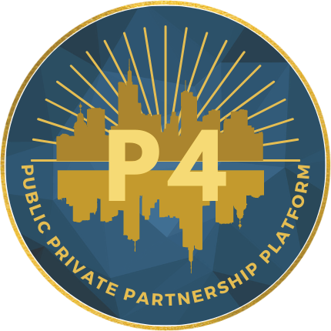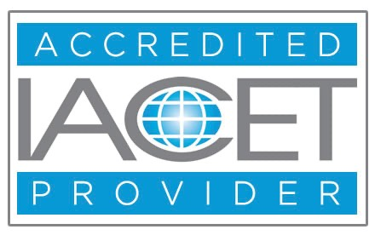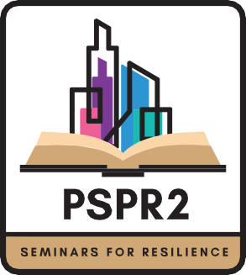
As an IACET Accredited Provider, G&H International, Inc. offers IACET CEUs for its learning events that comply with the ANSI/IACET Continuing Education and Training Standard.

