

General Membership Meeting Agenda
1/19/23
2 to 5 p.m.
Featuring: (Stephanie Sampedro, Student Loan Advocate for the Washington Student Achievement Council)
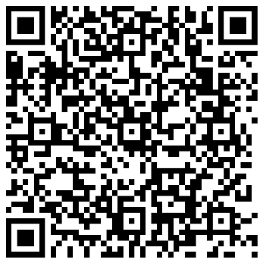
Check into the meeting: https://forms.office.com/g/n0wCkKea09
Facilitators: Taja Blackhorn and Jasper Marino
Recorders: Erika Redzinak, and Alison Mielke
Location: Virtual – Zoom Meeting Link: https://zoom.us/j/96683705169?pwd=cEtHUXFCZzV0a3h0eGdYdWpPTjFMZz09

2 to 2:10 p.m. – Welcome! (Taja and Jasper)
- New Member Introductions and membership check-in

Mission: The BRG exists to help Washington State create safe and inclusive workplaces where every LGBTQ+ employee can bring their full authentic self to work, enabling them to do their best work every day for the people of Washington. The BRG will provide resources and support to employees and the stakeholders serviced by state agencies.
- Approval of minutes – None to approve – virtual RAIN event in December

2:10 to 2:20 – Ice Breaker/Networking Activity
Elizabeth Fontanilla will lead us into a DES ice breaker activity!
Question:

2:20 to 2:30 p.m. - Announcements
- Upcoming Feb. RAIN newsletter – if you want to write an article, contact Kristen (kristen.jenkins@utc.wa.gov) or Caleb (caleb.baldwin@esd.wa.gov)!
- OFM ASL/CART services for RAIN
  - January to June 2023, OFM will request and pay for ASL/CART services only for select, pre-approved BRG events
    - All DIN Monthly General Membership meetings will have this service
    - 2 events per year per BRG can use this service
  - Reevaluating in the spring to see how the process is going and modify again if needed
  - Why the change?
    - The pilot wasn’t working as it was originally designed. Taking lessons learned and feedback to make process easier
- 2023 Public Service Recognition Awards
  - Office of Financial Management is asking you to start thinking about nominating state government and higher education employees and teams for one of the following awards. Nominations begin approximately Jan. 16 and closes on Feb. 26.
  - The Extra Mile Award is given to individuals or groups of state employees who surpass expectations for exemplary public service by demonstrating the following ideals:
    - Innovative techniques and methods
    - Outstanding leadership
    - Visionary thinking
    - Commitment to Diversity, Equity and Inclusion
    - Outstanding customer service
    - Extra Mile Practice Form (So you can preview the nomination form) - https://www.surveymonkey.com/r/T57YPYP
  - The Leadership Award is given to individuals at all levels of management who show exemplary leadership by demonstrating the following ideals:
    - Visionary Leadership
    - Commitment to service
    - A significant contribution to the advancement of state government
    - Personal integrity
    - Commitment to Diversity, Equity and Inclusion
    - Leadership Practice Form (So you can preview the nomination form) - https://www.surveymonkey.com/r/F5MLDZW

Notes:

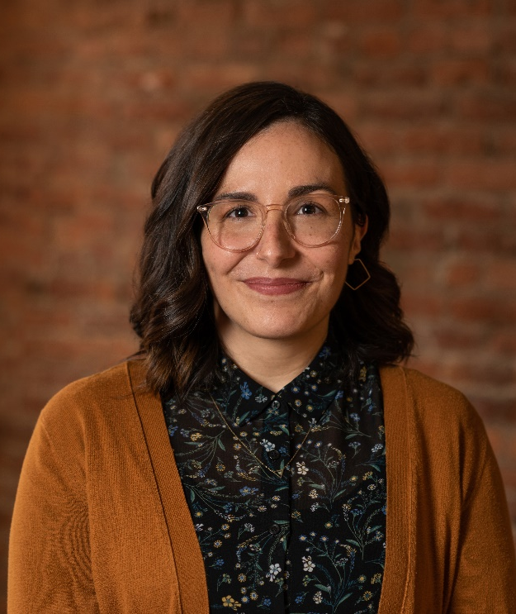

2:30 to 3:30 p.m. – Stephanie Sampedro, Student Loan Advocate for the Washington Student Achievement Council
Stephanie Sampedro has served as the Student Loan Advocate with the Washington Student Achievement Council since 2018. Working in collaboration with other state agencies, she receives and responds to all student loan debt complaints for student and parent borrowers in the state of Washington. She leads a coalition of fourteen State Student Loan Ombuds in advocating for borrower protection across the country. Stephanie is a fierce consumer advocate with a background in financial aid and consumer protection. She has worked in higher education at the community college level as well as at a Community Development Financial Institution (CDFI) loan fund where she ran a matched savings program and counseled borrowers on student loan debt repayment issues. Stephanie graduated from Swarthmore College and is currently working on a Masters of Public Administration from the Evans School of Public Policy and Governance at the University of Washington.
Notes:

3:30 to 3:45 p.m. – Break

3:45 to 3:55 p.m. – Subcommittee Report Outs
Safe Places:
- Updates on meeting with DVA
Best Practices:
- Expanding Family Definition updates
- Professionalism in the Workplace document updates
- Transitioning in the Workplace Toolkit
Communication and Outreach:
- Holiday Events – Thank you for participating – What would you like to see next year?
- Organizing speakers for the next year
  - Have a suggestion for a guest speaker? Email RAIN@ofm.wa.gov
- Speaking at ICSEW and a couple other state agency events
- Prepping for Pride month 2023
Trainings (ad hoc):
- New trainings up on RAIN website and people can register- please share widely!
- Interested in content development and/or facilitating? No experienced needed! Reach out to Jasper and Marika.

Notes:

3:55 to 4 p.m. – For the Good of the Order
Notes:

4 to 5 p.m. – Subcommittee Breakouts

