
LLN Hispanic Heritage Month Lunch and Learn:
50 Years of Bailadores de Bronce

Thursday, October 13, 12 to 1 pm
Register at Zoom Link

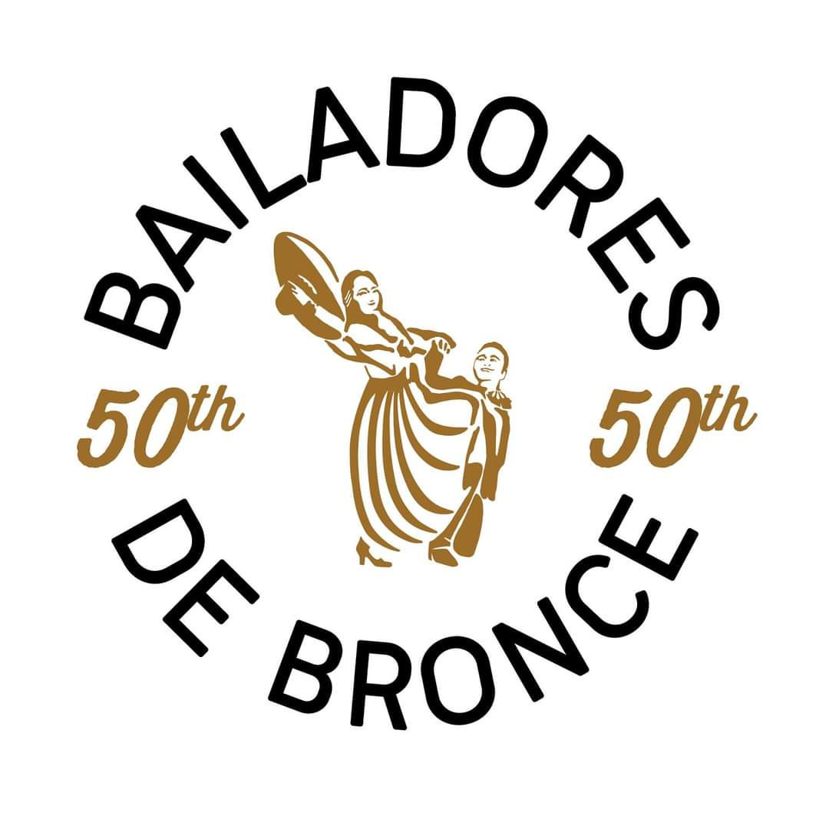
Adrian Olivas, Executive Director of the Seattle-based Mexican traditional dance and music group Bailadores de Bronce, will present highlights of their 50-year history

