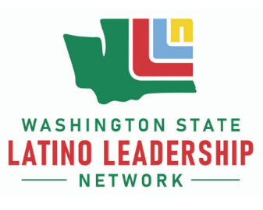
LLN Hispanic Heritage Month Lunch and Learn:
A Conversation with Maestro Alfredo Arreguín

Thursday, September 29, 12 to 1 pm
Register at Zoom Link

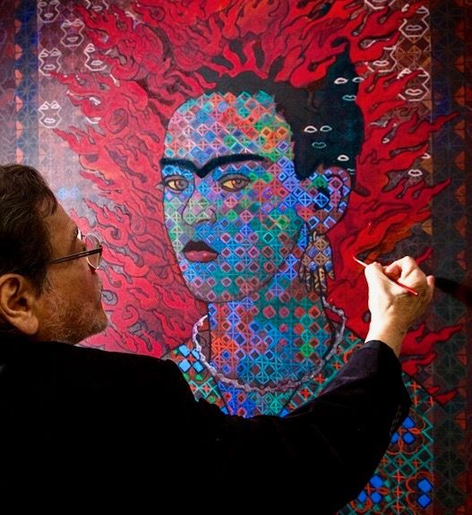

Portrait of the artist by photographer Kevin Cruff

Maestro Alfredo Arreguín will discuss his inspiration, career highlights, and the techniques of his pattern painting style, which reflects his Mexican and Pacific Northwest roots

