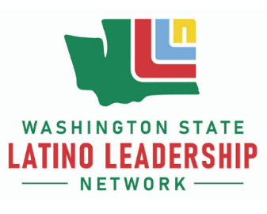
LLN Hispanic Heritage Month Lunch and Learn:
What’s in a Name? A Community by Many Other Name(s)

Thursday, October 6, 12 to 1 pm
Register at Zoom Link



Join LLN members to discuss the multiple names that the community is known as, including Latino/a/e/x, Hispanic, and others.

