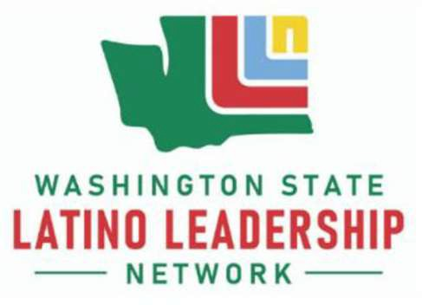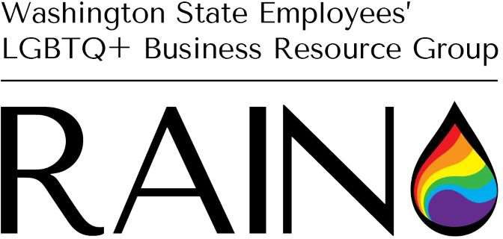

Power of Identity: The intersectionality of the LGBTQ+ and Latino/a/x/e Communities

VIRTUAL LUNCH AND LEARN INVITATION
PANEL START: June 30, 2022, at 12 pm
Link to register: Zoom Registration


On June 30, 2022, at noon, the Latino Leadership Network (LLN) and the Rainbow Alliance and Inclusion Network (RAIN) will be collaborating to host a lunch and learn panel to continue the discussion about intersectionality within the Latino/a/x/e and LGBTQ+ communities. There will be a Q&A at the end. All state employees are welcome to attend the lunch and learn to hear new perspectives and gain knowledge. Please distribute generously within your agency’s Diversity, Equity, Inclusion and Respect (DEIR) work.


