Statewide Certified Community Residential Services and Supports Provider Meeting Frequently Asked Questions – October 4, 2022
Thank you for participating our statewide provider meeting. Below are responses to frequently asked questions and information from presenters:

What are E-signature options?
Electronic signatures, or e-signatures, are an efficient and legal way to sign DDA documents without wet signing (signing with pen or ink) a physical document. One example currently being used is Adobe Fill & Sign.
DDA has two new electronic Signature Options: Adobe E-Signature and Voice Signature.

Who can use these options?
DDA clients, their legal representatives, and non-CDWA providers can use Adobe E-Signature, Voice Signature, Adobe Fill & Sign, or wet signature. (CDWA providers have their own process for E-signature and plan approval.) DDA Case Managers may also e-sign or wet sign the Service Summary.

Which documents can be signed via E-signature currently?
Adobe E-Signature is currently available for:
- DDA Service Summary
- Assessment Meeting Wrap-Up Form
- Rights & Responsibilities
- Voluntary Participation Statement
- Consent
- Attachment to Consent
- Annual SSP Form
- Privacy Practices
Voice Signature is currently available for:
- DDA Service Summary

Will this be available on other forms in the future?
Future plans for E-signature include:
- Client applications and reapplications
- Translated documents
- Expanding Voice Signature for all forms available for Adobe E-Signature

What will a plan look like once it’s been E-signed?
The flow of the DDA service summary goes from the Case Manager who will affix an e-signature or a wet/written signature to the provider, client, and/or legal representative for signature. All signed documents are returned to DDA, and it's possible that each signature may be on a different sheet of paper because we have four options to provide signatures, and it is up to each signer to choose the most person-centered and useful option for them.

CRM E-Signature Example:
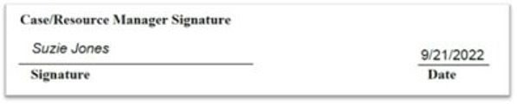
Client/Rep E-Signature Example:
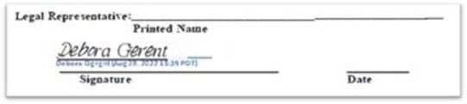
Client/Rep Voice Signature Example:
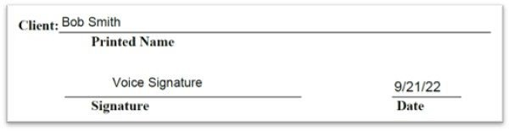

Who can providers contact with additional questions about E-signatures?
The DDA Case Manager is the best resource for providers and other signers to contact (and the CRM can contact their CARE Specialist or the Paper to Electronic Program Manager directly).

Where can I find resources and information about HCBS Integrated Settings?
- You can read the CFR here.
- More information and training materials from Medicaid can be found here.
- The Autistic Self Advocacy Network has some easy-to read toolkits here.
- DDA continues to work on additional resources to assist providers in understanding and implementing HCBS Integrated Settings requirements. Please look out for announcements via GovDelivery.

In what situations would the use of restrictive procedures require an exception-to-policy (ETP)?
Depending on the situation, an ETP may be required. However, it is important to remember to document any restriction in the individual’s PCSP (see DDA Policy 5.21). Refer to DDA Policy 5.15 for non-restrictive procedures, restrictive procedures permitted without an ETP, those restrictive procedures which are only permitted by ETP, and more specific information.

Are locks on doors required or are they merely an option if the individual/guardian requests them? According to CMS, lockable doors are a client right that must be available by default and not only upon request.
This does not preclude the necessity of the provider to obtain the individual’s consent (or guardian’s consent) for a modification or restriction, such as removing a door lock. Door locks can be removed if it is not safe, so long as modifications (with documentation) are in place. There needs to be prompt action if the request to have locks added or removed is made by a client.

If clients are renting or leasing a home from a landlord, and the landlord doesn’t provide locks on doors, who is expected to pay for this?
The individual or DDA.

Are providers required to train on HCBS Integrated Settings?
In order to know how to best support an individual, it is expected that staff who are working with a person understand their rights and are prepared to continue to provide daily support based on that knowledge. It would be difficult to follow expectations if DSPs don’t know what those expectations are.

Who do we contact with HCBS Integrated Settings compliance questions?
Please contact Lori Gianetto Bare: lori.bare@dshs.wa.gov

Is the Client Critical Case Protocol (CCCP) process person-centered?
YES! The entire protocol is based on the unmet need that the individual is experiencing. This can manifest itself in many different ways, but the CCCP process is trying to identify what the individual needs to be successful.

We are getting different directions from RCS and DDA about termination of service. What process/WAC do providers follow?
In Spring of 2021, all residential contracts were amended. This amendment removed the 10-day and 72-hour termination notice from the contract. Follow the current contract and DDA Policy 4.24. DDA Headquarters has provided training to RCS and there should no longer be mixed directions. Also, WAC is being revised to support policy and contract language. RCS will continue to hold you to the requirements under Chapter 388-101 WAC and Chapter 388-101D WAC while you are supporting that client.

Can the CCCP conference be used as a space to address critical issues with the guardian?
The CCCP conference may or may not be the venue for those conversations. It would need to be considered on a case-by-case basis. DDA may be able to provide mediation as an option for those tough conversations between guardians/clients and service providers. Ideally this option would be best deployed before the relationship is completely destroyed, so please talk to the individual’s DDA case manager to request.

If an individual has expressed not wanting to work with an agency, is a provider required to still follow the CCCP?
This may vary depending on the situation. There are many times that an individual chooses another agency without going through the CCCP process. Sometimes, it comes out at a CCCP meeting that individual doesn't want to continue services.

When can a termination of services notice be submitted?
It is a difficult decision to terminate services to an individual. These situations are not taken lightly, and termination is never the goal of the provider and CCCP process. A provider may not submit a termination notice until engaging in the CCCP process. “Engaging” has been further defined and agreed to as participating in the first conference. However, the expectation is that you come to that first meeting ready to make a good faith effort to work with the client and DDA in attempting to resolve the issues that brought you there. This has been consistent direction and been agreed upon by DDA and provider contract committee.

