Employment First in Washington.

Alderbrook 2018

  - David Mank, Ph.D.,
  - Professor Emeritus
  - Indiana University

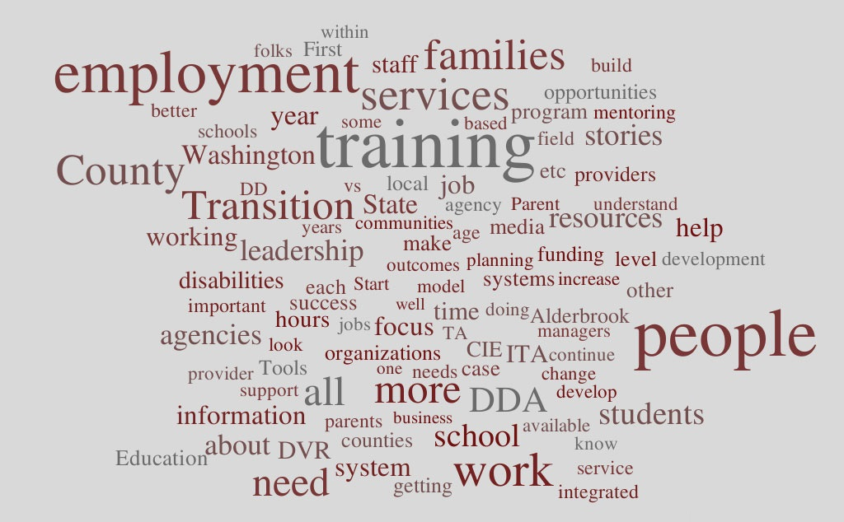

Introduction
Fifteen years ago, in 2004, the State of Washington issued its Working Age Adult Policy. This Policy, a first in the nation, affirmed a fundamental belief that all people with intellectual or developmental disabilities (I/DD) have talents and ability to contribute in typical workplaces in every community. This Policy, which has guided the development and expansion of competitive integrated employment states:

“Pathways to Employment: Each individual will be supported to pursue his or her own unique path to work, a career, or his or her contribution to/participation in community life. All individuals, regardless of the challenge of their disability, will be afforded an opportunity to pursue competitive employment.” (Washington State Working Age Adult Policy, 2004).”

Seven years ago, in March 2012, the Washington State Legislature passed legislation to support employment as the first choice of services for adults of working age.
Since 2010, Washington has:
- Delivered more than a 50% increase in the number of people with (I/DD) working in competitive integrated employment.
- Increased, in every year, the number of people with the most significant disabilities (High Acuity) earning minimum wage or higher.
- Increased average hourly wages from $9.99 to about $11.50.
- Reversed, in 2018, a decade long trend of decreasing hours work weekly. The average weekly hours work had decreased from 14 to 10 hours per week. This has increased to more than 12 hours per week in 2018.
- Delivered the highest rate of CIE services and employment outcomes in the nation as reported by The Institute for Community Inclusion at the University of Massachusetts.
- Significantly reduced the number of people in pre-vocational or non-employment services, from more than 750 in 2012, to fewer than 100 in 2018.
- Continued investment in School to Work outcomes with more than half of students leaving school with CIE services or an employment outcome.

In October 2018, 150 stakeholders in competitive integrated employment met for two days at the Alderbrook Resort near Union, Washington. The purpose of the gathering: to improve employment outcomes for people with I/DD in Washington. Participants included: employment provider personnel, county personnel, school personnel, family members, individuals with disabilities, case managers, training and technical assistance providers, as well as state agency personnel from Vocational Rehabilitation, the Office of the Superintendent of Public Instruction, and the Developmental Disabilities Administration.
This event revisited the setting, the purpose and the intent of the 2017 Alderbrook event and the 2007 Alderbrook event, following the implementation of the Working Age Adult Policy.

National Context
As reported in 2017, the national context of CIE for people with I/DD is important to consider. Events and circumstances in seven areas can be considered, at this time, which can influence the State of Washington’s continued progress.
- The Centers for Medicare and Medicaid Services (CMS), “Settings Rule” sets the expectation that, by the year 2022, that all services and supports, including employment, will be provided to people with I/DD in fully integrated settings.
- CMS continues to investigate and made changes in how employment services can be funded, with the intent of making payment to providers of services for milestones and employment outcomes, instead of the longstanding hourly fee for service funding structure. Several additional states are considering or have begun to make use of this funding approach.
- In September 2018 a report was issued, about Oregon’s progress in CIE based on The US Department of Justice (DOJ) reached Settlement Agreement (SA) in Oregon for reducing the segregation of adults with disabilities in sheltered work settings. This document reports that Oregon is increasing CIE and reducing reliance on sheltered work, meeting the expectation and the metrics established in the SA. This court case is based on The Americans with Disabilities Act (ADA) and the Supreme Court Olmstead Decision which established the right to integrated vs. segregated settings. Initially applying to residential settings, the Oregon case, in particular, establishes that the decision applies to work settings as well.
- The national debate continues to unfold about the payment of sub-minimum wages to people with I/DD. Maryland is the most recent state to pass legislation to eliminate sub-minimum wage. The City of Seattle has also done so. Self-advocates continue to lead on this issue in Washington DC and in the State of Washington.
- Attention to the implementation of the 2014 Workforce Innovation and Opportunity Act (WIOA) continues, which promotes competitive integrated employment for all people with disabilities, limits the use of sub-minimum wages for youth 24 or younger, and emphasizes transition from school to post-secondary education and competitive integrated employment. In addition, WIOA created an Advisory Committee charged with making recommendations on ways to increase competitive integrated employment, and address the use of sub-minimum wages. The committee issued its Final Report and Recommendations in September 2016. This report and its recommendations have been the subject of 2 bipartisan and bicameral Congressional Briefings and a US Senate Hearing. One central theme of this report is the need to build the capacity, in communities across the country, to deliver competitive integrated employment services and outcomes. By recent report, related legislation about sub-minimum wage and capacity building is under discussion in the US Congress.
- New threats to CIE and an expectation of full inclusion have emerged in defense of segregated settings, integrated employment and sub-minimum wages. These threats from a few national organizations are important to notice, as many national and other organizations continue to emphasize the value of CIE and the voice of self-advocates about CIE and full inclusion.
- Proposed national legislation is emerging. This includes the Transformation to Competitive Employment Act, which would provide grants to states and other entities to build capacity to deliver CIE and eliminate sub-minimum wages over time. In addition, the Raise the Wage Act would increase the federal minimum wage to $15 an hour over time and include people with disabilities. The future of these proposed Acts remains to be seen, as the national discussion of each continues.

Washington State Context: Expanding Improvements since 2007
Conventional wisdom often tells us that things don’t change much in a single year. While this may often be true, CIE outcomes are improving year by year in the State of Washington and has improved since 2007. Following, are charts and graphs prepared and presented by John Butterworth, Ph.D., of the Institute on Community Inclusion (ICI) at the University of Massachusetts, Boston.
John Butterworth PowerPoint

Accomplishments in the last year
The State of Washington has improved CIE outcomes for decades and in recent years. It is especially important to note in the following graphic, the employment improvements since the 2004 Working Age Adult Policy.
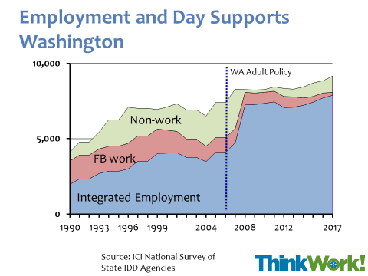

In addition, improvements are evident across Acuity Levels.
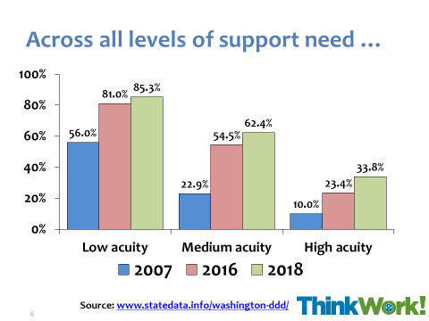

Furthermore, after a decade of decreases, the number of hours worked weekly is increasing across all Acuity levels.
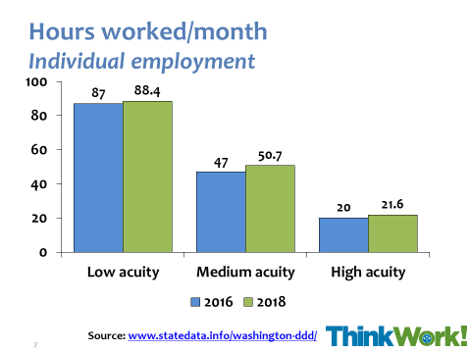

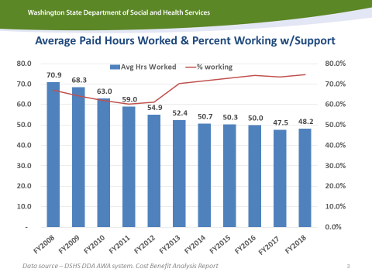
It also important to note that the State of Washington has established specific goals and methods to increase the number of hours worked weekly. This includes work by providers of CIE Services as well as a state-wide effort to inquire with each individual about their preferences for working hours. This is evident in the document below now in use statewide.
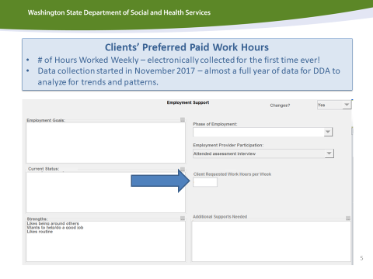
In addition, statewide, this is a focus on increasing employment outcomes for those individuals with a High Acuity label. The next graphic shows an increase in the number of these individuals earning minimum wage or better. This number has increased every year since 2010.
These data provide evidence that things can change and improve in a single year. In fact, these data show improvements year by year in the State of Washington for many years running.
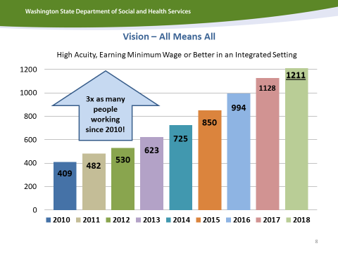
WA State DDA Slides
In addition, there are other changes in Washington that speak to continued improvement in CIE for people with I/DD. These changes include:
- Expanding stake holders’ involvement.
- CEA’s initiative to “Up the Hours”, in alignment with the statewide effort.
- Increasing role and voice of self-advocates in Washington.
- Continued success in School to Work Transition outcomes.
- Expanding focus on multi-cultural families.
- Growing involvement by schools and OSPI in investment on CIE.

Employment First in Washington: Alderbrook 2018
At Alderbrook Redux 2017, one year ago, seven issues were noted as especially important in the next decade.
- Continue work addressing the issue of the number of hours worked weekly and the need for wraparound supports.
- Track national developments.
- Revisit funding structures, protocols and rates.
- Continue investment in Transition from School to Work.
- Expand attention to multicultural communities.
- Sustain each other.
- Sustain the Vision of All Means All.
Washington’s DDA Office presented information about work and progress in each of these areas.
Reports updating recent work and progress were also provided by Wise, the Community Employment Alliance (CEA), Parent Coalitions, and Self- Advocates.
- Wise present the content and volume of CIE related Training and Technical Assistance (TA) in Washington. This included expanded CIE training and certifications ACRE and CESP; work on County TA Plans; multiple webinars and on-demand trainings; Individual Technical Assistance (ITA). In terms of the ongoing need for training and TA, Wise noted that half of provider staff have been on job 5 years or less.
- CEA reported work on the work to increase the average number of hours worked weekly in CIE called “Up the Hours”. CEA also reported on its CIE advocacy work with the Washington State Legislature.
- Parent Coalitions reported on: the “I Vote” Campaign; work with the Legislature and collecting stories to share with constituents and Legislators. In addition, the Parent Coalitions are emphasizing employment in its Birth to 5 work.
- Self-Advocates reported its efforts to expand self-advocacy statewide, and its continued emphasis on “All Means All” in employment.

Design of the Washington 2018 Employment First Discussion Event
A single year has passed since the last Alderbrook discussions. This event included a discussion of “Resources” related to promoting CIE. In addition, discussion was organized around Challenges and Strategies in five areas. This set a structure for a number of discussions. This was followed by local action planning based on county or geographic area. In addition, Alderbrook 2018 participants had a visit and discussion with the Secretary of WA State DSHS.

Resources Discussions
Ideas for resources and organizations, tools and strategies were brainstormed and discussed. Resource ideas were discussed in the areas of: State and County; Employment Agencies; Schools and OSPI; Families; Self-Advocates; and, Employers. View the full set of ideas recorded.
Highlights of the Resources discussions included:
- Importance of “gatherings” to support and learn from each other. This includes the now annual Community Summit, as well as “Recruit, Train, Retain” (RTR), Alderbrook discussions, “Off the Clock”, Leadership and other training events and more.
- Presence of multiple organizations in the private sector and the public sector that contribute to CIE.
- Use of multiple media outlets to “tell the story” of CIE. This includes conventional media outlets as well as growing social media.
- Consistent use of training and technical assistance resources for personnel in many roles.
- Expanding emphasis on Transition from School to Work statewide.
- Growing presence and involvement of school personnel and OSPI.
- Importance of Employment Agencies.
- Growing voice of Self-Advocates.
- Family engagement and involvement.
- Importance of relationships and discourse with employers and the business community.
- Ongoing role of Washington DDA and Counties to promote CIE.
- Growing emphasis on multi-cultural families and communities.

Five Discussions
Much of this Washington Employment First Forum focused on discussion in five areas: Systems Improvement; Training and Technical Assistance; Storytelling; Leadership; and, Transition. Challenges and Strategies were discussed in each area. View the full set of recorded notes for each of these discussion areas.
Highlights from each of the five discussion areas included the following:

Systems Improvements
- Growing role of school personnel and OSPI in transition outcomes.
- Work with multi-cultural communities.
- Work on “Values Based Payment” ideas.
- Opportunities across relationships and roles, including, DDA, Case Management, DVR, Counties, Schools.
- Outreach to and involvement of Families.

Training and Technical Assistance
- Need for increasing CIE competencies.
- Increasing Training and TA for Managers in Agencies.
- Attention to the need for building expanding skill sets beyond the basics of CIE.
- Ongoing need for Training and TA for personnel in many related roles.
- Need to build cultural competence.

Storytelling
- Growing role of social media in telling the story.
- Need to focus on multiple audiences with varied interests.
- Emphasize business success stories.
- Importance of messaging directly to people with disabilities and families.
- Role of video in telling the story.
- Telling the story to change community attitudes.

Leadership
- Need to empower leadership at all levels.
- Growing a Leadership Culture in Agencies.
- Need to grow “Mentoring” in agencies.
- Building more diverse leadership in all roles.
- Developing career paths.
- Leadership inside and outside government.
- Involving more self-advocates in leadership roles.

Transition
- Start the transition process with individuals and families as early as possible.
- Expand involvement of schools in transition.
- Set goals for transition outcomes every year.
- Include Benefits Planning with families in the transition years.
- Outreach to Pediatricians.
- Invest in Pre-Employment Transition Services.

Community Action Planning
Participants also had the opportunity to discuss ideas and plans going forward based on their county or geographic areas. In 2017, participants used the following tool to frame discussion and make plans to improve CIE outcomes. Participants had the opportunity to review their plan and progress from a year ago. And to reframe intentions for 2019 and beyond.
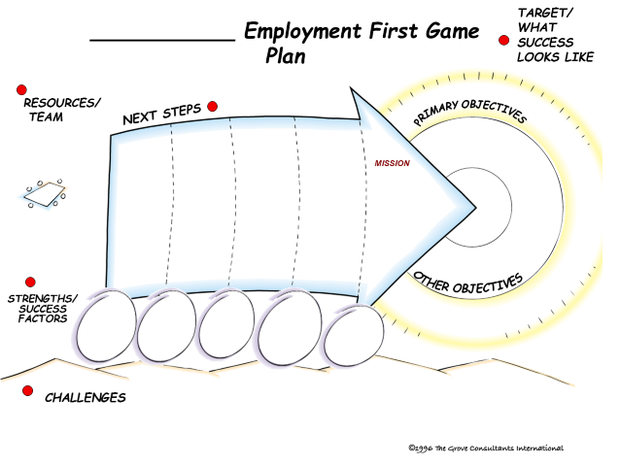

A Visit from the DSHS Secretary
Participants also had the opportunity to hear from and engage in discussion with Washington DSHS Secretary, Cheryl Strange. This unique visit provided the Secretary’s insights in to the work of Washington’s Employment First Leadership. The Secretary was knowledgeable, interested, supportive, and engaged about this work. In addition, the questions and answers and ensuing discussion with the Secretary provided a context and shared vision for Employment First for people with I/DD in Washington State.

A Few Observations
Fifteen years since the Working Age Adult Policy, and eleven years since Alderbrook 2007 and the launching of full implementation of the policy, and five years since Washington’s Employment First Legislation, Washington State has identified what’s working, what needs improvement and generated action steps to improve competitive integrated employment for people with significant disabilities.
As a participant – observer and a (near four) decades’ long window into employment of people with I/DD in the State of Washington, I have witnessed the sustained and successful work of many people in these years, and the positive changes in the lives of people with I/DD. Between Alderbrook 2007 and 2017, ten years apart, we might reasonably expect to take note of improvement in employment outcomes. And we did so. In just a year since 2017, we might not expect to see improvements. And yet we did notice and discuss improvements, as well as set new goals. Following are a few observations from Employment First Washington, Alderbrook 2018.
- Things can improve in a year.
- Things can improve year after year.
- Improvements lead to bigger goals.
- Expanding the involvement of many stakeholders’ matters.
- Expanded involvement of Schools personnel and OSPI is important.
- Expanding voice of self-advocates is a tremendous asset.
- Ongoing alignment with Parent Coalitions matters.
- Focus on outcomes and close review of data leads to new ideas.
- The presence and discussion with DSHS Secretary Cheryl Strange is an important affirmation of the importance of this work.
- New leadership has and is emerging even as legends retire.
- There is a sustained willingness to: listen, disagree; argue, change one’s mind, learn, discover and support each other in the process.

The Path Ahead
Finally, I offer my thoughts on The Path Ahead for Employment First, Washington.
- Continue work addressing bigger goals on the issues of the number of hours worked weekly, the need for wraparound supports, and including more people with high acuity
- Keep the idea and the goal of “living wage” in the conversation.
- Continue the discussion of funding structures, protocols and rates (e.g. Values Based Payment”).
- Double down on the successful work and investment in Transition from School to Work.
- Sustain the emerging attention to multicultural communities.
- Pursue greater involvement of self-advocates in leadership and in roles in training and technical assistance statewide.
- Sustain the Vision of All Means All.

2018 in Historical Context
The State of Washington in Employment First is unique. The first Working Age Adult Policy in the Nation. An early adopter of Employment First commitment. An early explorer of innovations, and demonstrations of quality employment. A decades long accountability to outcomes, measured, reported and discussed in the face of, sometimes unforgiving, data. All of this began in the 1970s with documented belief in the abilities of people with significant disabilities, an appreciation of the value of work in everyday lives, and a commitment to big ideas.

Previous Employment Forum Papers:

- 2007 Report
- 2017 Report

