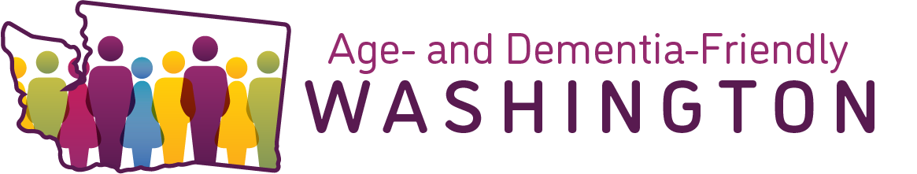

Community Forums Outreach Toolkit

Purpose:
This toolkit is designed to encourage community members to participate in the upcoming Age- and Dementia-Friendly Community Forums. Their input will inform programs and policies that better support older adults and people living with dementia across the state.

Email:
Use this sample email copy to draft a message to your email lists, partner organizations, or community networks. Customize as needed to fit your audience and help spread the word about the Age- and Dementia-Friendly Washington initiative.
Subject: Your Voice Matters: Register today for an Age- and Dementia-Friendly WA Community Forum

Email Body:
Washington State is taking meaningful steps to become more age- and dementia-friendly — and we need your help to ensure every voice is heard.
As part of Washington’s participation in the AARP Network of Age-Friendly States and Communities and Dementia-Friendly America, we’re gathering input from residents across the state. Your insights will guide how we plan for more inclusive, supportive communities where people of all ages can thrive.

We are hosting 5 Community Forums, please select the one that best suits your needs and schedule:
- Thursday, April 2 from 10:00 am – 12:00 pm
  - ASL/CART services will be provided
- Thursday, April 9 from 10:00 am – 12:00 pm
  - This session is for people living with memory loss or dementia
- Thursday, April 23 from 1:00 pm – 3:00 pm
  - ASL/CART services will be provided
- Tuesday, April 28 from 10:00 am – 12:00 pm
  - This session will be conducted in Spanish
- Thursday, April 30 from 1:00 pm – 3:00 pm
  - This session is for Tribal community members

Register for a Community Forum here: Age- and Dementia-Friendly Washington | Washington State Department of Health

Together, we can make Washington a place where everyone can age with dignity, purpose, and connection.

Here’s how you can help:
- Share the invitation to register for a Community Forum with your networks
- Use our ready-to-go social media toolkit and flyer
- Encourage community members, caregivers, and older adults to select one of the Community Forums to attend.

Social Media Posts:
Use these sample social media posts to help promote the Age- and Dementia-Friendly Washington initiative and encourage community members to attend a Community Forum.
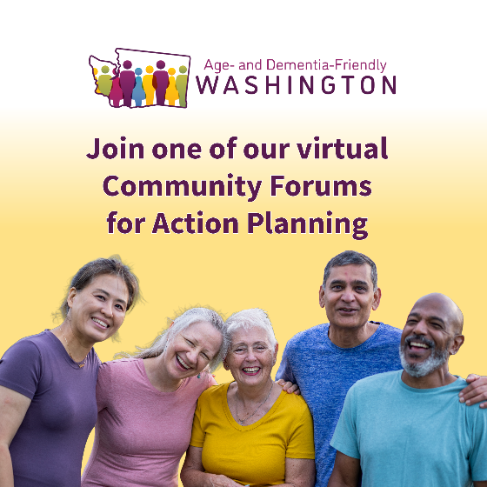 | Have ideas about how we can build communities where people can age well and stay connected?  Join one of our upcoming virtual Community Forums for Action Planning. We’re gathering input on how to better support older adults, including people living with memory loss or dementia.  Multiple sessions are available in April, including forums for the general public, people living with memory loss or dementia, Spanish speakers, and Tribal community members.  Share your ideas and help shape Age- and Dementia-Friendly Washington communities. Register today: https://doh.wa.gov/age-and-dementia-friendly
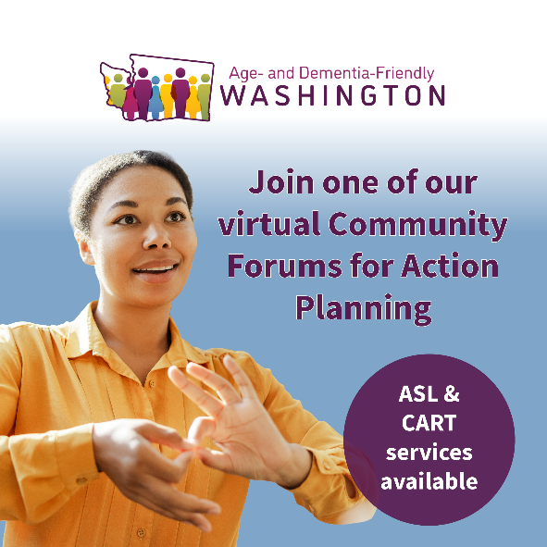 | Join an upcoming virtual Community Forum for Action Planning and share your ideas on how we can better support older adults and people living with memory loss or dementia in our communities.  Two sessions will include ASL and CART services to help make the conversation accessible:  • April 2, 10 a.m.–12 p.m.  • April 23, 1–3 p.m.  Your opinion matters. Help us continue to build an Age- and Dementia-Friendly Washington: https://doh.wa.gov/age-and-dementia-friendly
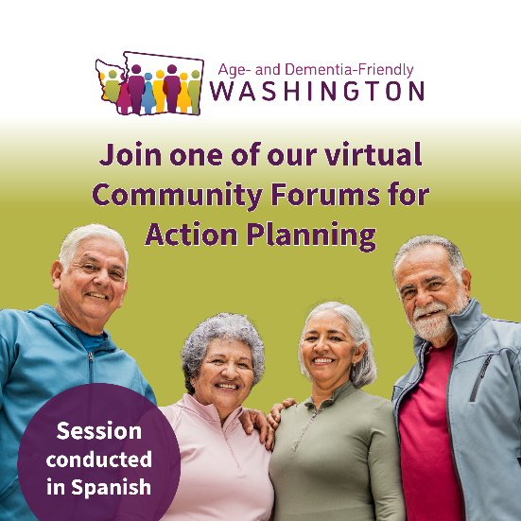 | ¿Habla Español? We’re hosting a Community Forum for Action Planning entirely in Spanish and would love to hear your ideas.  Join us virtually on April 28 from 10 a.m.–12 p.m. for a conversation held completely in Spanish, where community members can share ideas about how businesses, government, and communities can better support older adults and people living with memory loss or dementia.  Or alternative text in Spanish:  ¿Habla Español? Estamos organizando un Foro Comunitario de Planificación de Acciones completamente en Español y nos encantaría escuchar sus ideas.  Únase a nosotros virtualmente el 28 de abril de 10 a.m. a 12 p.m. para una conversación realizada completamente en Español, donde miembros de la comunidad podrán compartir ideas sobre cómo las empresas, el gobierno y las comunidades pueden apoyar mejor a las personas mayores y a quienes viven con pérdida de memoria o demencia.  Register for the session: https://doh.wa.gov/age-and-dementia-friendly

Flyer:
Use this flyer to promote the Age- and Dementia-Friendly Washington initiative and encourage community members to attend a Community Forum. You can print and post it in public spaces, share it at events, include it in newsletters, or distribute it digitally.
