

**HELMS Portal Users**

**User Guide for Partners**

March 25, 2024

# Logging In

The SecureAccess Washington (SAW) website will be used to access the HELMS public portal. To access the HELMS public interface, follow the steps outlined below:

1. Open theSecureAccess Washington (SAW) website at <https://secureaccess.wa.gov/myAccess/saw/select.do>
2. Enter your **Username** and **Password** and click the **Submit** button on the Sign In page.

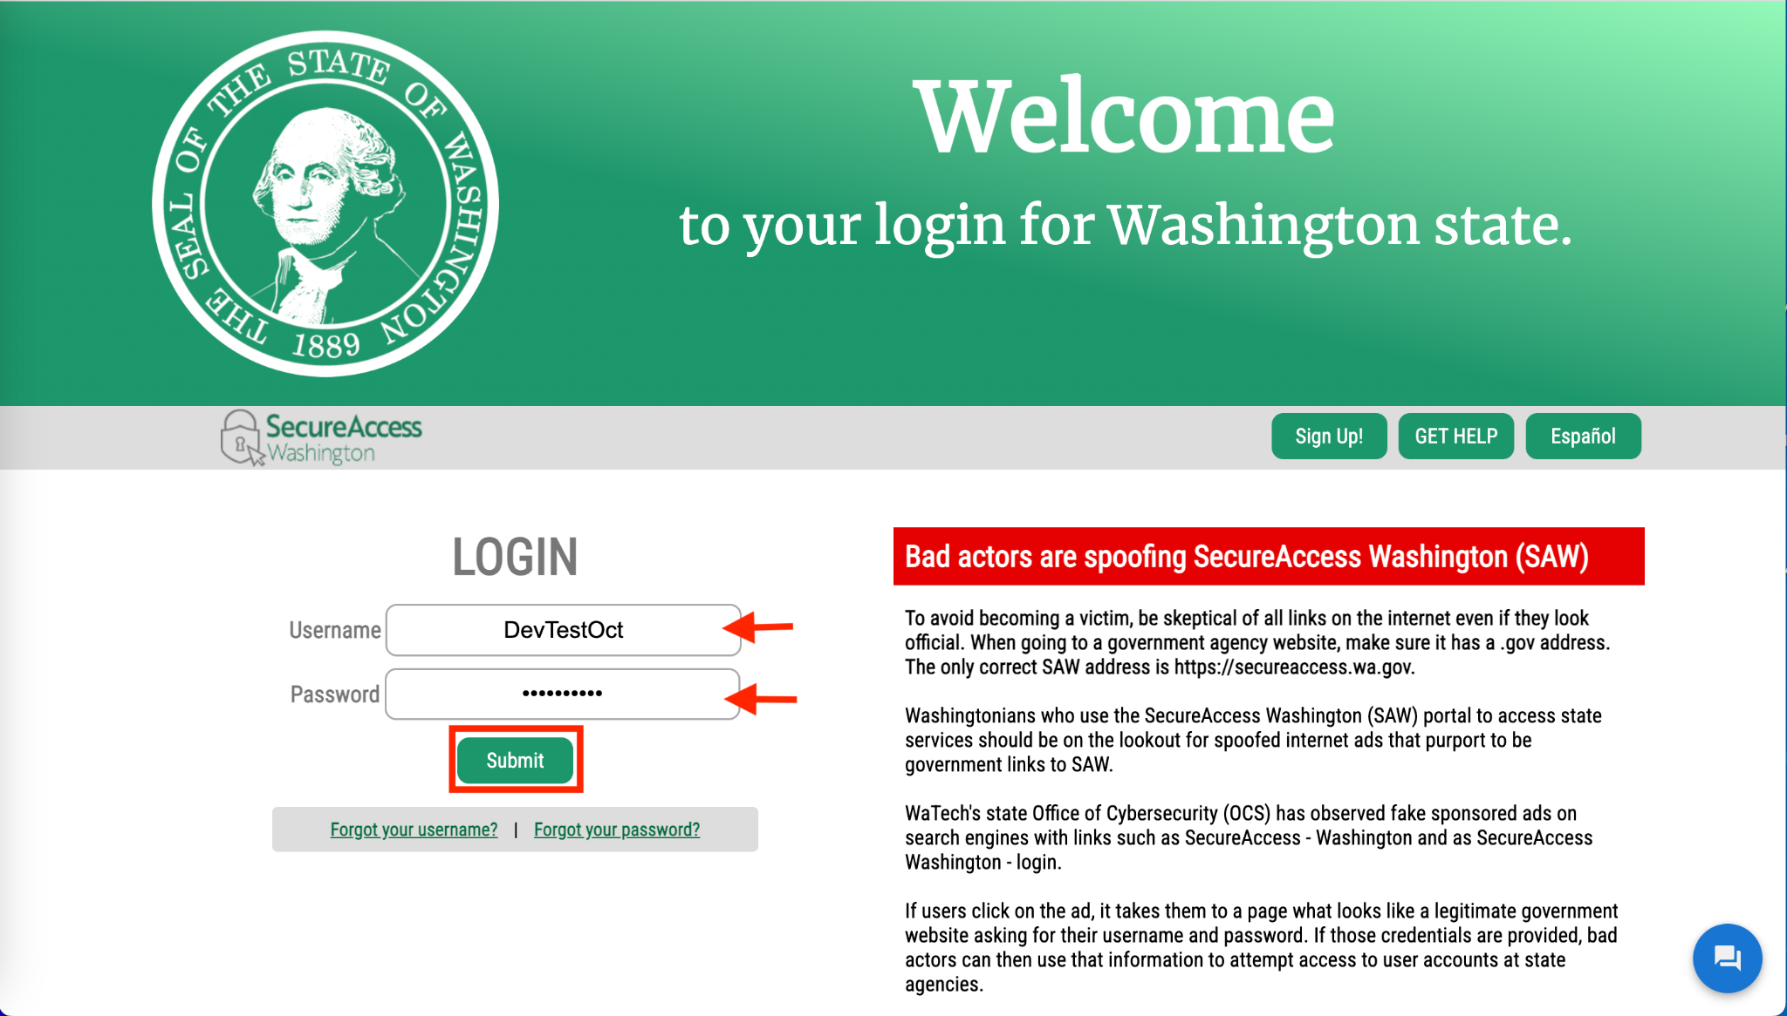

You will be directed to the SecureAccess Washington (SAW) landing page.

1. Click the **Access Now** button on the **Online Application Portal provided by the Department of Health** tile.

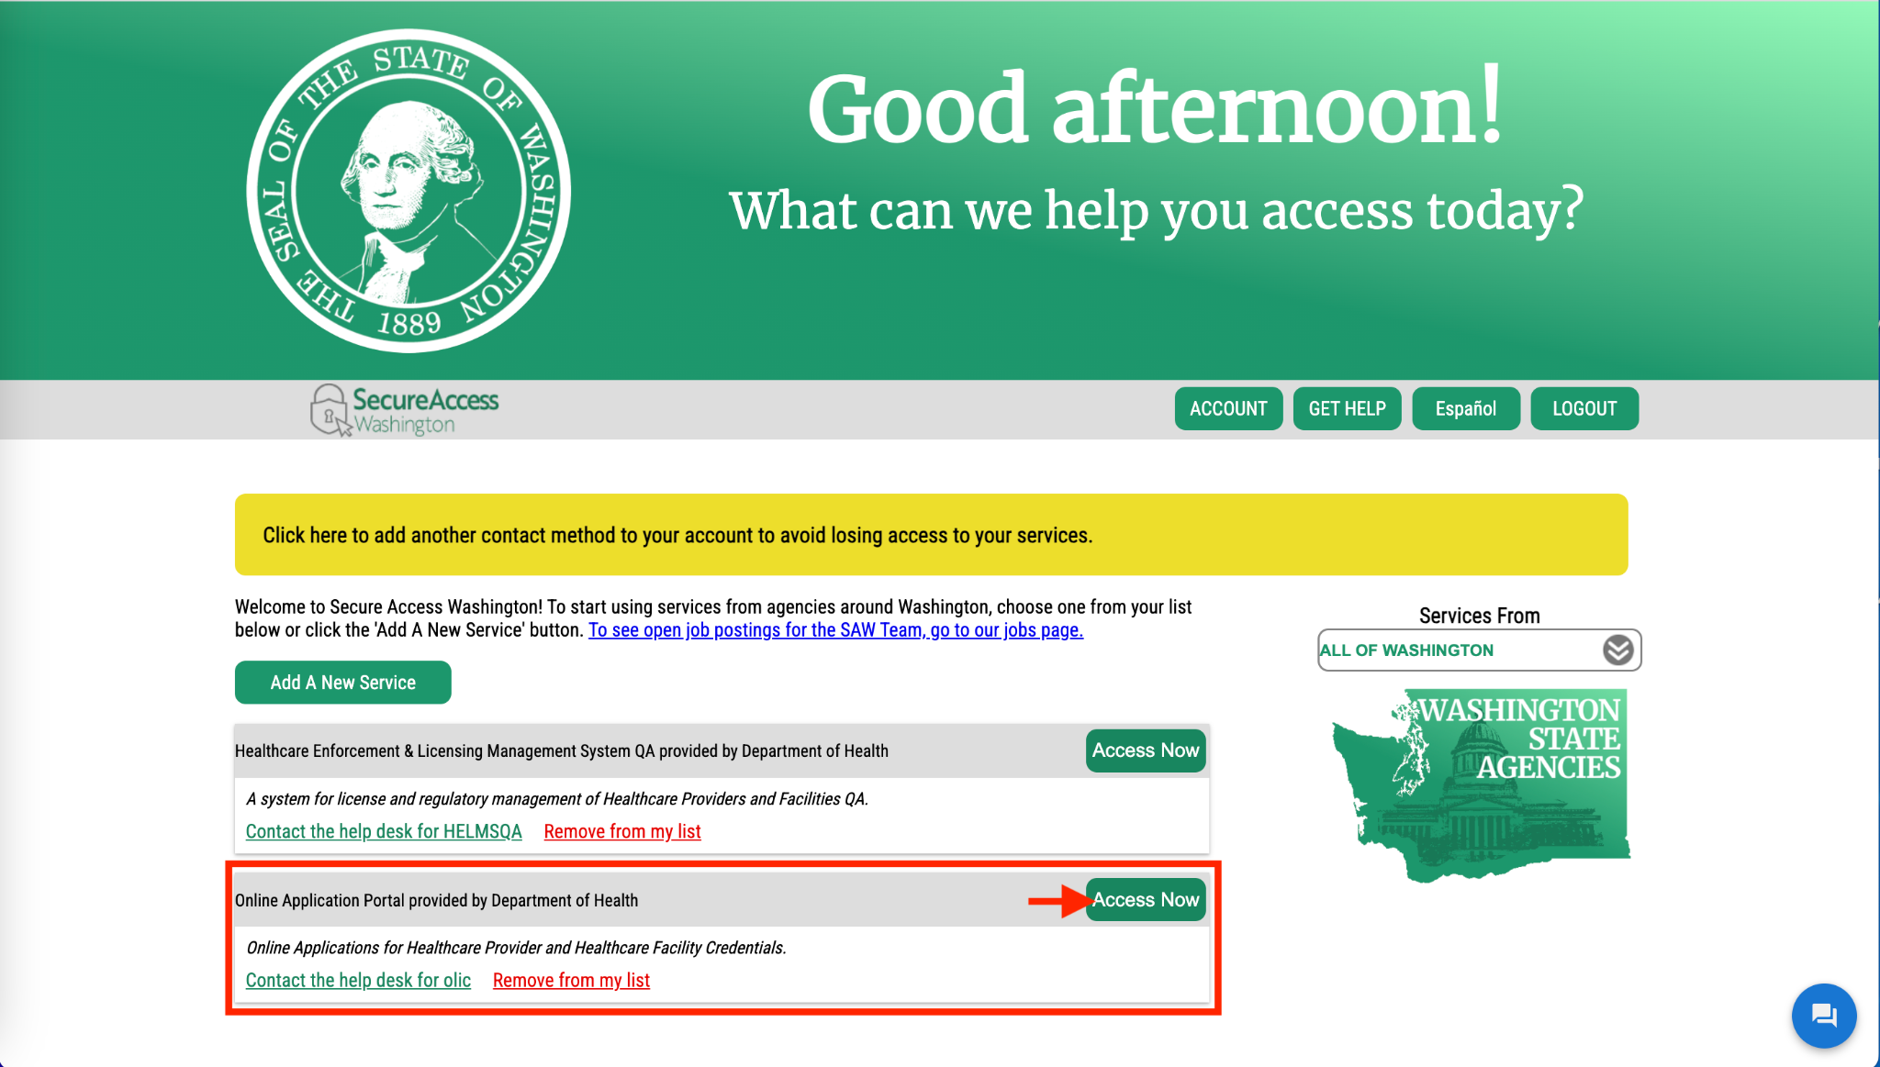

1. If you have an account and have previously logged in, you will be directed to the Profile page.

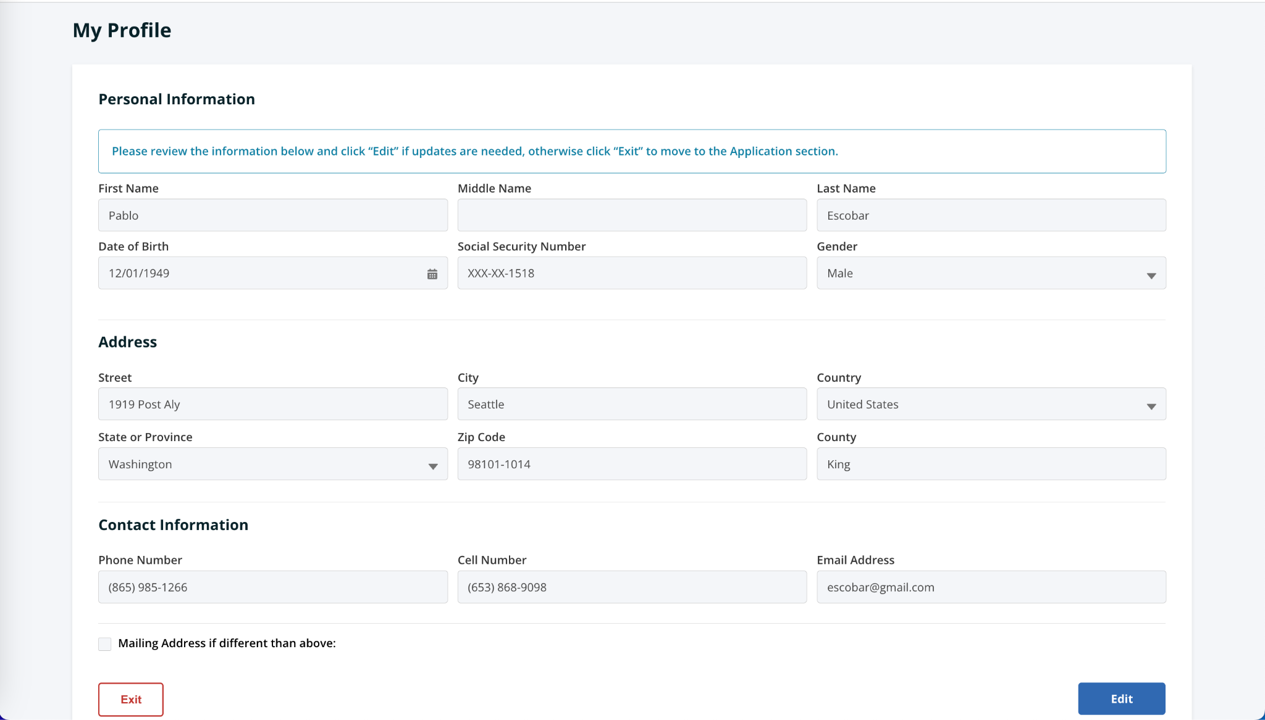

1. If you are a first-time user, you will be directed to the **Locate your Account** page on the HELMS portal. Enter the correct details and then click the **Submit** button to find your account.  
   **Note**: **Social Security #** field is mandatory. If you do not have your Social Security number, select the checkbox to make the field optional.

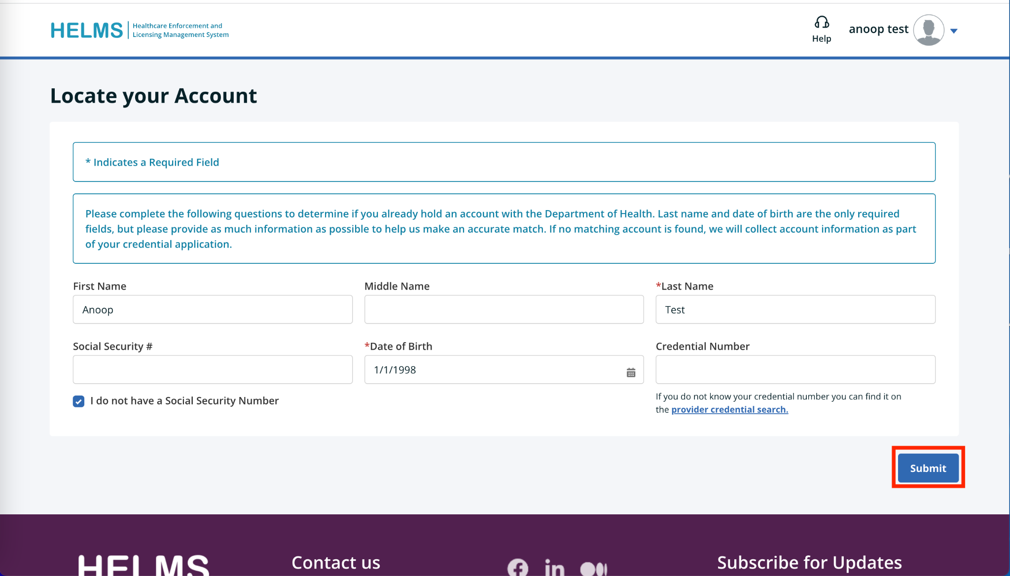

Any of the following scenarios can occur:

1. Exact Match
2. Partial Match
3. No Match
4. **Exact Match**: If the system finds the information you entered, you will be directed to the **My Profile** page.



1. **Partial Match**: If the system finds your entered information with a partial match, you may have to select the correct address and then click the **Submit** button.

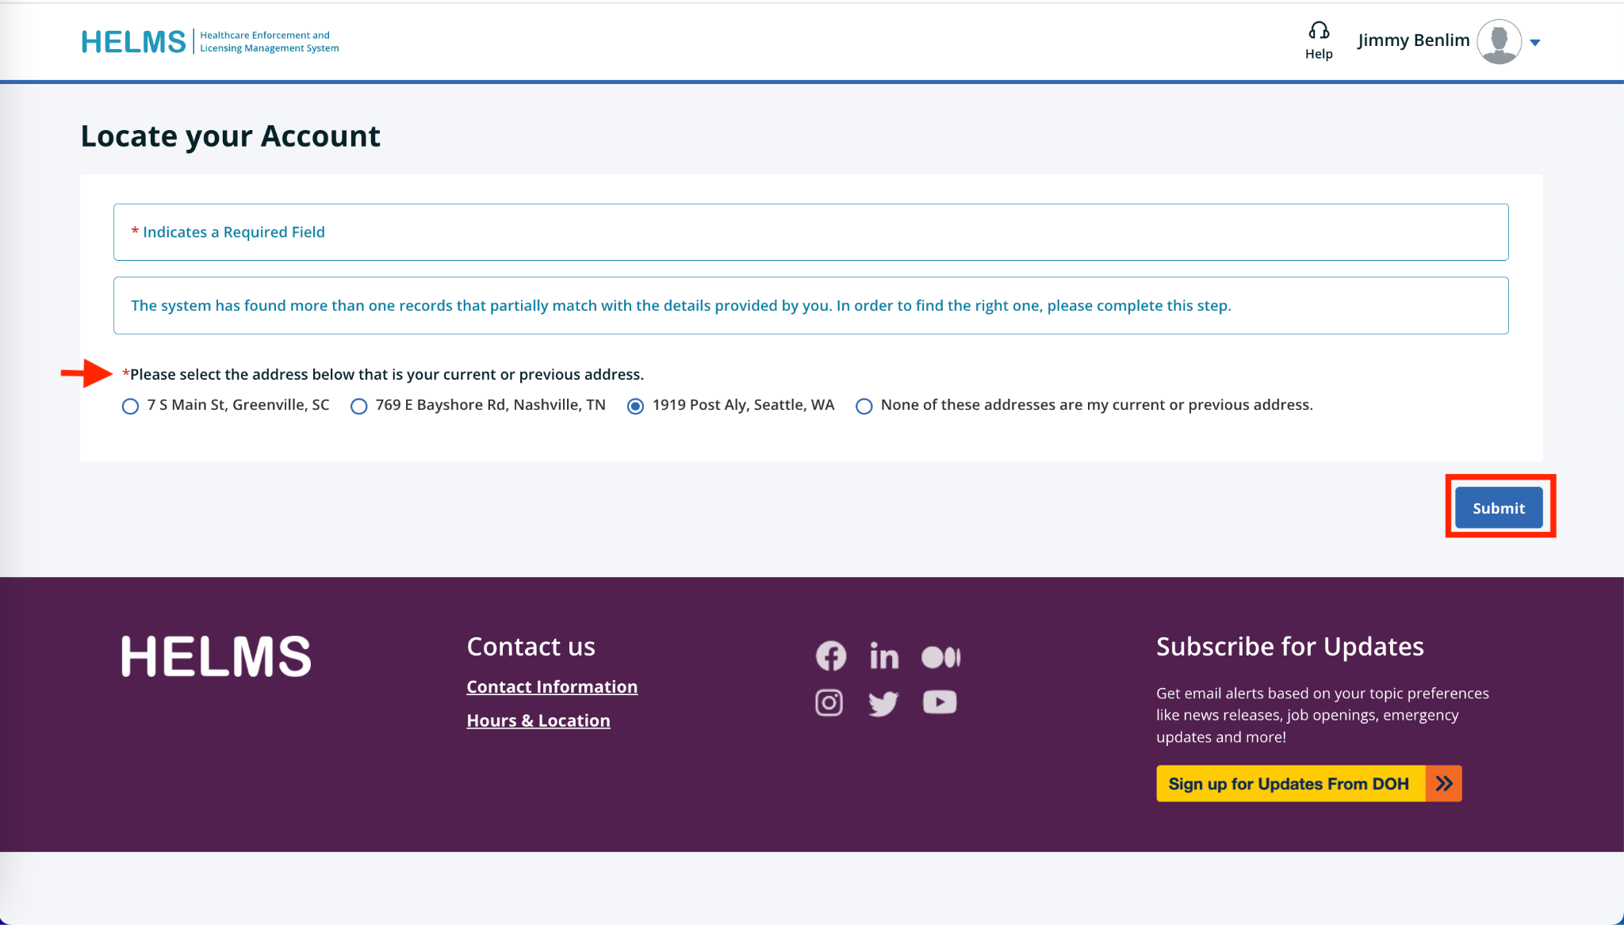

* If you select the correct address, you will be directed to your profile page.



* If you select the incorrect address, an error message displays on the page. Select **Yes/No** to the question “Do you currently hold, or have you ever held, a healthcare license or credential in Washington State?” and then click the **Submit** button.
* If you select **Yes**, you will be allowed to search again for your information in the system.
* If you select **No**, a new account will be created for you.

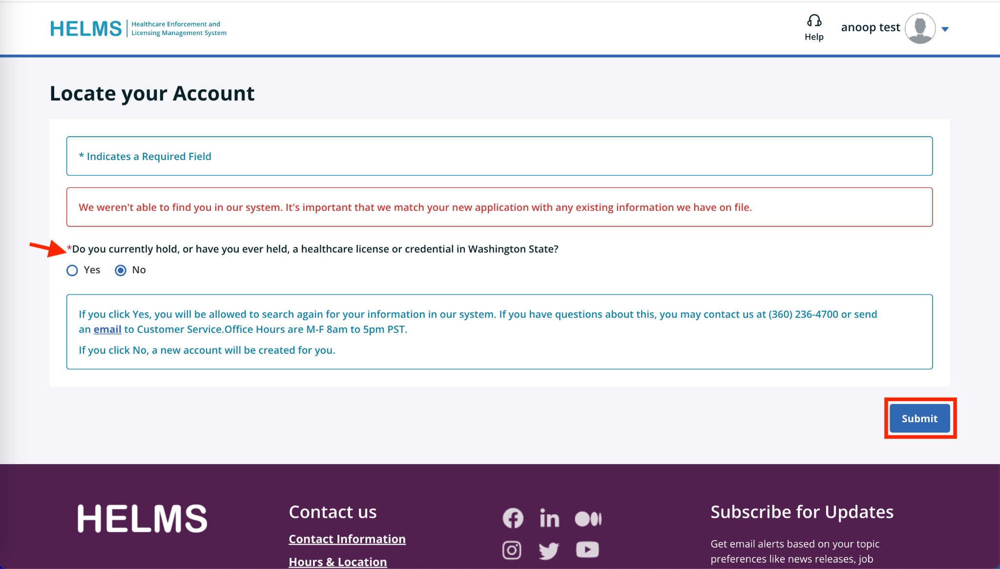

1. **No Match**: If the system cannot find your information, an error message displays on the page.

Select **Yes/No** to the question “Do you currently hold, or have you ever held a healthcare license or credential in Washington State?” and then click the **Submit** button.

* If you select **Yes**, you will be allowed to search again for your information in the system.
* If you select **No**, a new account will be created for you.



1. To create your new account, you will be directed to the **My Profile** page. Click the **Edit** button to fill in the information.

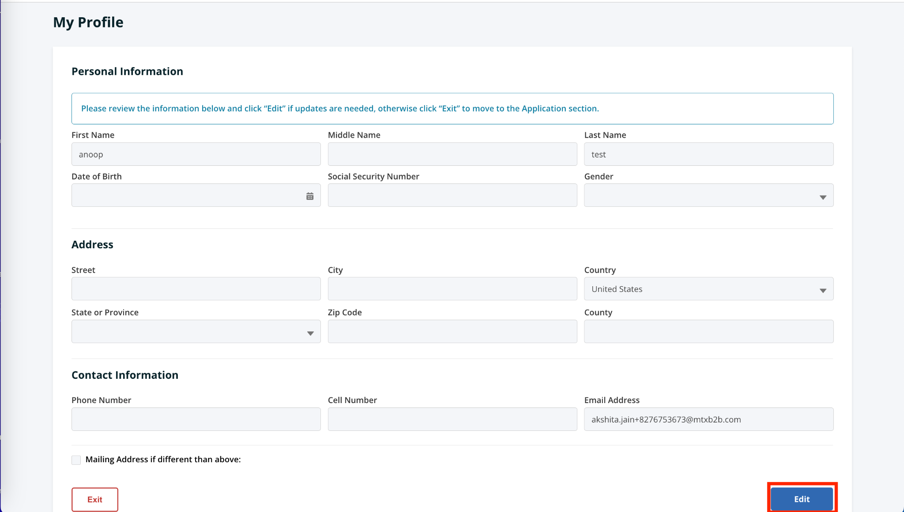

1. Enter all the required information in the **Personal Information** section.

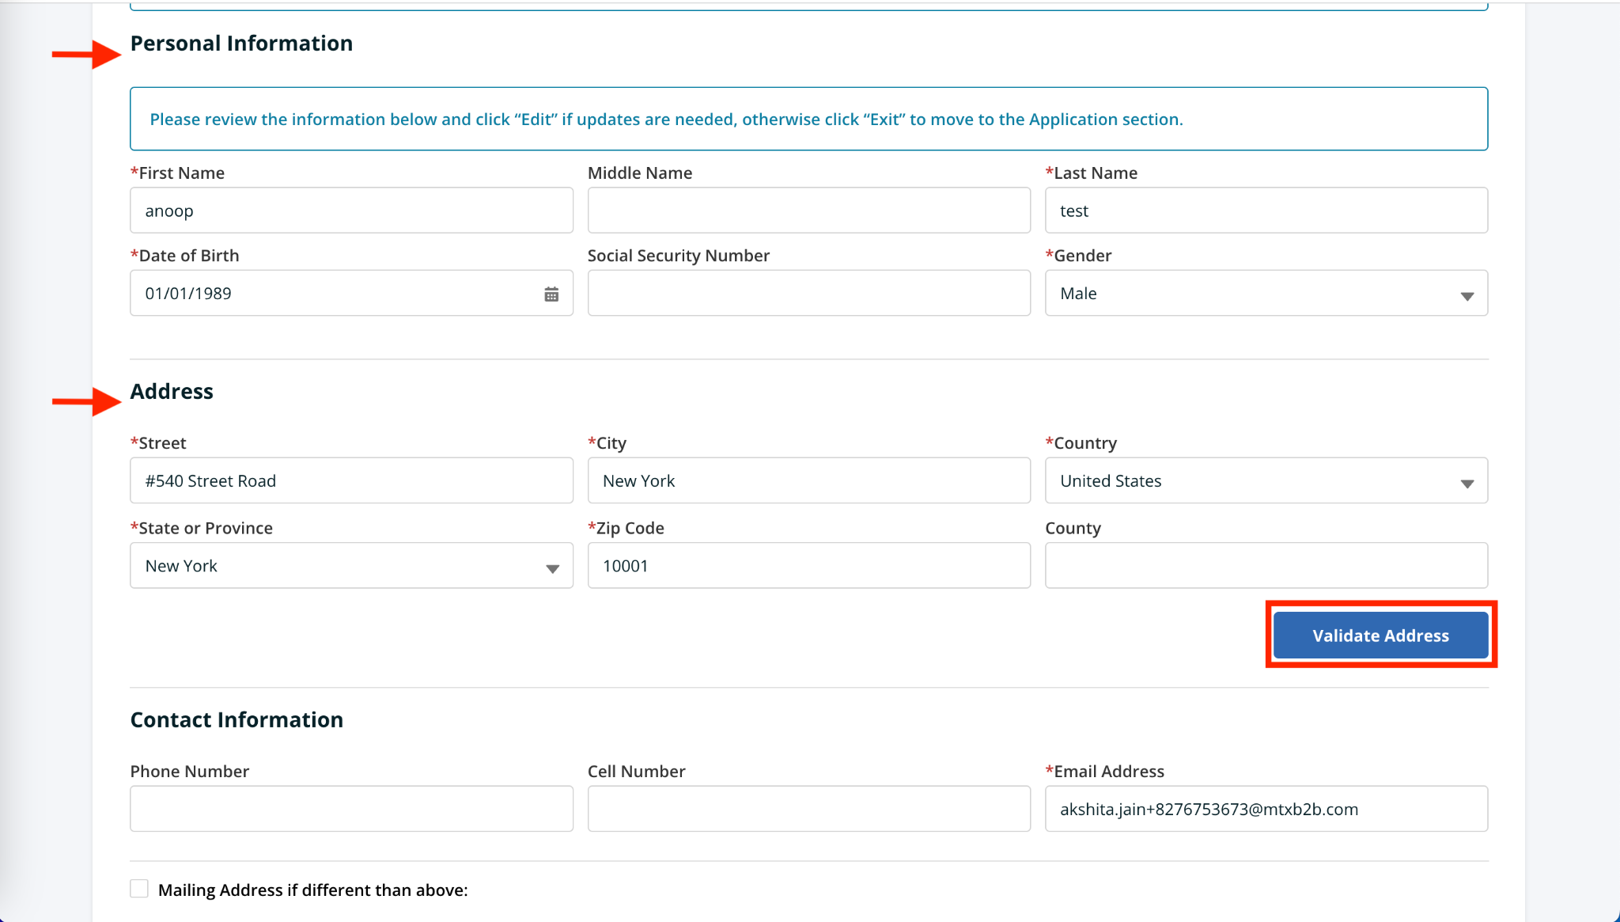

1. Enter all the required information in the **Address** section.  
   **Note**: After entering the address, the Validate Address button will be activated. Click the **Validate Address** button to confirm the address.



You can select the System Recommended Address or proceed with the Original Address and then click the **Submit** button.

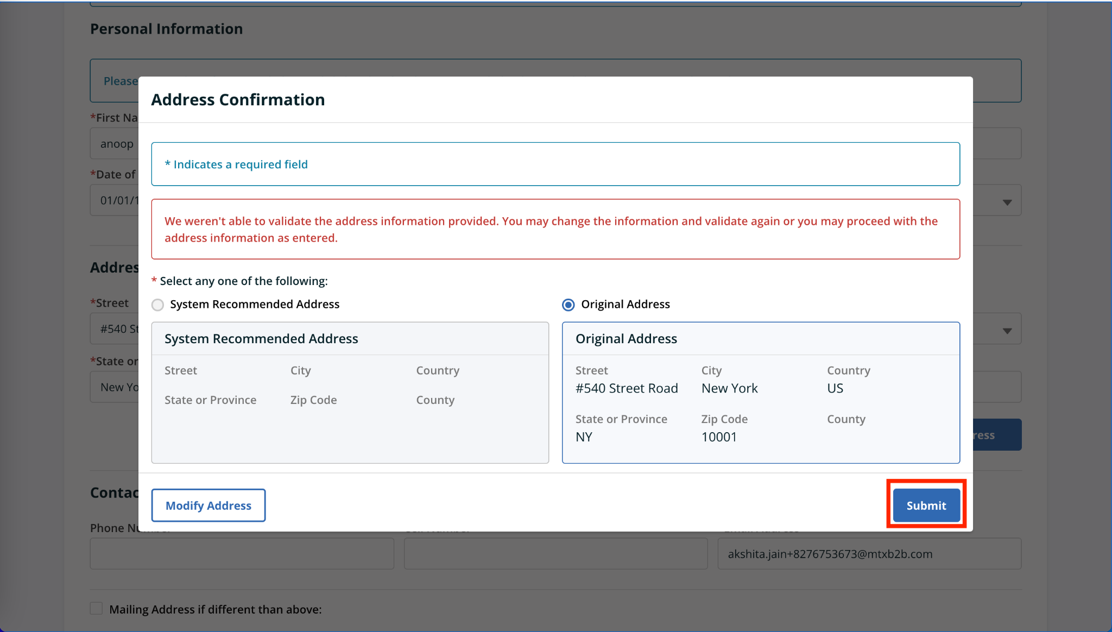

1. Click the **Save** button after entering all the required information.  
   **Note**: If you select Mailing Address if different than the above checkbox, you must enter the mailing address.

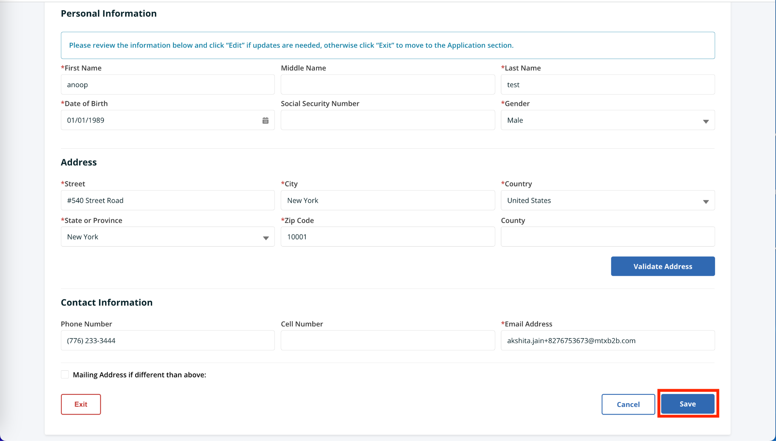

* The entered information will be saved. Scroll to the bottom, then Click the **Exit** button.

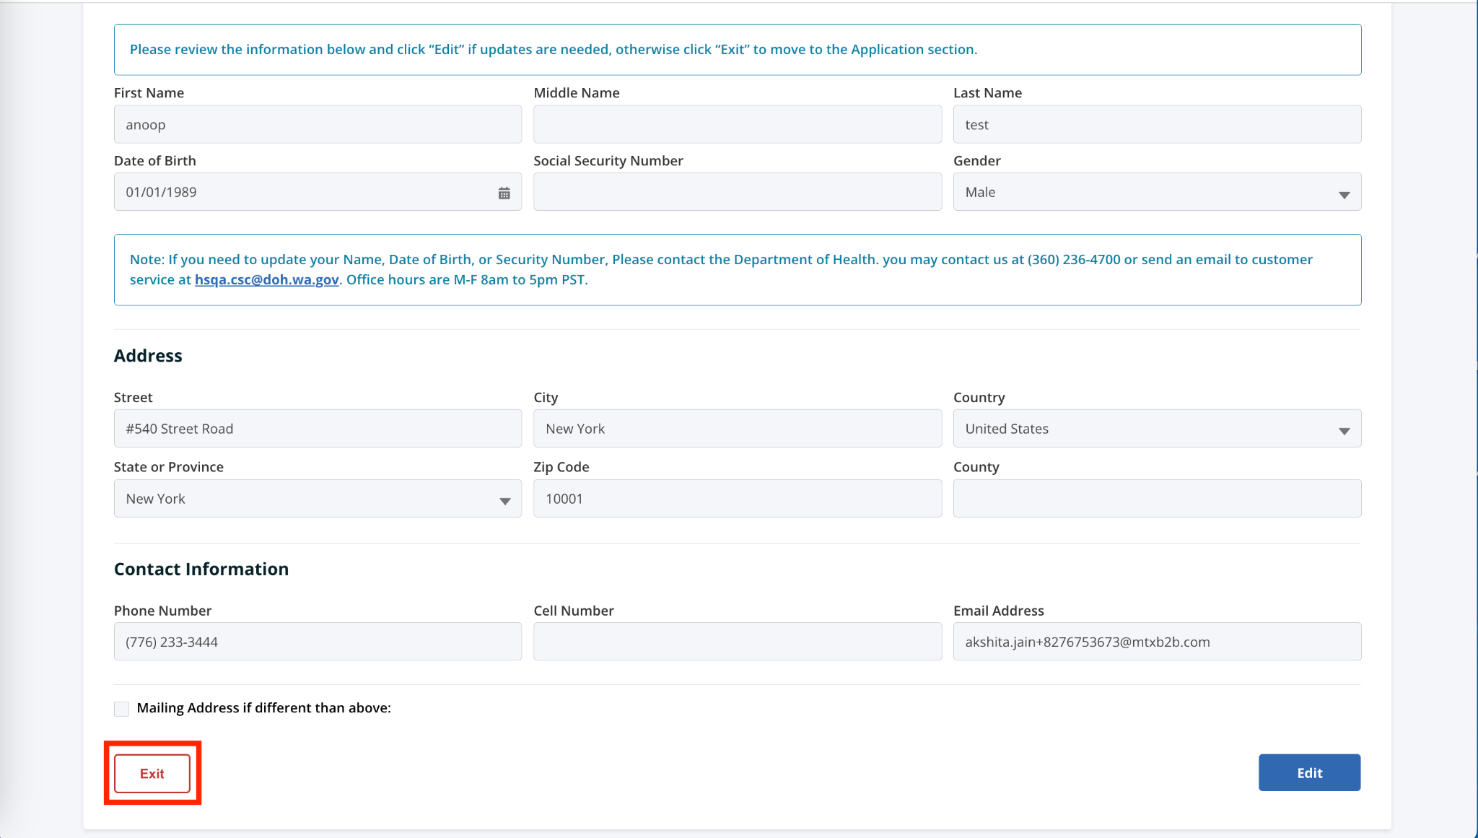

The account is created, and you will be directed to the **My Applications** page.

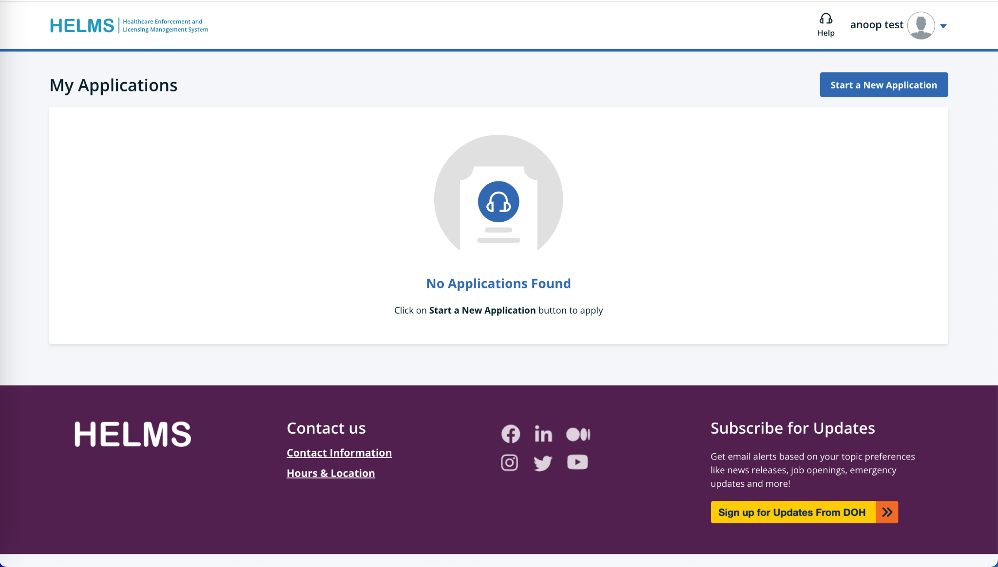

# Submitting Application

Login to the HELMS Public portal and follow the procedure outlined below to fill out and submit an online application.

## Submitting a New Application

1. Click the **Start a New Application** button on the **My Applications** page to initiate a new online application.

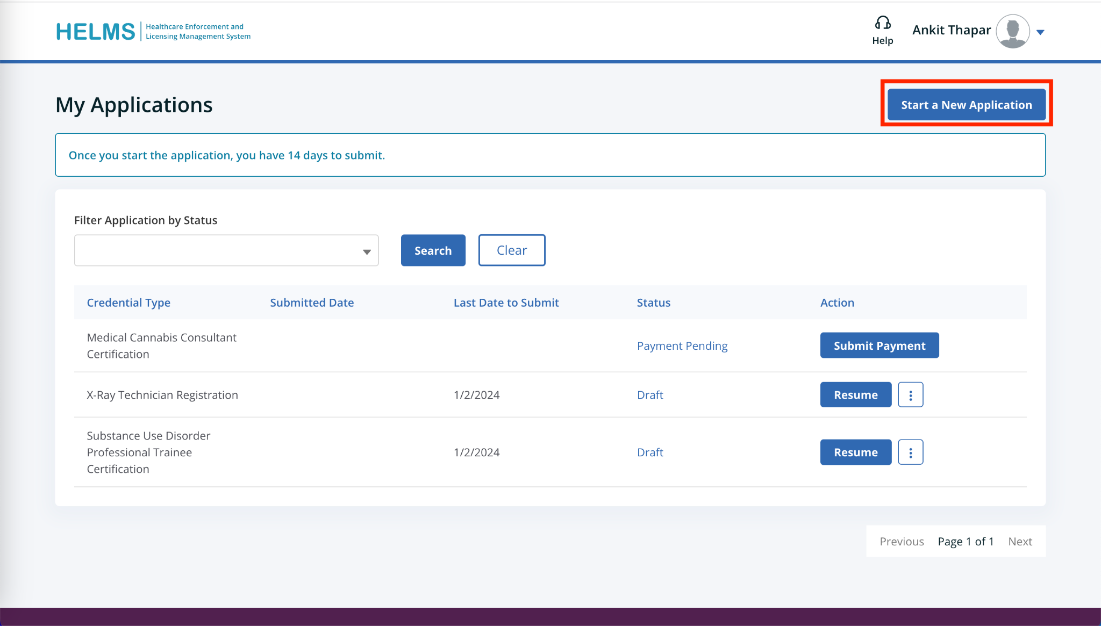

1. You will be directed to the Select License page.
2. You can search for the license using the **Search By Name** or the **Search From List** options.

**Search By Name**:

1. Click the alphabet to see the list of licenses starting with that alphabet. Select the **License** checkbox and then click the **Next** button to initiate the process.

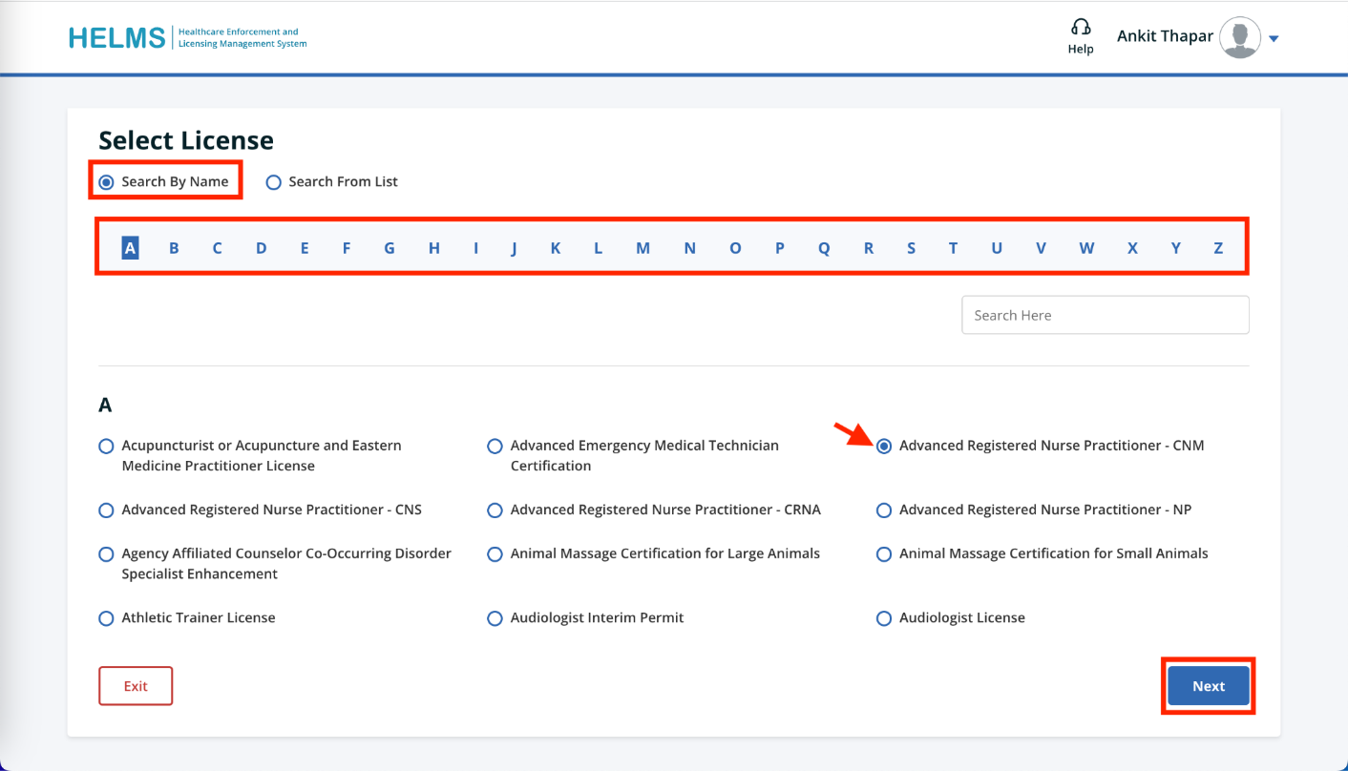

**Search From List**:

1. Select a Profession from the **Program Type** drop-down list. This displays the **Credential Type** field.
2. Select the appropriate **Credential Type** from the drop-down list. The list of Credential Names related to the selected Credential Type will be displayed.
3. Select the required **Credential Name** checkbox and click the **Next** button.

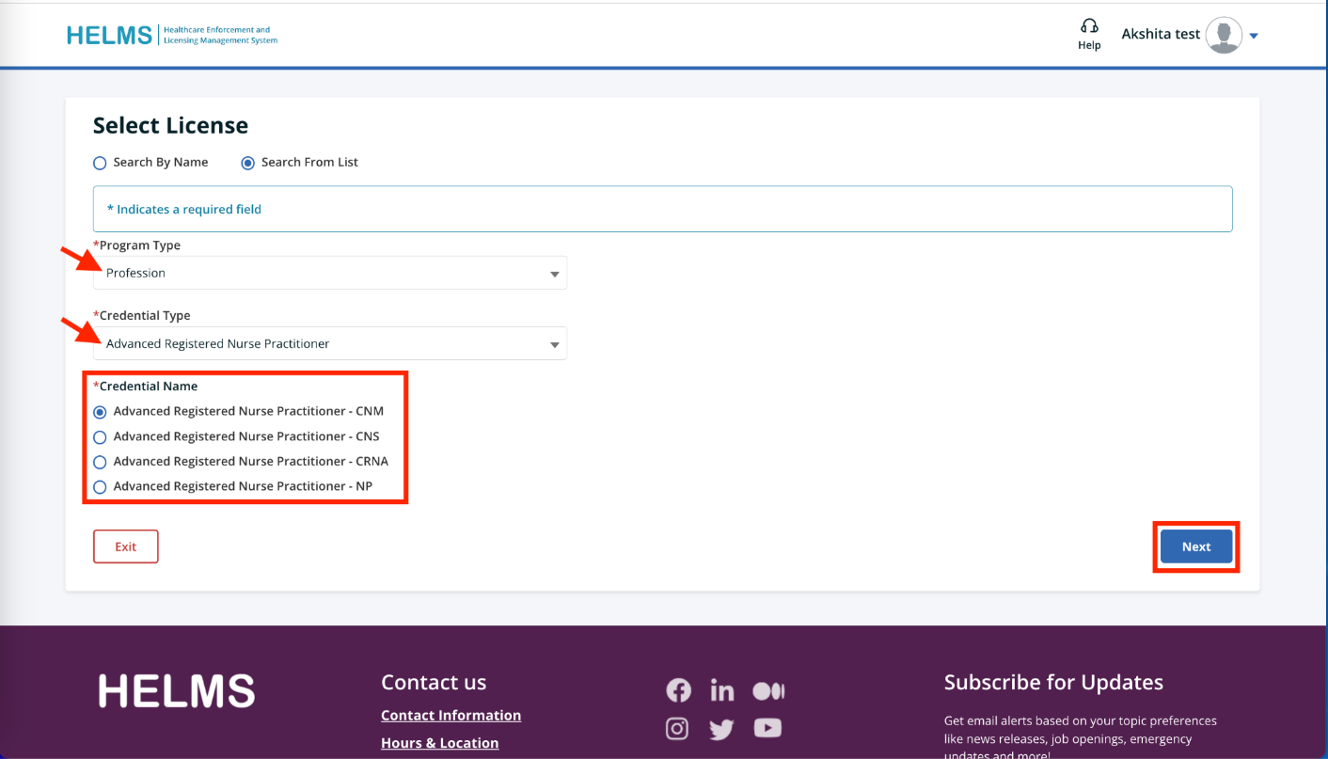

# Additional Questions

Contact us here:

* [Health Systems Quality Assurance customer service](https://doh.wa.gov/about-us/programs-and-services/health-systems-quality-assurance/health-systems-quality-assurance-contact-us)
  + Call 360-236-4700
  + Email [HSQA.CSC@doh.wa.gov](mailto:HSQA.CSC@doh.wa.gov)
* [Chiropractor, chiropractic X-ray related credentials](●%09https:/doh.wa.gov/licenses-permits-and-certificates/professions-new-renew-or-update/chiropractor-chiropractic-x-ray-technician/contact-us)
  + Call 360-236-2822
  + Email [CQAC@doh.wa.gov](Mailto:cqac@doh.wa.gov)
* [Physician and physician assistant related credentials](https://wmc.wa.gov/contact-us)
  + Call 360-236-2706
  + Email [Medical.complaints@wmc.wa.gov](mailto:medical.complaints@wmc.wa.gov)
* [ARNP, RN, LPN, nursing tech, nursing education programs](https://nursing.wa.gov/contact)
  + Call 360-236-4703
  + Email [Nursing@doh.wa.gov](mailto:Nursing@doh.wa.gov)

Or check out our [website](https://doh.wa.gov/about-us/contact-us) for more information.