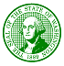

STATE OF WASHINGTON
DEPARTMENT OF HEALTH
Olympia, Washington 98504

Dear Nursing Home Administrator,

On behalf of the board I would like to thank you for your leadership and dedication to our seniors during the COVID-19 pandemic. In this unprecedented time, leadership in our senior communities takes on a new level of importance to successfully navigate this pandemic and keep residents and staff safe, engaged and supported.
In light of the COVID pandemic the board felt it was important to support our NHA’s with an emergency measure around continuing education requirements of the NHA license. Therefore, an emergency measure was passed to expand the type of continuing education that can be counted to the 36 hours required every two years and how many hours may be counted on one particular topic. Please refer to Rule Making Order WSR 20-21-035, included with this letter, for the specific language.
In summary, you can count COVID-19 (or other pandemic) related education activities for your ongoing education up to all 36 hours required. This is intentionally broad, and some examples include: COVID-19 education webinars, pandemic policy development and research, association COVID educational calls, DOH educational calls on COVID, self-study on COVID and COVID related topics. This is certainly not an exhaustive list but may provide a reference to get started.
If the study does not offer an attendance certificate or proof of attendance you should use the attached attestation to record your study and maintain the document in your files for future proof of study completed.
If you have questions about topics of study or how to complete the attached form, please contact Kendra Pitzler at (360) 236-4723.

Thank you,
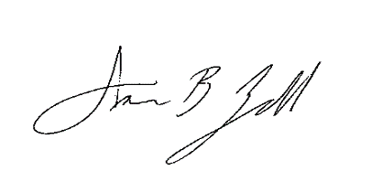
Annie Zell, HSE, NHA, CALA
WA Board of Nursing Home Administrators Chair

