Documenting Depression Screenings, Referrals, and Follow Up in FLO

Depression Screening:
What are we measuring?

HVSA Aligned Measure: Percent of primary caregivers enrolled in home visiting who are screened for depression using a validated tool within 3 months of delivery if enrolled pregnant or 3 months of enrollment if enrolled postnatally.
Instructions:
Complete a depression screening for primary caregivers using the PHQ-9 form within 3 months of delivery if enrolled pregnant or 3 months of enrollment if enrolled postnatally.

Which form should I use to document Depression Screenings?
- Use the PHQ-9 Form for Depression Screening.
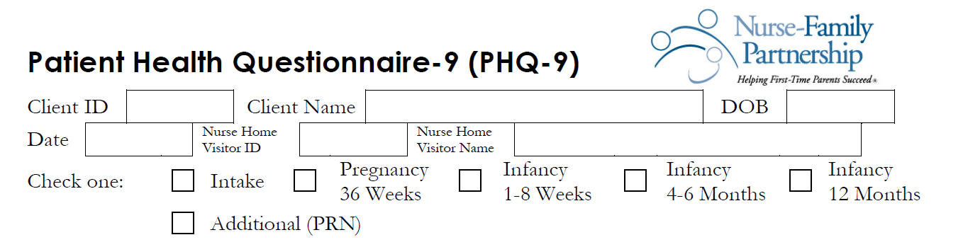
- Remember to enter the date this assessment was done.
- Screening within 3 months of delivery may correspond to a 1-8 weeks Infancy Visit.
- If enrolled postnatally (e.g., due to a transfer from another state), PHQ-9 should be conducted within 3 months of enrollment and documented here.

- Fill out the responses for the 9 questions in the PHQ-9 Form and calculate the total score.
  - For HVSA, a total score of 10 or greater (moderate to severe depression) is determined to be a positive screen requiring mental health interventions or referral.
  - Any suicidal ideation (1-3 scores for Question 9), regardless of any total score, is also a positive screen.

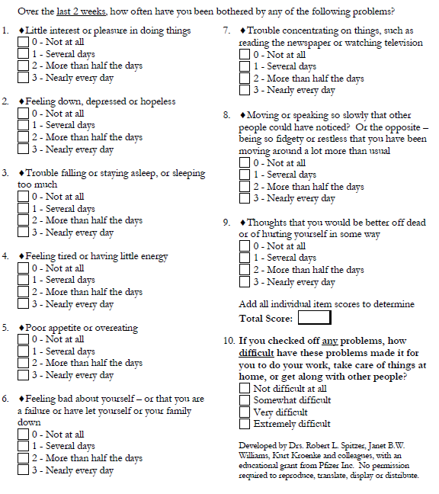
- Enter the information on the Form into FLO.

Completed Depression Referrals:
What are we measuring?
MIECHV Performance Measure 17: Percent of primary caregivers referred to services for a positive screen for depression who receive one or more service contacts.

Instructions: If the total PHQ-9 score is 10 or higher or the caregiver answered something other than “not at all” to question 9, the depression screening is positive and a referral is needed. The referral is considered complete when the caregiver receives one or more service contacts as indicated by a documented follow up.

Which forms should I use to document Depression Referral and Completion?
- Use the Referrals to Services Form to document a referral made.
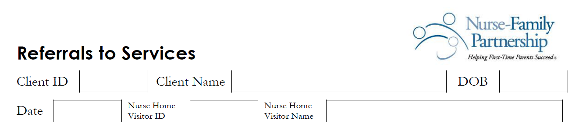
✓
- Remember to enter the date a referral was made.
- Date of the referral needs to be on or after the date of positive screen.
- Check #9. Mental health treatment or therapy for referred.
- If a nurse home visitor provided the mental health intervention, this form still needs to be filled out per NSO guidance.

- Use the Use of Government & Community Services Form to document referral completion.
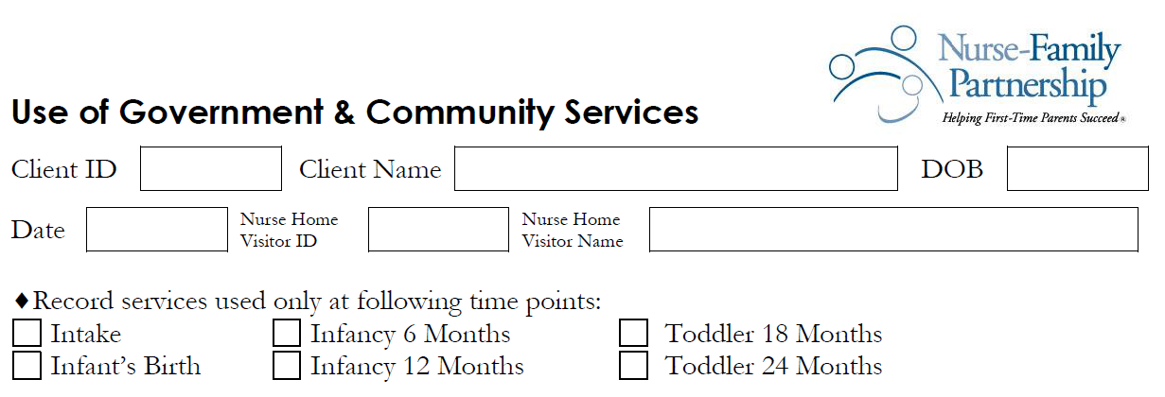
✓
- Remember to enter the date this form was filled out.
- Date of referral completion needs to be on or after the date of a positive screening, and on or after the date of referral made.
- If the nurse home visitor provides the mental health intervention or a client receives outside counseling or therapy, nurse home visitor needs to appropriately document in the Use of Government & Community Services Form.

- Enter the information on the Form into FLO.

