Documenting Depression Screenings, Referrals, and Follow Up in Visit Tracker

Depression Screening:
What are we measuring?

HVSA Aligned Measure 2: Percent of primary caregivers enrolled in home visiting who are screened for depression using a validated tool within 3 months of delivery if enrolled pregnant or 3 months of enrollment if enrolled postnatally.
Instructions:
Complete a depression screening for primary caregivers using the PHQ-9 form within 3 months of delivery if enrolled pregnant or 3 months of enrollment if enrolled postnatally.
How do I enter a depression screening into Visit Tracker?
Step 1: Log into Visit Tracker and click on the “Guardians” link in the horizontal menu at the top of the page.
Step 2: Choose the guardian that was screened from the drop-down menu on the Guardian Data page.
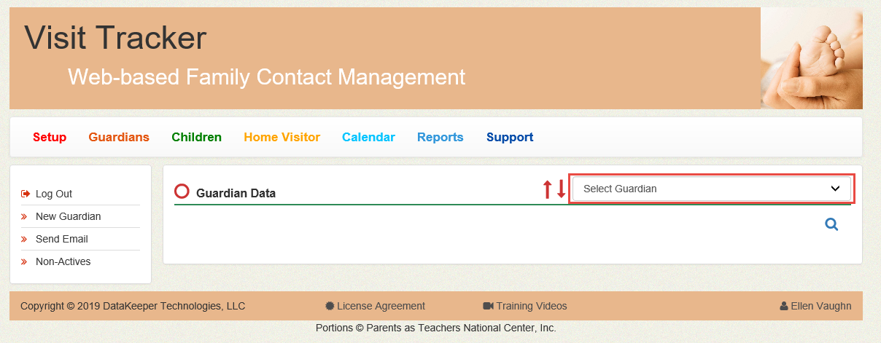
Step 3: Click on the “Assessments” link in the menu on the left side of the screen.
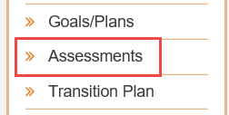
Step 4: From the Assessment page, click on the “+” button in the orange Assessments bar. A drop down menu will appear.
Step 5: Choose PHQ-9 from the drop down menu. (If you don’t see the PHQ-9 option, contact your program’s Visit Tracker administrator to update the Assessments settings in the Setup section.)
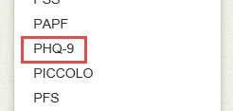
Step 6: Fill out the PHQ-9 form with the guardian’s responses. Make sure to enter the date that the screening was completed, not the data entry date. Click create.
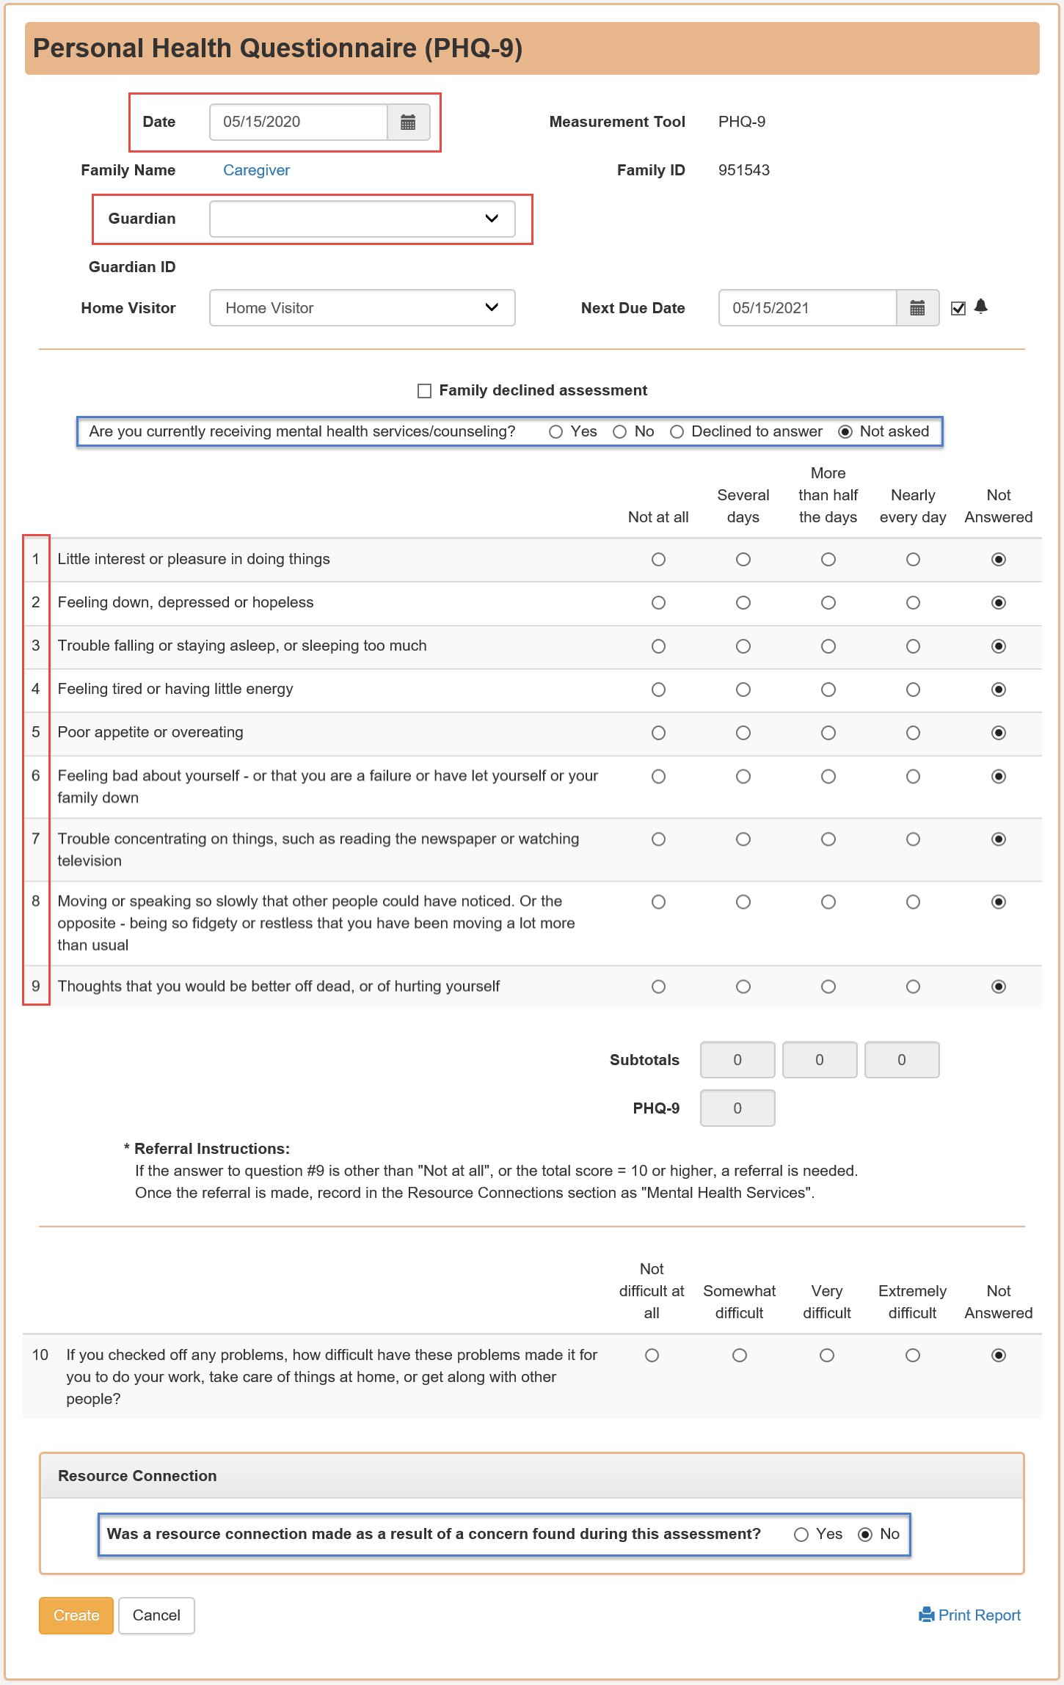

Completed Depression Referrals:
What are we measuring?
MIECHV Performance Measure 17: Percent of primary caregivers referred to services for a positive screen for depression who receive one or more service contacts.

Instructions: If the total PHQ-9 score is 10 or higher or the caregiver answered something other than “not at all” to question 9, the depression screening is positive and a referral is needed. The referral is considered complete when the caregiver receives one or more service contacts as indicated by a documented follow up.

How do I document a depression referral in Visit Tracker?
There are three routes to documenting a depression referral in Visit Tracker.
Option 1 is to enter a resource connection straight from the PHQ-9 form by clicking “Yes” after the question “Was a resource connection made as a result of a concern found during this assessment?”
Option 2 is to enter a resource connection while completing a Personal Visit Record (PVR).
Option 2 – Step 1: Choose the guardian from the drop-down menu on the Guardian Data page.
Option 2 – Step 2: Click on the “Contact” link in the menu on the left side of the screen.
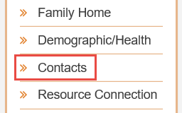
Option 2 – Step 3: Within the list of Contacts, click on “Private” next to the visit date when the screening occurred. This will open the PVR form.
Option 2 – Step 4: Find the Resource Connections section of the PVR, and click on the “+Add” button.
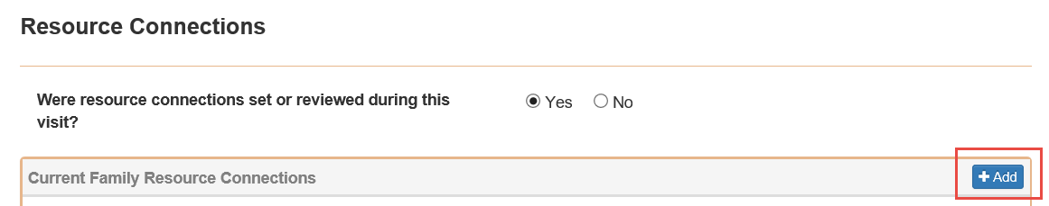

Option 3 is to enter a referral from the Resource Connections page.
Option 3 – Step 1: Choose the guardian from the drop-down menu on the Guardian Data page.
Option 3 – Step 2: Click on the “Resource Connection” in the menu on the left side of the screen.
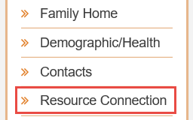
Option 3 – Step 3: Click the “+” button in the orange Resource Connection bar.
Each of these routes will take you to the Resource Connection form:
- Complete the Resource Connection form. Be sure to enter the date the referral was made (not the date the form is being completed), and choose “Mental Health Services” as the Connection Type.
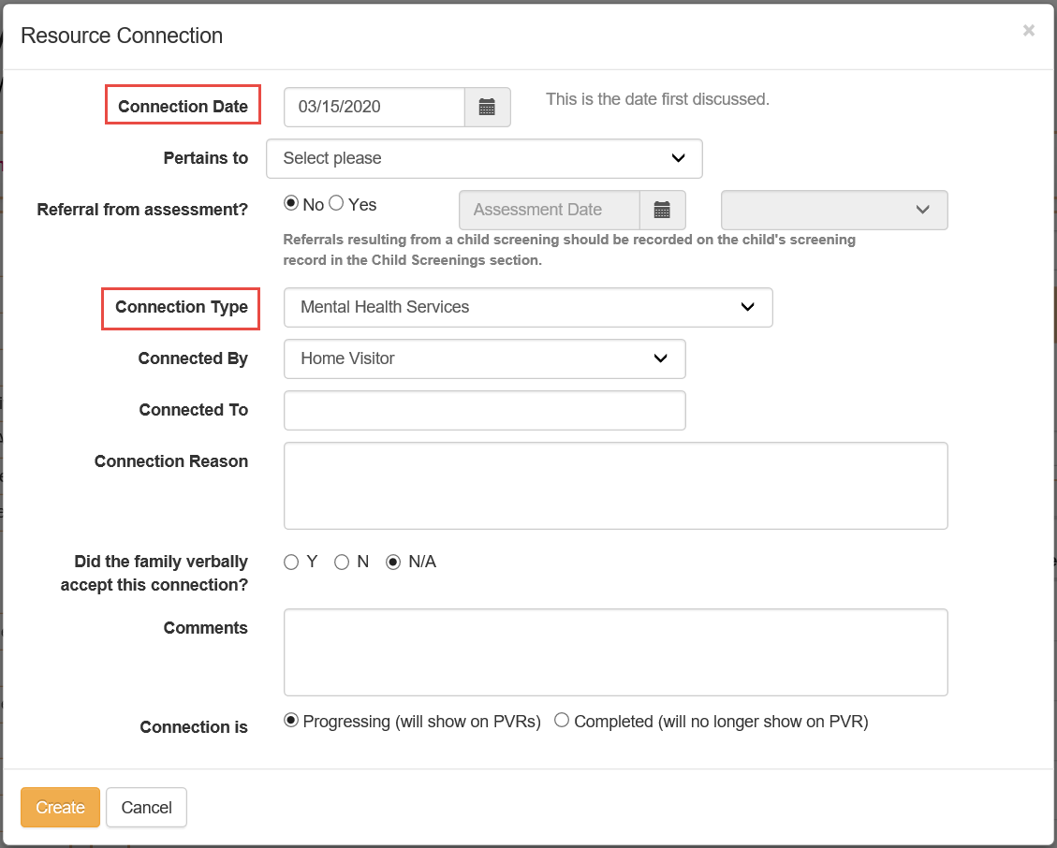
How do I document a completed referral in Visit Tracker?
- Choose the guardian from the drop-down menu on the Guardian Data page.
- Navigate to the Resource Connections page via the menu on the left side of the screen.
- Find the existing referral in the Family Resource Connections table and click the pencil icon to open the Resource Connection form.
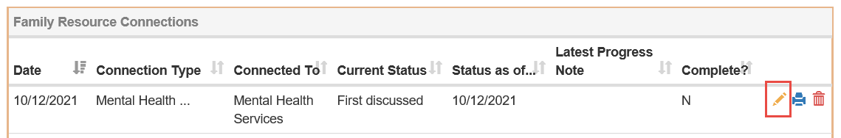
- In the “Resource Connection – Status History” section at the bottom of the form, click “+Add new status.”
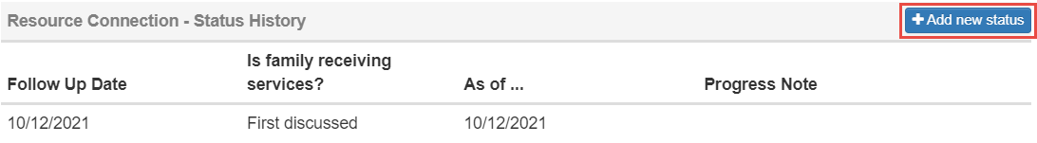
- Enter the date you followed up with the caregiver, and choose “Yes, received services” from the “Status – receiving services?” drop down menu.
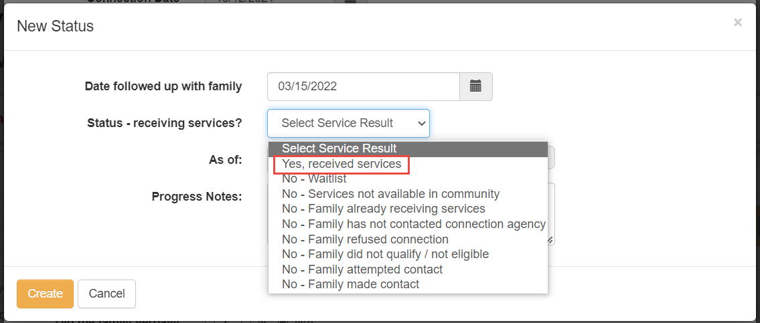

- Enter the date the caregiver received services and click “Create.”
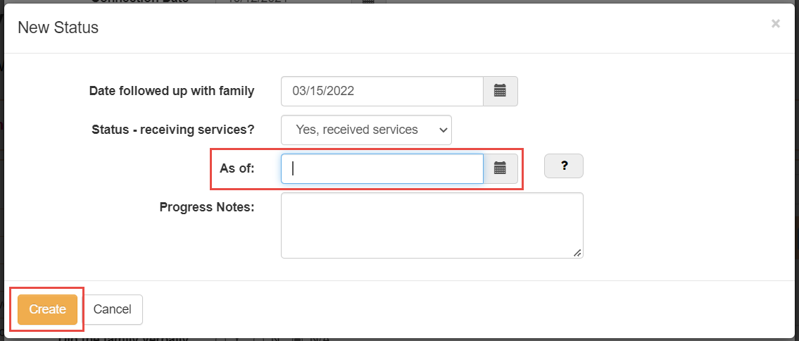

How do I document that a caregiver is already receiving mental health services in Visit Tracker?
There are 2 options for documenting that a caregiver is already receiving services.
Option 1 is to enter this information directly on the PHQ-9 form.
- Choose “Yes” after the question “Are you currently receiving mental health services/counseling. An additional field will appear asking for the “as of” month. Enter the month when you asked the caregiver if they were already receiving services.


Option 2 is to “Add a new status” to the Resource Connection via the Resource Connections page.
- Choose the guardian from the drop-down menu on the Guardian Data page.
- Navigate to the Resource Connections page via the menu on the left side of the screen.

- Find the existing referral in the Family Resource Connections table and click the pencil icon to open the Resource Connection form.
- In the “Resource Connection – Status History” section at the bottom of the form, click “+Add new status.”
- Enter the date you followed up with the caregiver, and choose “No – Family already receiving services” from the “Status – receiving services?” drop down menu.
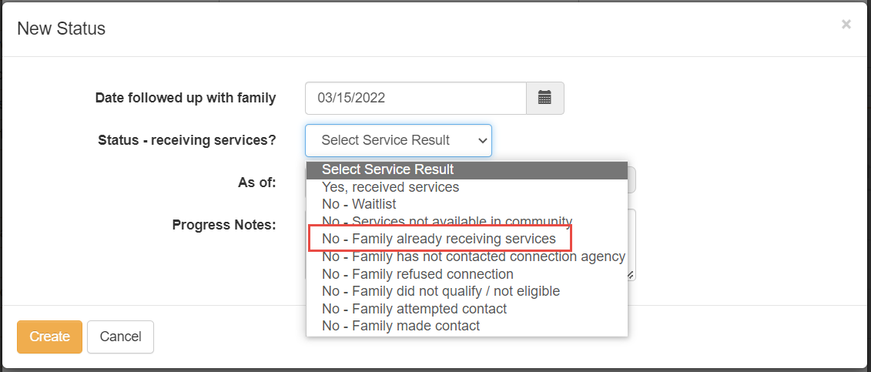
- Enter the date the caregiver told you they were already receiving services (likely the same date you followed up with the family), and click “Create.”
