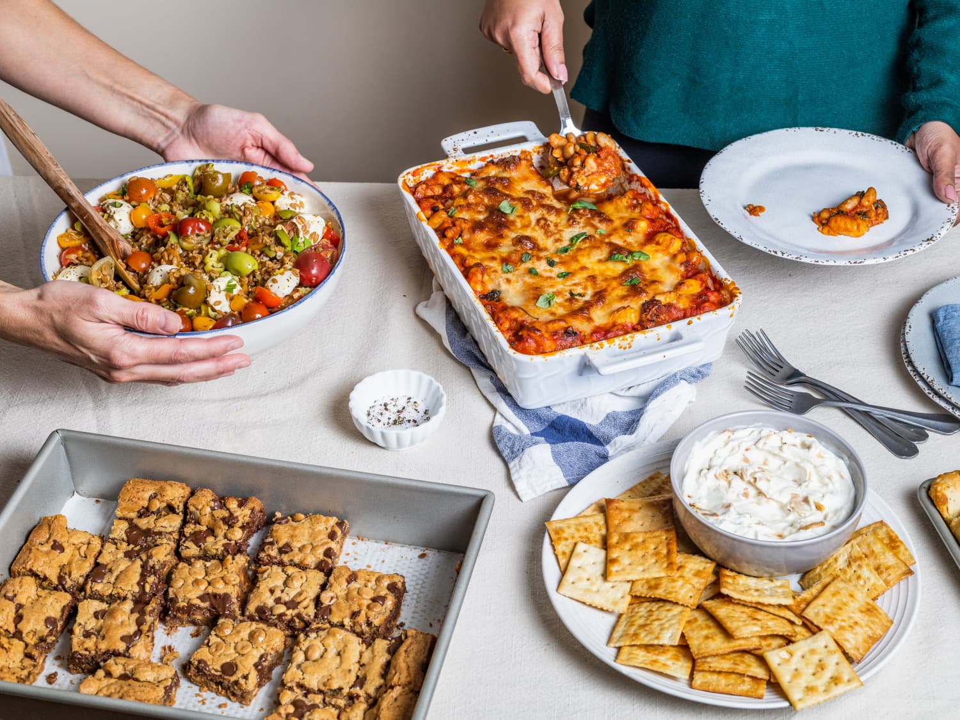
Join Us!
Celebrate Deer Park Night
What: A celebration of our Deer Park community, favorite foods, fitness, care for the earth and our love of reading.
When: Thursday, April 23 - 5pm to 6:30
Where: Deer Park Cafeteria, Gym, Lobby, Library

The evening will include:
Shopping at the school book fair!
*Read-Alouds
*Make your own bookmark
*Centreville Regional Library
*Meet Asha Jyothi
*Food tastings from Deer Park Families
*Family Fitness & Healthy Living Night
*DP Green Team Exhibits
*Performances by community groups

If you have any questions, please contact Nicole Wheeler, nmwheeler1@fcps.edu or Erin Stamp emstamp@fcps.edu
***************************************************************************

If you can donate your family’s favorite finger food/dessert please sign up using the link below. You can drop food off in the office on April 23, 2026 any time or bring it when you come in the evening.
https://www.signupgenius.com/go/10C0448A8AA28AAF4C43-62812765-family

