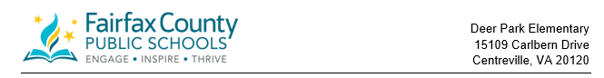

Community Preschool Peer Project
Deer Park is pleased to announce that we will have community peers in our preschool program. The early childhood special education staff members have been investigating the possible opportunities for our students to participate in integration activities with typically developing peers. This will involve teaching preschoolers with delays and without delays in the same classroom. It can provide young children with a more stimulating environment, teach coping skills in a variety of situations, and provide the opportunity to practice appropriate social skills.
Our program will invite 10 community preschoolers (4 morning Class-based Special Education, 4 morning Preschool Autism Class, 2 afternoon Class-based Special education), who are aged 3 ½ -5 years, to participate in our daily preschool activities. The children from the community will have the opportunity to make new friends and share experiences with current early childhood special education students. Our students will, in turn, benefit from being with community peers who can model appropriate language, motor, and social skills.
All children learn through their play. Intellectual growth occurs in a social context, influenced strongly by the quality of social interactions. The goal of this program is to encourage active learning and promote social interaction and acceptance through shared experiences between the community children and our preschoolers with special needs. Feel free to contact me for further explanation of our program. Your thoughts and suggestions are welcome, as we are all partners in this effort.
The Deer Park Preschool Team will host an informational playdate on June 5th, from 9:00-10:00. Parents will be notified by June 14th if space is available for their student. If a student is enrolled as a community peer they will need to complete a registration packet with the school registrar. If you are interested in this program, please ask the office for a peer model interest form.
Sincerely,

Bob D’Amato
Principal, Deer Park Elementary School

