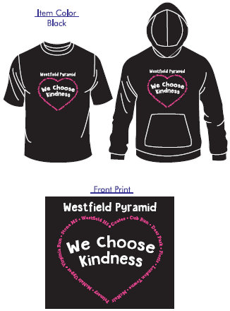

**Westfield Pyramid Kindness T-Shirts**

Westfield Pyramid Schools are committed to promoting kindness,

empathy, and inclusion. Schools will celebrate Kindness Week in February and we invite **all** students and staff in the Westfield Pyramid to wear their “We Choose Kindness” shirts signifying a personal commitment to choosing kindness. We are offering short-sleeve shirts and hooded sweatshirts in black with white and pink ink. Why pink?

The color is based on an anti-bullying campaign started by Travis Price and David Shepherd, who took a stand for a fellow student who was bullied for wearing a pink shirt to school.

Order forms are due by **January 15th** and items will be delivered to your child’s classroom by February 7. If you would like to purchase, please complete the form below or order online (QR Code above) and return to Jenna DeKeuster (School Counselor) with **checks made out to Virginia Run PTA. *We will not be accepting any payment after January 15th.***

Student Name(s) ___________________________________________________________

Student Teacher(s): _________________________________________________________

|  |  |  |  |  |  |  |  |  |  |  |  |
| --- | --- | --- | --- | --- | --- | --- | --- | --- | --- | --- | --- |
| **Size/Type** | **# Youth Small** | **# Youth Medium** | **# Youth Large** | **# Adult Small** | **# Adult Medium** | **# Adult Large** | **# Adult**  **XL** | **# Adult**  **XXL**  **(Add**  **$2/shirt)** | **# Adult XXXL**  **(Add**  **$4/shirt)** | **Cost per shirt** | **Total $** |
| **Short Sleeve**  **T-shirt** |  |  |  |  |  |  |  |  |  | **$15** |  |
| **Hooded Sweatshirt** |  |  |  |  |  |  |  |  |  | **$25** |  |

**Total # of items ordered on this form: _____________ Total $:_____________ CASH CHECK (Circle One)**