VRES BINGO NIGHT

*Sponsored by the Virginia Run PTA*

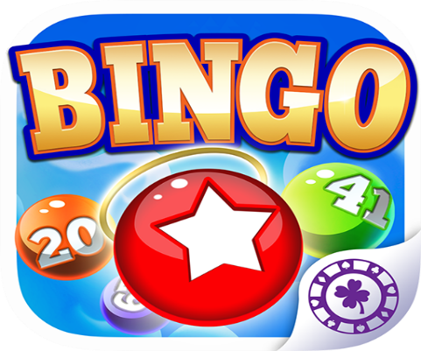

**TOP THREE REASONS TO ATTEND VRES BINGO NIGHT**

1. The opportunity to spend quality time with family.
2. It’s a great way to meet new people and get to know your child’s classmates.
3. The opportunity for the kids to win fun prizes and shout, “BINGO”!

**Where:** Virginia Run Cafeteria

**When:** Thursday, November 14, 2024

* Snacks, candy and drink sales in support of the Sixth Grade Celebration begin at 6:00 p.m.
* Bingo starts at 6:30 p.m.

**Registration Options:**

* Complete form below and send in with payment in an envelope marked PTA Bingo Night.
* Checks made payable to “Virginia Run PTA”
* Just show up and pay at the door. We accept Zelle, Paypal, and Venmo. There will be a QR code set up to scan for your convenience.

*\*Advanced registration helps us to better plan, but is not required.*

**Every student must be accompanied by an adult.**

**Questions?** Contact Cara Priester at vresvpsocial@gmail.com or Donna-Rose Dingee at [donnarose1215@yahoo.com](mailto:donnarose1215@yahoo.com)

BINGO Registration Form

* **Option 1:** Individual booklets (gets you 10 game boards – one for each round)

Number of booklets ________ x $3.00

* **Option 2:** Family Pack – 4 game booklets for $10

|  |  |
| --- | --- |
| **Student(s) Attending** | **Teacher’s Name** |
|  |  |
|  |  |
|  |  |
|  |  |

**Total Amount Enclosed**  __________

|  |  |  |
| --- | --- | --- |
| Parent Name: | Phone #: | Email: |