**Reflections Art Competition**

For over 50 years, National PTA’s Reflections program has helped students explore their own thoughts, feelings and ideas, develop artistic literacy, increase confidence and find a love for learning that will help them become more successful in school and in life.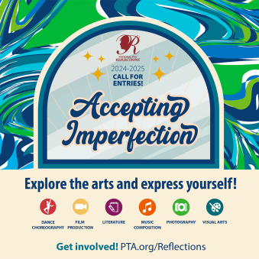

**The Theme 2024-2025 is:**  ***"Accepting Imperfection"***.

Students in Pre-K through grade 6 are invited to create theme-based artwork in the categories of dance choreography, film production, literature, musical composition, photography or visual arts*.* And participate in the appropriate division for their grade: Primary (Pre-K – Grade 2), Intermediate (Grades 3-5), Middle School (Grades 6-8).

**HOW TO ENTER.** Entrants must submit their artwork and [student entry form](https://drive.google.com/file/d/1LqO_HTwpZZ6TMRMvfjZJ8beeKPdUZAP5/view?usp=sharing) to Willow Springs PTA Reflections Program lead Yanshun Sui at [yanshun.s@gmail.com](mailto:yanshun.s@gmail.com) by Nov 15, 2024. Entrants must follow requirements and instructions specific to each arts category and division

**Reflections categories and contest entry rules**

Students may submit art work for any of the following categories in the stated file format.

* **Dance Choreography**: Solo and ensemble works of all dance styles are accepted. Entrant must be the choreographer and may also be the performer or one of the performers. If background music is used, cite it on the entry form. Video file must not exceed 5 minutes in length and 1 GB in size. Acceptable formats: AVI, FLV, WMV, MOV, and MP4.
* **Film Production**: Accepted short film styles include: Animation, narrative, documentary, experimental or media presentation. Use of PowerPoint is prohibited. Entrant must be screenwriter, cinematographer, editor and producer. If background music is used, cite it on the entry form. Video file must not exceed 5 minutes in length and 1 GB in size. Acceptable formats: AVI, FLV, WMV, MOV, and MP4.
* **Literature**: Accepted forms of fiction and non-fiction include: Prose, poetry, reflective essay, screenplay and play script, narrative and short story. Entrant may write in their primary language as long as an interpretative English translation is also attached. Use of copyrighted material is prohibited. Writing must not exceed 2,000 words and may be handwritten or typed. Acceptable formats: Single-sided print on 8 1/2″ x 11″ paper or PDF.
* **Music Composition**: All music styles and combination of instrumentation are accepted. Entrant must be the composer and may also be the performer or one of the performers. Use of copyrighted material is prohibited. Audio file must not exceed 5 minutes in length and 1 GB in size. Acceptable formats: Acceptable formats: MP3, WMA, WAV, ACC, FLAC. Notation (score/tablature) in PDF format is only required for middle and high school divisions
* **Photography**: Photo must be a single print or digital image. Collages and collections of photos are not accepted. Entrant must be the photographer and may use a variety of digital editing techniques including, but not limited to, multiple exposure, negative sandwich and photogram. Use of copyrighted material is prohibited. Print image dimensions must be no smaller than 3″ x 5″ and no larger than 8″ x 10″. Acceptable print formats: Mounted on mat or poster board no larger than 11″ x 14″.
* **Visual Arts**: Works of both fine and design arts are accepted, including, but not limited to: architectural drawing and models, ceramics, collage, computer generated images and graphics, crafts, drawing, fashion clothes and jewelry, fiber work, mixed media, painting, printmaking and sculpture. Use of copyrighted materials is prohibited. 2D artworks must be mounted on sturdy material and no larger than 24″ x 30″ with matting. Framed entries are not accepted. Include one digital image of artwork with your submission. 3D artwork submissions must contain 3 digital images of artwork at different angles. Image(s) are used for artwork identification, judging and exhibition purposes.

If interested or have questions, please contact Reflections team at yanshun.s@gmail.com.