**Impact Aid ParentVUE Access**

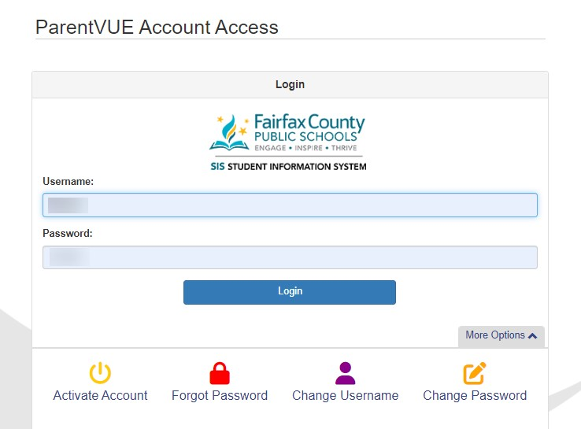

***Parent login to ParentVUE:***

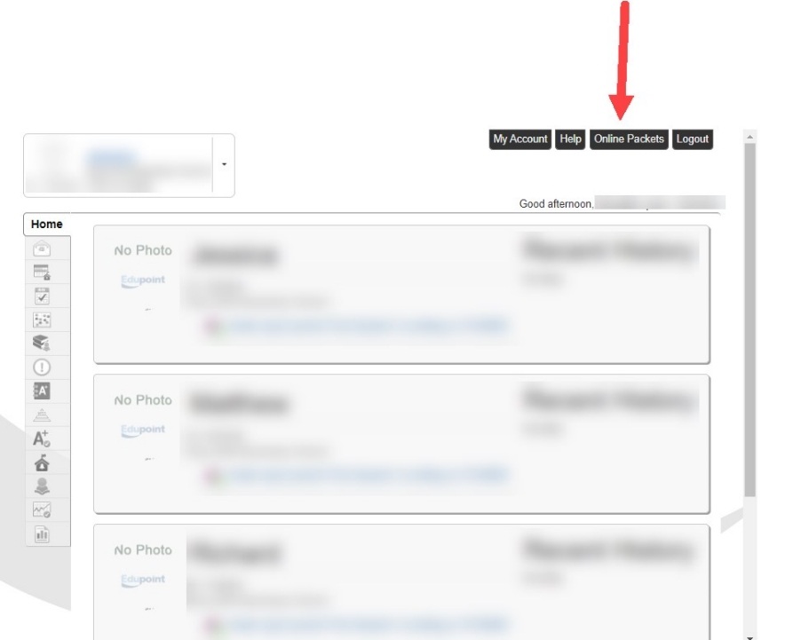

***Parent selects Online Packets:***

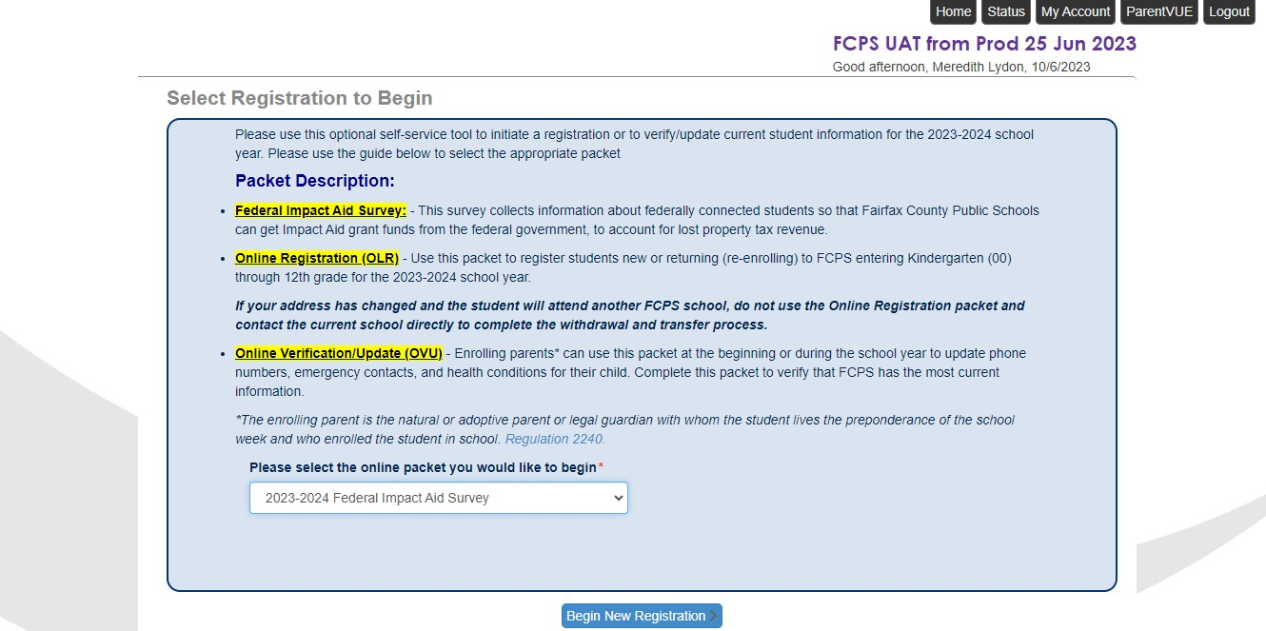***Parent selects Federal Impact Aid Survey from Dropdown Menu:***