Absence Reporting
Absence reporting is found under “Change” on the bottom toolbar. 1) Select “Change”. 2) Select the date of the absence. 3) Select your child’s name 4) Select "Plan" 5) Select "Absence". 6) In the “More Info” section, please include the reason for the absence. 7) Select “Submit” on the bottom toolbar.
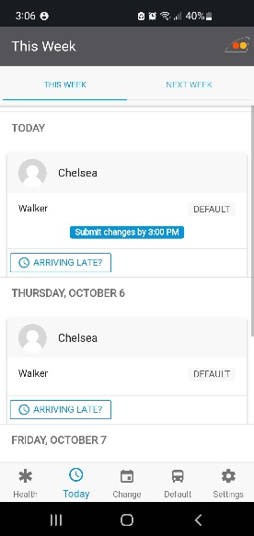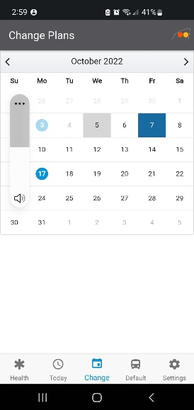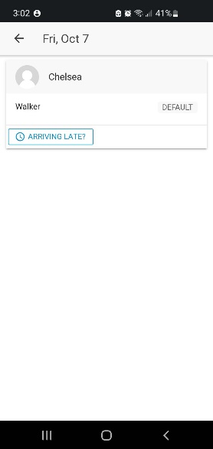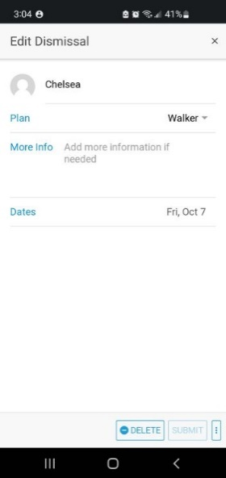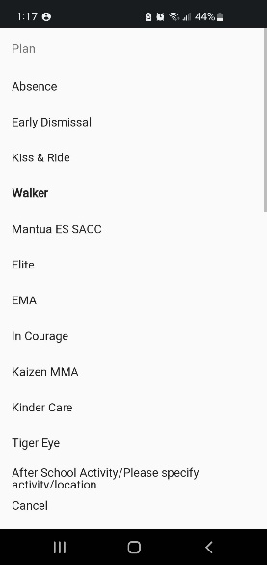

Single Day Changes, Seasonal Schedules, and Afterschool Activities:
Daily changes or a temporary dismissal change, such as an afterschool activity for a scheduled extended period, should be selected through the same “Change” option pictured above. 1) Select “Change” 2) Select the first date of the scheduled activity. 3) Select your child's name. 4) Select “Plan” 5) Select “After School Activity” at the bottom of the list 6) In the “More Info” section, input the name of the activity and the location 7) Select “Dates” and click on all of the scheduled dates for the after-school activity 8) Select “Submit
****Do not make these types of dismissal changes by clicking the “Default” button on the home screen. A “Default Plan” is a yearlong plan based on the child’s more permanent dismissal plan and schedule. Default plans should not be changed based on seasonal schedules. Doing so may result in errors in the dismissal instructions given to your child.****
