GoFan FAQ and Instructions
How does my student’s pass get to my student’s phone?
For purchasing one Student Pass, it will be easiest to purchase the pass directly in your student’s GoFan account.
For purchasing multiple passes, it’s easiest to have one purchaser buy all passes and then transfer them. Each pass may only be transferred one time. Each person that will receive a pass needs to have their own GoFan account with their own email address (not a school email.) All passes purchased for the family will initially show up in the purchasers GoFan account with a one-time transfer option. Transfer each pass to the email associated with each account. The pass will go to the recipient’s email. Once it is accepted the pass will be in the student account.
How do I use the pass to get into a game? *Passes are valid for regular season, home games, and only one entry per event.*
Pull up your GoFan account (app or website) on your mobile device. Go to “Tickets” on bottom menu bar

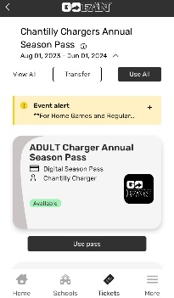
Click “Use pass”

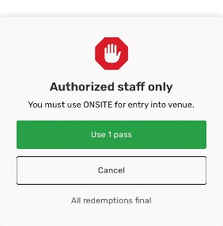
STOP THERE and see a gate attendant for entry. After you click “use pass”, you’ll see the stop message below. The “Use 1 pass” button MUST be green for entry. Once that button is clicked, the pass is temporarily deactivated. If the pass is deactivated/unavailable, the gate staff will not allow you to enter.
For questions contact membership1@chantillychargers.org

