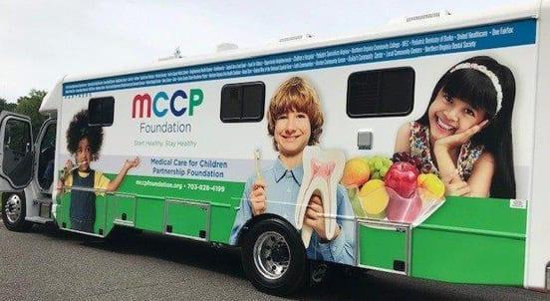

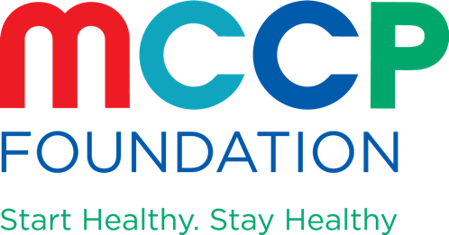

Free Dental Hygiene Screenings at Annandale High School

Our MCCP and NOVA DENTAL VANS are coming this Saturday

Northern Virginia Community College and Medical Care for Children Partnership will bring our Mobile Dental Vans to Annandale High School to provide free dental screenings for children from 3- 19 years old. A parent or guardian must be present so that we can discuss how to find affordable dental treatment if needed. We will also teach children about good dental care to prevent cavities and other dental problems. And we have goody bags for them!

Medical Care for Children Partnership (MCCP) works with community partners to offer access to comprehensive medical and dental care to eligible uninsured children of working families in Fairfax County. NVCC’s Medical Education Campus in Springfield has an excellent dental hygiene training program with a clinic that offers dental cleanings at a reasonable cost. Together we are working to bring dental care to communities that have had limited access to dental preventive services and treatment.

Date: Saturday December 3

Time: 10 am- 1 pm

