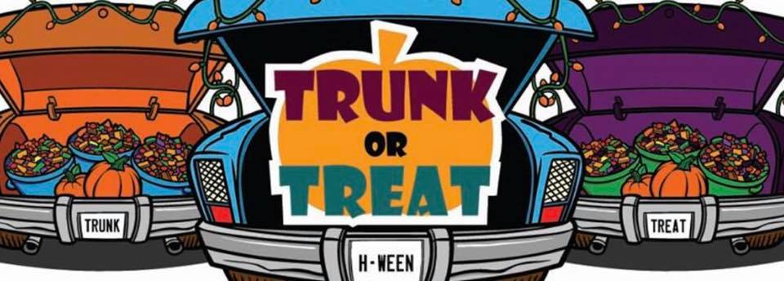

Sunday, October 23, 2022
Trunk or Treating begins at 12:30pm
If you would like to decorate your trunk please arrive by 12noon.
There will be music, moon bounce and the Kona Ice Truck

