
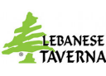


BES PTA RESTAURANT NIGHT

Lebanese Taverna Fundraiser
15% of sales go to Belvedere!
October 12 4:30PM Pickup
Belvedere ES Parking Lot
PRE-ORDER ONLINE
https://www.giftrocker.com/secure/Order/?h=95c4fea4
Orders need to be placed by
9:00pm on Tuesday, October 11
