Forming Teams for FIRST LEGO League!
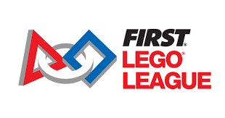

FIRST LEGO League is a program which guides youth through STEM learning and exploration at an early age. From Discover, to Explore, and then to Challenge, students will understand the basics of STEM and apply their skills in an exciting competition while building habits of learning, confidence, and teamwork skills along the way.

Lees Corner PTA is looking to form teams for the upcoming season of the FIRST LEGO League. Teams of up to ten members are led by two parent volunteer coaches.

Any student K-6 who is interested in joining the Lees Corner FIRST LEGO League team, please email: LeesCornerFLL@gmail.com.

More information is available at: www.firstlegoleague.org

