Go to www.edukitinc.com by June 30, 2022
for best pricing and free shipping.

Saratoga Elementary PTA offers the EduKit program as a convenient option for busy families to order school supplies for the 2022/2023 year. EduKits include the supplies approved by our school.

- Extended ordering is available July 1 – July 29 for an additional fee.
- Your student’s order will be in their homeroom on the first day of school.

Kits and Items | Price*
Kindergarten Kit | $54.71
Grade 1 Kit | $60.83
Grade 2 Kit | $55.98
Grade 3 Kit | $63.73
Grade 4 Kit | $63.53
Grade 5 Kit | $58.92
Grade 6 Kit | $64.49
Headphones – Required for Kindergarten-Grade 5 or bring from home | $5.35
Earbuds – Required for Grade 6 or bring from home | $5.99
*Prices are valid on orders placed by 6/30/22.
*Sales tax, if applicable, will be added at checkout.

Go to www.edukit.com Enter Saratoga Elementary School

*Sample box, items vary per grade.
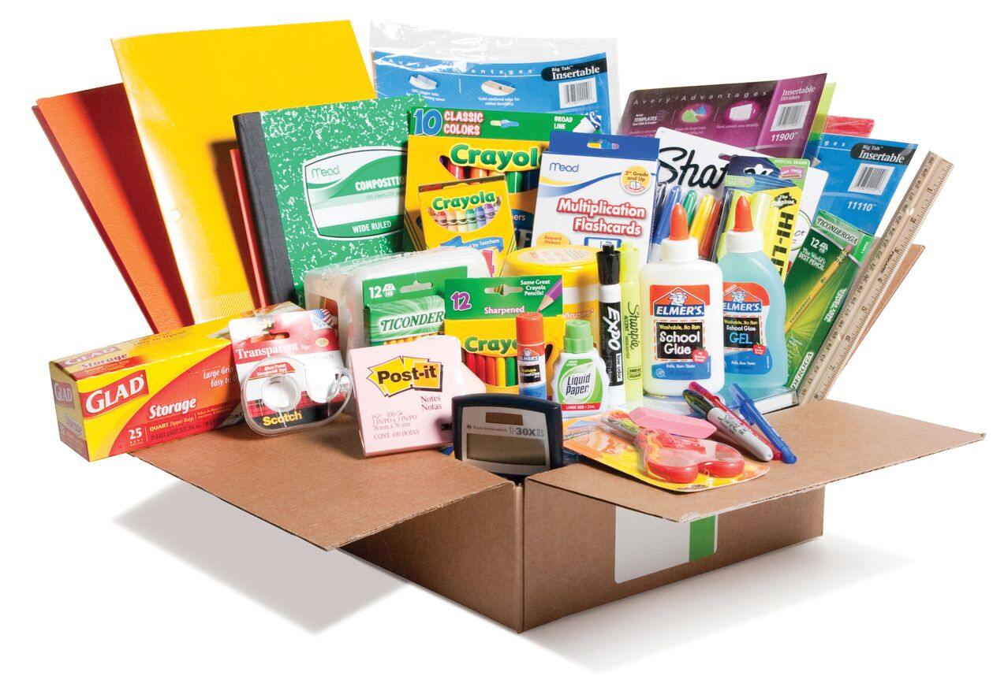

Questions?
Contact Karen Reiley
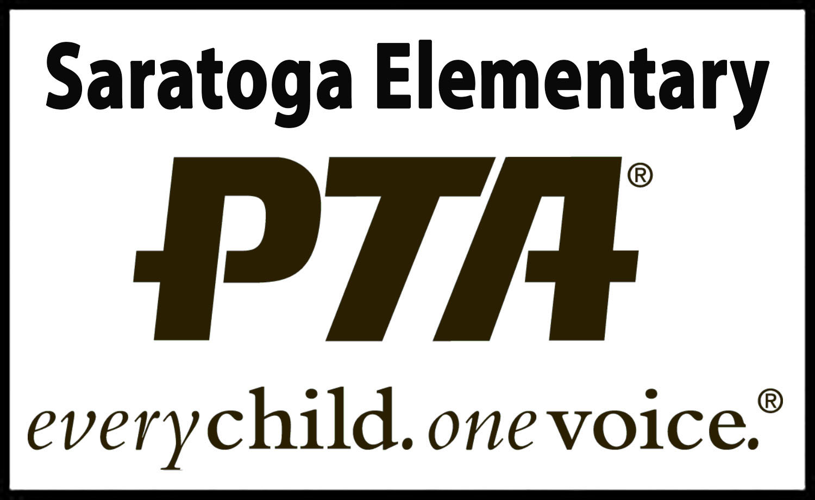
Koachkaren2003@yahoo.com

