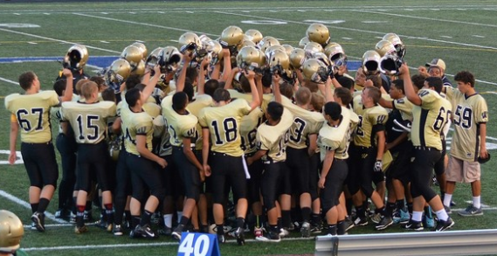
Westfield Bulldogs Freshman Football 2022
Take a picture of the completed form & send to Head Coach: Jason Sachlis: (jason.sachlis@fcps.edu)

Player Name & FCPS email:________________________________________________________

Personal Email (not FCPS email, personal account only): _______________________________________

Guardian/s Name/s: _________________________________________________________________

Guardian/s Email/s: __________________________________________________________________

Player Bio: Height ____________ Weight ___________ Date of Birth _______________________

Current School/Grade Level: ______________________________________________ /____________

Experience: (No previous experience is necessary. All interested students are encouraged to join!)

- How many years have you played organized 11 on 11 football? ____________________________________

- What was the most recent year you played 11 on 11 football? ____________________________________

- What primary position did you play? Offense ____________________ Defense _______________________

- Circle all Special Teams Experience? (Punting, Place Kicking, Long Snapping, Punt/Kick Return)

- What football experience do you have not covered by the above questions? ______________________

__________________________________________________________________________________

__________________________________________________________________________________

*All personal information is intended for communication purposes between Westfield High School Athletics Employees & student/parents. Purposes of student personal email address is to provide students access to electronic resources (hudl.com) used for viewing practice/game film which will require player accounts which can not be requested through the FCPS email account. Such requests for accounts will not be sent until student enrollment at Westfield High School.
Jason Sachlis (Coach Sachlis): jason.sachlis@fcps.edu
Westfield High School
Social Studies Instructor
World History I (Honors) Team Lead
Freshman Football Head Coach

I am elated to welcome students and families to the Westfield High School Athletics family! Our freshman football coaching staff is highly anticipating getting started on our upcoming season which will begin this Spring 2022 and continue with summer camp opportunities, before officially beginning August 2022.
I am proud to share with you that our staff of coaches includes 4 full-time FCPS staff members, including 3 teachers at Westfield High School, which provides us with the unique opportunity not only to instruct, but also build and strengthen relationships with students both on the athletic field as well as the classroom. The addition of a 5th coach who has had three student/athletes graduate from WHS, and is a highly-regarded coach in the county, results in freshman football players being coached by staff who cumulatively offer over a half century of experience coaching developmental football! Additionally, as FCPS coaches, we each are required to have First Aid certification and Concussion Education certification. Combined with a sincere program moto of building good football players & better people, I want to ensure you that we offer an extended family to our players that is both qualified and committed to providing an atmosphere that welcomes student/athletes with all levels of experience and ability and provides opportunities for growth and experience that our students will benefit from throughout their lives.
All that is required for students to participate in this opportunity is a positive mindset including a willingness to communicate with staff and receive instruction, a commitment toward implementing the instruction offered, and a commitment to achieve the goal of becoming the best team we can be. To achieve this final goal, players are expected to give their best efforts to learn and apply individual football techniques, familiarize themselves with our football team’s scheme, and be supportive of other teammates. Again, to help students, regardless of prior experience, achieve these goals, Westfield Freshman Football offers a staff of teachers/coaches that have been working together longer than any other school in the region.
Finally, there are also opportunities for parents/volunteers to become more actively involved with much needed support from game day roles such as photographer, videographer, on field roles in assistance of referees, and meal coordinators. If you are interested in filling in part-time or full-time, there is no experience needed. As I’ve said before and you’ll come to find out for yourself, Westfield Football is family. If you and your students are interested in becoming part of this first-class culture, please complete the questions/information attached and return to me at the email address on the header of this page. More information will be forthcoming later this spring. This letter is to simply introduce myself, provide you with a little information on our program, and begin the process of welcoming you to our family. If you have any questions, please do not hesitate to contact me.

Go Bulldogs!

