Updates from John Lewis High School’s Student Services Department
Week of September 20, 2021

Calendar Dates:
September 29 - Senior Parent Night at LHS Auditorium (6:00pm)
October 1 - Interim time (half-way through the quarter)
October 6 - Hispanic Parent Night at LHS Auditorium (6:00pm)
October 20 - Freshmen, Sophomore & New Student Parent Night (6:00pm)
October 29 - End of Quarter 1
November 1 and November 2 - Teacher Workdays (Student Holidays)

Announcements & Information:

Senior Conferences with Counselors
All seniors will be meeting with their school counselors this quarter. Meetings will be held in a group setting and one on one. Counselors will ensure each senior knows their graduation requirements, learns about post-secondary planning, and understands how to apply to colleges, review deadlines and processes.

Senior Parent Night - September 29, 2021
All parents of seniors are invited to attend our Senior Parent Night on September 29, 2021 at 6:00 in the Auditorium. The Student Services Department will give a review of senior year, what to expect and prepare for, discuss the college application process including financial aid and scholarship opportunities, and present options available to students for college & career planning. We will meet in the Auditorium - see you there!

Freshmen, Sophomore and New Student Parent Night - October 20, 2021
Previously scheduled for 9/22, our parent night will happen on October 20 at 6:00pm in the Cafeteria. Join the Student Services Team for a welcome to school, an overview of this school year, a preliminary discussion on graduation requirements and post-secondary planning.

Student Schedules – No Schedule Changes
Students have just returned to school and are getting adjusted to their courses. We are not accepting schedule change requests at this time. School counselors are working with students who have inaccurate or incomplete schedules, and with students who have transferred to our school or district.

In October, there will be an opportunity for our students to apply for a schedule change. Schedule changes may not be possible due to very limited space availability in our classes; nonetheless, there will be a process available. Prior to applying for the schedule change, multiple interventions must be demonstrated, and the student, teacher and parent/guardian should exhaust all efforts to find success in the current course. Changes will not be considered without multiple interventions and steps taken; typical interventions include students staying after school for extra help (Wednesdays and Thursdays are late bus days), the teacher understanding the perspective of the student and working with the student, the student taking advantage of retake opportunities, and clear communication between the student, teacher, and parent/guardian. Students must have positive attendance in the course as well as completed all work in the course to be eligible for consideration; these two aspects help to demonstrate the student’s effort and commitment to being successful. A schedule-change application will be available at the interim time (October); students should see their counselor.

Student Lockers
Lockers will be assigned to students this year by request. Please use the following form. Students will receive their locker assignment within 48 hours of the request; it will be sent to their fcpsschools.net email address. For questions, please contact Mrs. DeBardi in the Student Services Department at sadebardi@fcps.edu. Locker Request Form

College & Career Center

College Visits to the College & Career Center in person except where noted
Seniors: in order to attend any college visit, please register in your Naviance Student. Sessions are for seniors only.
9/20: 2:15 ODU
9/21: 9:15 Univ. of Mary Washington; 11:52 Capitol Technology Univ.
9/22: 9:15 Western New England Univ.
9/23: 9:15 GMU; 2:15 Roanoke College
9/23: Common App Q&A (virtual)
9/27: 9:15 Macalester College ; 10:30 Trinity Washington in DC; 11:22 Shenandoah Univ; 11:52 Univ. of Maryland of Baltimore County; 2:15 Merrimack College

VDOT Career Fair
This year’s Career Fair will be held virtually on October 7, 2021 from 9:00am-1:00pm. The goal of the event is to increase student understanding of careers in civil engineering, technology, construction, architecture, and the environment. To register, click: https://www.jobsconnected.com/vdot/

NOVA’s Dreamers Website Now Available
Northern Virginia Community College is excited about their new dreamers website, which supports undocumented, DACA, and TPS holders. This website was created to provide accurate and timely information to assist dreamers as they navigate the admissions process. As well, this site also contains valuable information about services and supports that promote the success of immigrant students. https://www.nvcc.edu/dreamers/?utm_content=&utm_medium=email&utm_name=&utm_source=govdelivery&utm_term=

Testing

PSAT and SAT FREE Online Practice Tests
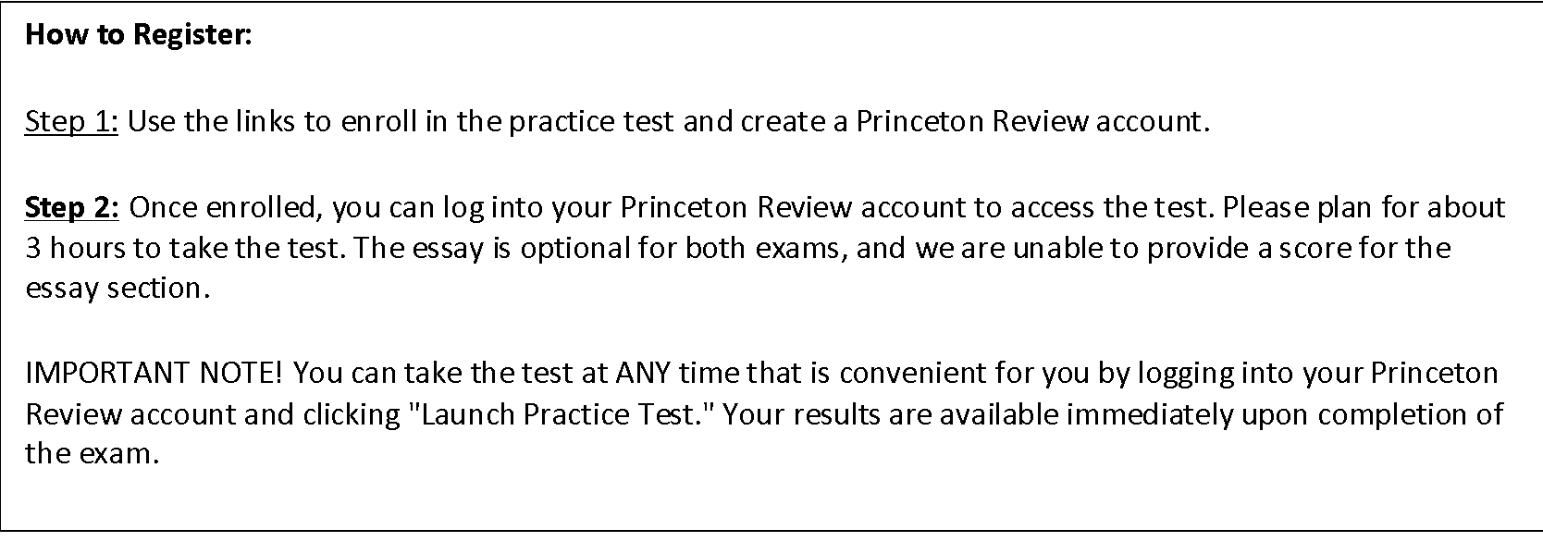
The Princeton Review is pleased to offer both the PSAT and SAT online practice tests for students at Fairfax County Public Schools. Students will receive a full-length score report immediately after taking the exam. Please see the flyer with details: HERE and the registration links: SAT Practice Test and PSAT Practice Test. Registration is due by September 30th.
Resources for Students & Families

Parent/Guardian/Student TECH Support Hub
Bookmark this site in case you need help with Schoology, ParentVue, Naviance, connectivity, laptop, laptop battery, and more. https://itweb.fcps.edu/ParentView/index.cfm

FREE Breakfast and Lunch for all FCPS Students
Please take advantage of the Food & Nutrition Program that offers free breakfast and lunch to our students. Households are not required to submit the free/reduced meal application this year, but still should apply so students receive other benefits (such as in class fees). More details are here: https://www.fcps.edu/return-school/food

Applications for the Free and Reduced Meals program are available online.
https://www.myschoolapps.com/Application **Any family who has qualified in the past for free/reduced lunch should reapply. The program expires after one calendar year from the date of acceptance. Students/families can receive multiple benefits, such as a reduction in class fees, uniform expenses, school parking fees, and other assistance. **Families should fill out the application as well as the Consent to Share form.

Social Services
The Fairfax County Department of Family Services offers supports for families, children, the elderly, people with disabilities, and more. If you or a loved one needs support, please click here.

Partnership for Healthier Com. Affordable healthcare at 703-698-2550

Crisis Link Hotline at 703-527-4077, or Text them at 703-997-5444, chat online with a specialist at www.crisischat.org or www.imalive.org

Substance Abuse Prevention
Substance Abuse Prevention Specialists work with the students to bring them the most accurate, up-to-date information (including medical, physical, social, and psychological consequences) on substance use, addiction, and treatment. Treatment, including refusal skills and cessation techniques, are taught to help students learn the tools and strategies they need to stop using these substances. Ms. Joseph is the Lewis Pyramid SAPS and is here to support our students.
https://www.fcps.edu/resources/student-safety-and-wellness/alcohol-tobacco-and-other-drug-programs

