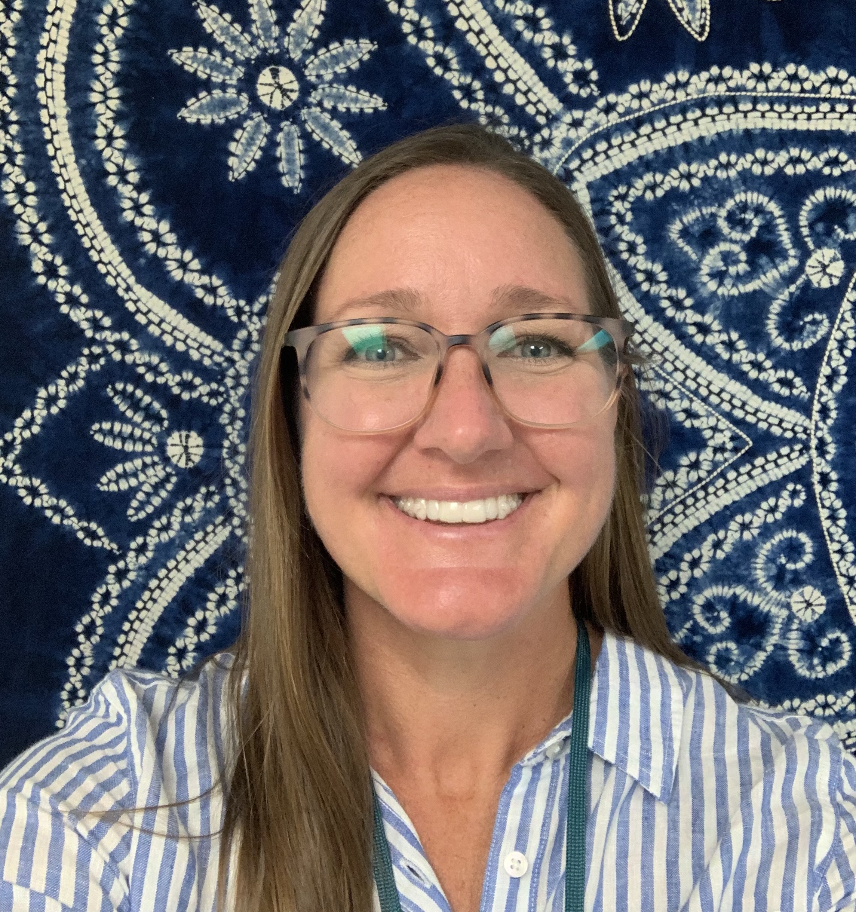 |  | Laura Leigh GOttula, LCSW  Military and Family Life Counselor  Robinson Secondary School
Welcome to the 2021-2022 school year! My name is Laura Leigh Gottula, and I am the Military and Family Life Counselor at Robinson Secondary School. I am very excited to be working with military students and their families. MFLCs provide nonmedical counseling to enhance social, academic, and emotional skills to support the wellbeing of military students and their families. Sessions are in-person, and all services are free and confidential. I am available to all military families and for consultation with school staff Monday-Friday. Hours are flexible to fit your schedule. Please feel free to contact me for more information.  Contact  PHONE:  C:(571)419-1794  EMAIL:  GottulaL@magellanhealth.com  Lgottula@fcps.edu  Office  Subschool 10 |  | Issues addresssed  - School Adjustment  - Deployment and separation  - Reunion adjustment  - Sibling and parent-child communication  - Behavioral concerns  - Fear, grief, and loss  How do we make a difference?  - Engaging in activities with children and youth  - Providing short term, non-medical counseling support  - Available at no cost to assist children and youth, parents, family members, and staff of child and youth programs  - Providing behavioral interventions in classrooms, at camps, and in Child Development Centers to assist staff in setting and managing boundaries  - Modeling behavioral techniques and providing feedback to staff  - Being available to parents and staff to discuss interactions with children and other concerns  - Facilitating psycho-educational groups  Services are private and confidential except for child abuse or neglect, domestic abuse, illegal activity, or any other duty-to-warn situations.  Presentation Topics:  - Anger Management  - Building Resiliency  - Deployment  - Children and Moving  - Communication  - Conflict Resolution  - Coping Strategies  - Divorce and Separation  - Relationship Skills  - Reintegration  - Stress Management

