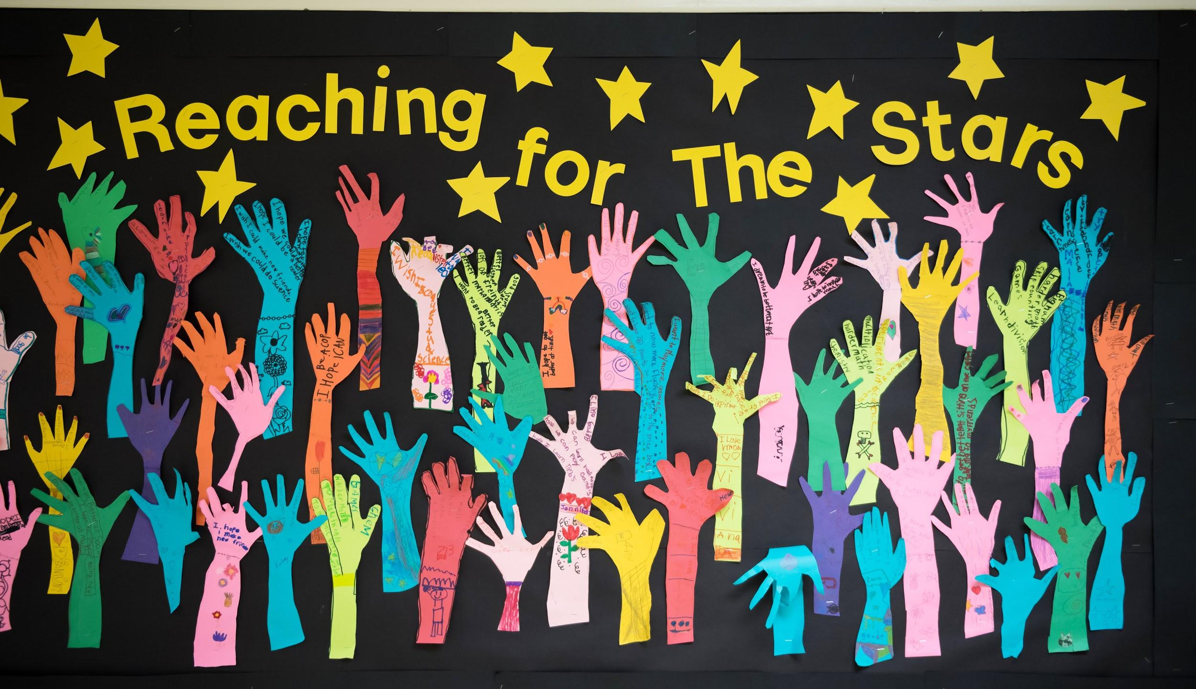
FCPS Summer Learning
Bridge to Kindergarten,
Bridge to First & Summer SOAR

Virginia Run Elementary School is now registering students for our
FCPS Summer Learning Programs.
These programs are an opportunity for you and your child to have a FREE AND FUN summer learning experience.

Dates: July 12th - July 30th Hours: 9:40 - 1:40

Bus transportation will be provided.

Bridge to Kindergarten: An opportunity for your rising kindergartener to become familiar with the school environment.

Bridge to First: An opportunity for your rising first grader to support the move to first grade.

Summer SOAR: An opportunity for current 1st-6th graders to enhance their math and literacy skills.

Please respond by April 26th. Click here to respond.

Questions? Contact:

Site Director: Deirdre Herbert
Email Address: mdherbert@fcps.edu
School Office Phone: (703) 988-8900

Aprendizaje de verano de FCPS
Bridge to Kindergarten,
Bridge to First & Summer SOAR

Virginia Run Elementary School esta ahora registrando estudiantes para our FCPS Summer Learning Programs.
Estos programas son una oportunidad para que usted y su hijo tengan una experiencia de aprendizaje de verano GRATUITA Y DIVERTIDA.
Fechas: Julio 12 - Julio 30 Horas: 9:40 - 1:40

Se proporcionará transporte en autobús.

Bridge to Kindergarten: Una oportunidad para que su estudiante de kindergarten se familiarice con el entorno escolar.

Bridge to First: Una oportunidad para que su estudiante de primer grado apoye el paso al primer grado.

Summer SOAR: Una oportunidad para que los estudiantes actuales de 1º a 6º grado mejoren sus habilidades en matemáticas y alfabetización.

Responda antes del 26 de Abril. Haga clic aquí para responder Click here to respond.

Para preguntas? Contacte:

Site Director: Deirdre Herbert
Email Address: mdherbert@fcps.edu
School Office Phone: (703) 988-8900

