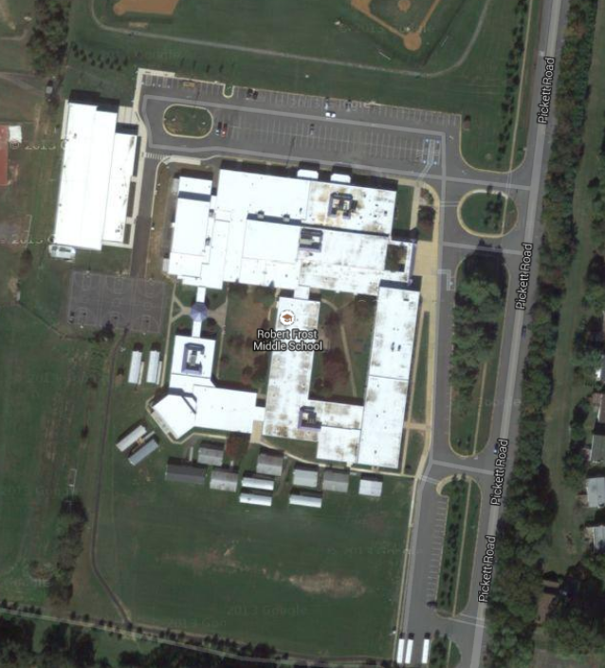

**Exit 2**

3

2

**Exit 1**

1

Stations:

1: DROP OFF, 7th and 8th grade English

2: PICK UP 7th grade English **only**

3: Library Virtual Check out

**12-6 ONLY**

**Traffic direction**

Entrance