
Do you want your driver’s license?

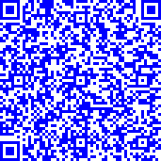

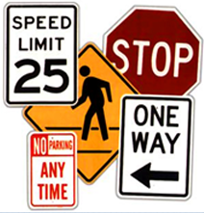
Behind the Wheel
(Driving Instruction)

To register with Mr. Afrane scan the QR code or go to:

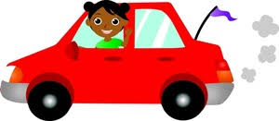
- https://aceclasses.fcps.edu/
- Driver Education (left side of the page)
- Behind the Wheel Driver Education
- Click on Lewis HS
- Find the date and time that works for you.
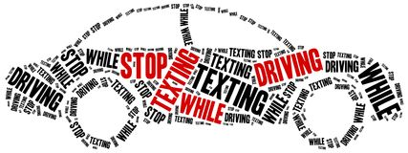
Available Starting Dates and Times:
04/05/2021 @ 6:00 pm
05/06/2021 @ 6:00 pm
05/17/2021 @ 6:00 pm
05/27/2021 @ 6:00 pm

Required for 1st day of class:
Learner’s Permit
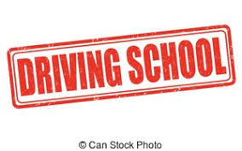
District-8 classroom course completion card or concurrent enrollment form
At least 15 hours of driving experience recorded in the driving log
Online confirmation receipt (signed by a parent)

