
SUPPORT YOUR SENIOR!

Class of 2021 ALL NIGHT GRAD CELEBRATION - ANG
A Safe, Alcohol & Drug Free Night for Fairfax Seniors to Remember

GRADUATION YARD SIGNS & CAR MAGNETS FOR SALE!

The Fairfax HS All Night Grad Committee is offering graduation yard signs and car magnets!

Questions? Contact ang@fairfaxptsa.org attn: Yard Signs/Car Magnets

Order Deadline is Friday, December 11th, 2020

Please fill this form ONLINE at www.fairfaxptsa.org/ about-all-night-grad-ang.
OR
Please fill this form and check the boxes below and complete the form on the back.
Please make checks payable to FHS PTSA
Return with completed form with payment to: Fairfax High School Main Office
Attn: ANG YARD SIGNS
3501 Lion Run, Fairfax, VA 22030

“Fairfax Class of 2021 Graduate Name” Personalized Yard Sign: $20 - Deadline December 11
Student Name: (first) (last-optional)

18” x 24” weather resistant, reusable sign with metal stake. See sample on reverse.
You may also choose to purchase an additional sign to be placed along Lion Run on Graduation Day. (by the All-Night Grad Committee)

# of signs picked up: _____________ ($20 each)
# of signs to be placed on Lion Run on Graduation Day* ____________ ($20 each)

Total # of signs ordered: ____ @ $20.00 each = $_______

“Fairfax High Class of 2021 Seniors” Generic Yard Sign: $15 - Deadline December 11
18” x 24” weather resistant, reusable Generic Yard Sign with metal stake. See sample on reverse. This yard sign is WITHOUT seniors’ name.

“Fairfax High Class of 2021 Seniors” Car Magnet: $6 - Deadline December 11
8.7” x 11.5” weatherproof and fade-resistant, your car magnet will look great for a long time and they will stay on your car at freeway speeds. See sample on reverse. This car magnet is for the senior class of 2021.

“ Fairfax High Lion Pride” Generic Car Magnet: $6 - Deadline December 11

8.7” x 11.5” weatherproof and fade-resistant, your car magnet will look great for a long time and they will stay on your car at freeway speeds. See sample on reverse. This car magnet is generic WITHOUT the class year.

*PLEASE COMPLETE THE BACK OF THIS FORM*

Contributions of any amount will help keep our students safe on graduation night.
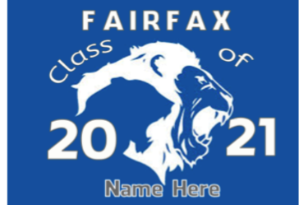
Support ANG | Quantity | Total
“Graduate Name” Personalized Yard Sign $20
(student’s name replaces “Name Here”)

Please provide name of student. Either FIRST NAME ONLY, LAST NAME ONLY or BOTH.
NAME: _________________________
“Generic” Yard Sign $15
(this yard sign does not include student’s name)


“Class of 2021” Car Magnet $6
(this car magnet says Class of 2021)
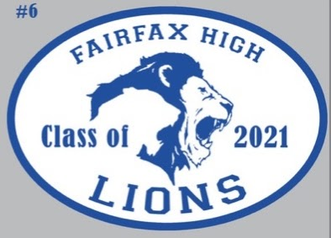
“Generic” Car Magnet $6

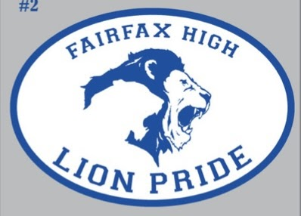
Make checks payable to: Fairfax PTSA OR pay online  www. fairfaxptsa.org/about-all-night-grad-ang | TOTAL:
Your Name Company Name (if applicable): Address: City: State: Zip:
Phone: Email:
The FAIRFAX High School Class of 2021 Appreciates Your Support!

