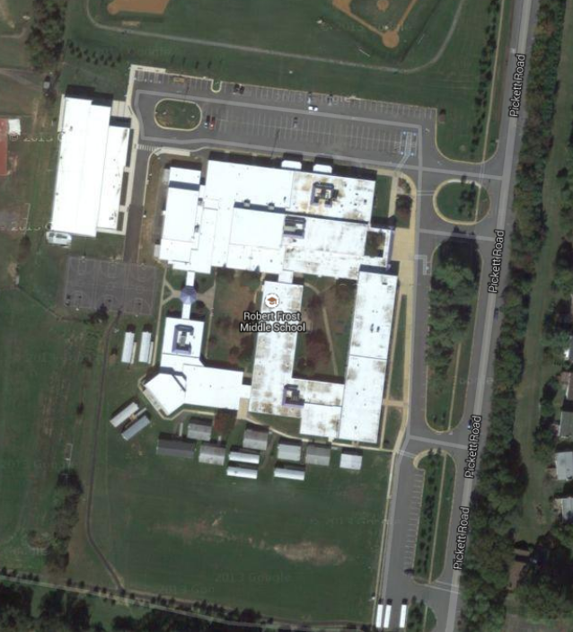

Follow the blue arrows into the parking lot.

Park along curb at #1.

Exit vehicle and walk along path to cafeteria door at #2.

Please wait in the car if another family is in front of you.

Exit parking lot via the orange arrow.

2

1

**Exit**

**Traffic direction**

Entrance