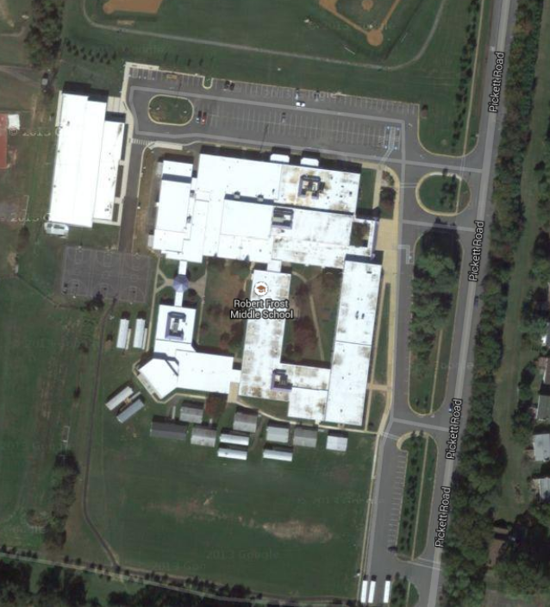

Stations:

1: FACS (7th & 8th)

2: Engineering (**7th grade only**)

3: English 7 (**all 7th grade students**)

4: English 8 (**all 8th grade students**)

5: Library pick-up (pre-order only)

**Exit 2 is for all 8th** grade students and people picking up library books. **All others use Exit 1.**

**Exit 2**

**Exit 1 1**

**Traffic direction**

4

3

2

5

1

Entrance