VIRTUAL AUTHOR VISIT

with Ginjer L. Clarke

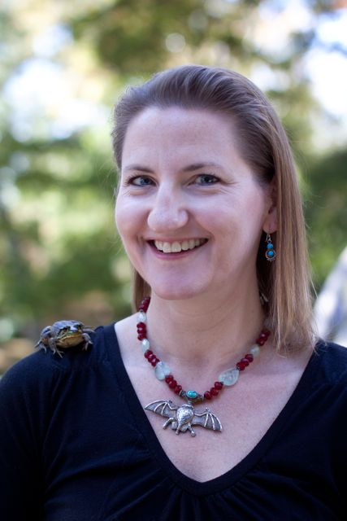
Ginjer L. Clarke loves to learn about weird animals! She writes fun, fact-filled nonfiction science books about wild, wonderful animals and places that make learning about nature entertaining and engaging. Her books have sold a total of more than 3 million copies worldwide since 2000 and have been on the Publisher’s Weekly list of top 100 best-selling children’s books. She was raised in Baltimore, MD, is a graduate of James Madison University, and now lives in Richmond, VA, with her husband, teenage son, and some silly-looking pets.

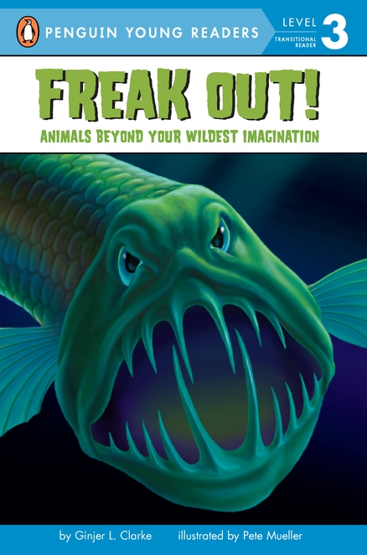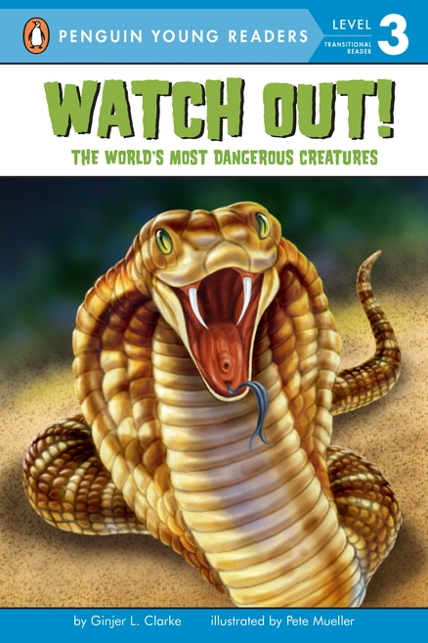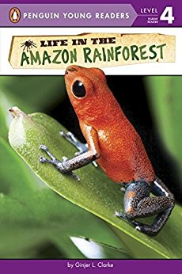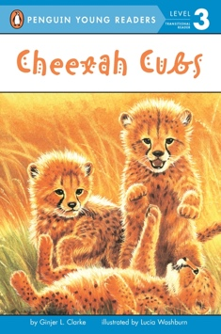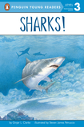

Here are some other fun facts about Ginjer Clarke:
- Her favorite animal is the African elephant, and she has more than 100 different elephant objects in her home collection.
- She has been dancing since she was 5 years old and still dances at least three times every week for exercise.
- Ginjer once won a year-long reading contest (and a trip to Kings Dominion) in the fifth grade for completing 13,275 pages.
- She can juggle a little and jump-rope pretty fast, but she can’t whistle or blow bubbles with gum.
- Her favorite color is turquoise, and her favorite food is anything with chocolate and peanut butter.

visit her website at: www.GinjerClarkeBooks.com
or Facebook page at www.facebook.com/ginjerclarkebooks

